INTRODUCTION

INTRODUCTION OF WEBSITE
This website is design to provide image defusion and ecncryption facilities to the existing users and new users according to their qualification, satisfaction and experience inside and outside the country. This website offers users encrypt and decrypt images according to their need.
Here we are using the technique in which Resolvers can obtain public keys of zones in one of two ways. Resolvers can utilize the image to query for the public key or they can be statically configured with the key. Regardless of the method used, problems exist with both. In the case where keys are obtained through the image, the issue of trusting the key arises. In order to trust the retrieved key, it must be signed and this signature must be reliable. Providing the assurance that the signature on the key is reliable means that the public key of the signing authority must also be obtained, be signed, and be found reliable and so on. The solution to ending this recursive chain of events is to configure the resolver with the public key that authenticates the signed keys below it. In other words, a trusted zone key can be used as a starting point for verifying all keys found below it. A likely set of trusted public keys with which a secure zone can be statically configured are those of the root zone.
The static configuration of a resolver with the public keys from many different zones has one advantage in that the compromise of one of the zone's private key does not result in the compromise of the keys for all the other zones. The disadvantage of statically configuring each resolver with keys for many different zones is that it does not scale well. If one key for one zone must change, then all the resolvers must be configured to reflect this change.

OBJECTIVE

OBJECTIVE OF DESIGNING THE WEBSITE
Objective:

Crypto system is responsible for encrypting the user’s data and provide a secure mechanism to store it in a virtual drive. This virtual drive will be created by the system for the particular user for the very first while using the system. This system will provide limited storage area where the data can be saved. As we can say that, it’s a cloud storage medium where data can be accessed from any location. This system will also enable you to synchronize your desktop or laptop while using this crypto system. For implementing security mechanism, each user’s should have a valid login id and password and the verification of user’s account will be done through their valid email id.Upon accessing this crypto system, users can simply drag and drop their documents from their system to their virtual hard drive where it will take some time for encrypting the documents and process of encryption and decryption will depend upon the size of document and their type. User friendly interface has been provided, so that users can easily access all the provided features. It uses strong bit encryption mechanism and its virtual hard drive and easily loaded and unloaded at any location as per the user’s choice.
Existing System:

Existing system was not able to perform the encryption procedure before saving the data to the virtual hard disk and it was not protected by the strong bit encryption mechanism. Simple drag and drop feature was not available under the existing system and to load these documents users were bound to use the browse method provided by the html browser. It was not able to perform validation checkup and displaying the type of data during uploading session. It was not able to create multiple virtual drive and can create single virtual drive only under the desktop or laptop and not to other removable media.
Proposed System:

This new crypto system has been provided with all security check ups which can be performed while encryption and decryption of documents.Its validation and verification process will be done from the server side and display the information of various fields such as type of document loaded, its actual size, date and time under specified virtual drive. The admin of the documents will have the authority to set parameters for their various documents such as read, write along with advanced operations such as copy and paste the documents to other virtual drive location. Its strong bit encryption algorithm will make ensure that others will not able to hack or change their file attributes.

SYSTEM ANALYSIS

System analysis is a management technique which helps us in designing a new system or improving an existing system. “System” word derived from the word Systema, which means an organized relationship among the functioning units or components. There are various definitions of the word System, but most of them seem to have a common idea that suggests that a system is an orderly grouping of independent components linked together according to a plan to achieve a specific goal.

System analysis is a software engineering task bridges the gaps between system level requirements engineering and software design. Requirement engineering activity result in the specification of software operational characteristic indicates software interface with other system elements and establish constraints that software must meet. Requirement analysis allows the software engineer to refine the allocation and build models of at, functional and behavioral domains that will be treated developing the system “Store Management and Automation” I did lot of analysis that what are the needs, what are the problems faced in existing system
System analysis is a detailed study of the various operations performed by a system and their relationship within and outside the system. There are four basic elements in system analysis as following:
- Output: First of all, we must determine what the objectives or goals are, what do we intend to achieve, what is the purpose of our work; in other words, what is the main aim behind the system.
- Input: Once we know the output, we can easily determine what the input should be. Sometimes, it may happen that the required information may not be readily available in the proper form. This may be because of the existing forms are not properly designed. If the information is vital to the system, we should make all possible efforts to make it available. The essential elements of inputs are:
  - Accuracy
  - Timelines
  - Proper format
- Files: As the word implies files are used to store data.
- Process: Here we come to the details of how the input and files are converted into outputs. This involves the programs and the way in which data is processed through the computer. The processing steps involve a set of logical steps which is called “Programs”.

SRS DOCUMENT INCLUDE
- Functional requirements.
- Nonfunctional requirements.
- Goals of implementation.

Functional Requirements

These requirements should specify the given inputs, validation condition on inputs, operations to be performed on the input and corresponding outputs on the operations, equations or logical operations that must be used to perform inputs to outputs. In addition, some abnormal inputs, system behavior for invalid inputs must be specified.

Nonfunctional Requirements

Nonfunctional requirements: static and dynamic. A static requirement includes number of terminals to be supported, number of users to be simultaneous supported; number of files system has to process and their sizes etc. Dynamic requirements include execution time behavior of the system such as throughput, response time, expected time for completion of the operation, acceptable ranges of different performance parameters should be specified.

Goals of Implementation

- This software is being developed keeping in mind not only its reusability but also its future enhancements.
We should take care that the specific database system to be used as per management requirement
IDENTIFICATION OF THE NEED
Every time when company is providing their new jobs or giving any special news, its details send to their clients through post employee lot of paper work and time. The new customers remain unknown about of all process and their details.
This website is design to provide online jobs facilities to the existing users and new users according to their qualification, satisfaction and experience inside and outside the country. This website offers students to access non-degree part-time and full-time employment opportunities on and off campus. As you look forward to life after college, your first priority should be to focus on the importance of securing an outstanding first job. That first job, whether it lasts twelve months or forty-five years, will start you on the path to your future life.
PRELIMINARY INVESTIGATION
The first step in the system development life cycle is the preliminary investigation to determine the feasibility of the system. The purpose of the preliminary investigation is to evaluate project requests. It is not a design study nor does it include the collection of details to describe the business system in all respect. Rather, it is the collecting of information that helps committee members to evaluate the merits of the project request and make an informed judgement about the feasibility of the proposed project. Preliminary investigation has three steps:

Request Clarification: Many requests from student and faculty in organization are not clearly stated. Therefore, it becomes necessary that project request must be examined and clarified properly before considering system investigation.
- Request Approval: Not all the request is desirable or feasible. However those that are both feasible and desirable should be put into schedule. After a project request is approved, its cost, priority, completion time, and personal requirement are estimated.
- Feasibility Study: Feasibility is the determination of whether or not a project is worth doing .The process followed in making this determination is called a feasibility study. The objective of a feasibility study is not to solve the problem but to acquire a sense of its scope. The goal of feasibility studies is to evaluate alternative systems and to propose the most feasible and desirable systems for developments. The prime focus of the feasibility study is evaluating the practicality of the proposed system keeping in mind a number of factors.

FEASIBILITY STUDY

TECHNICAL FEASIBILITY
Technical feasibility is concerned with specifying equipments and software that successfully satisfied the user requirement. The technical need of the system may be very considerably, but might include:
- The facility to produce outputs in a given time.
- Response time under certain conditions.
- Ability to process a certain volume of transaction at a particular speed.
- Facility to communicate data to distant location.
Technical feasibility centers on the existing computer system (hardware, software etc.) and what extent it can support the proposed system.
OPERATIONAL FEASIBILITY
It is mainly related to human organization and political aspects. The points to be considered are: what changes will be brought with the system?, what organizational structures are distributed?, and what new skills will be requires?
Generally project will not be rejected simply because of operational infeasibility but such considerations are likely to critically affect the nature and scope of the eventual recommendations. This feasibility study is carried out by a small group of people who are familiar with information system technique, who understand the parts of the business that are relevant t the project and are skilled in system analysis and design process.

ECONOMICAL FEASIBILITY
Economical analysis is the most frequently used technique for evaluating the effectiveness of a proposed system. More commonly known as cost/benefit analysis; the procedure is to determine the benefits and savings that are expected from a proposed system and compare them with cost. A system that can be developed technically it will be easily used if installed. Financial benefits must equal or exceeds the cost. The analysts raise various financial and economic questions during the preliminary investigations to estimate the following: -
- The cost to conduct to full system investigation.
- The cost of Hardware and Software for the class of application being considered.
- The benefits in the form of reduced cost or fewer costly errors

SOFTWARE AND HARDWARE REQUIREMENT SPECIFICATION

HARDWARE REQUIREMENT
Processor 1.2 GHz (or above)
Ram 128 MB (or above)
Monitor SVGA
Pointing device Mouse
Hard disk 10 GB (or above)
SOFTWARE REQUIREMENT
Operating System Windows 2007/2008/2010
Front End Language

- J2EE Java2 (jdk1.6,1.7,1.8)
- Java Server Pages (JSP)
- Servlet
- Hibernate
- Extensible Markup Language (XML)
Application Server Tomcat8.0
RDBMS Oracle 10g
RAD Tools Notepad
HTML Editor Macromedia Dreamweaver MX
Scripting Language Java Script

PROJECT CATEGORY

Web Based Application With RDBMS

FRONT END LANGUAGE
JAVA
Object-Oriented Programming
Java is object-oriented programming (OOP). Java was conceived by James Gosling, Patrick Naughton, Chris Warth, Ed Frank, and Mike Sheridan at Sun Microsystems in 1991. This language was initially called “Oak” but was renamed “Java” in 1995. The object-oriented methodology is inseparable from Java, and all Java programs are, to at least some extent, object-oriented. OOP is a powerful way to approach the job of programming. Programming methodologies have changed dramatically since the invention of the computer, primarily to accommodate the increasing complexity of programs. To support the principles of object-oriented programming, all OOP languages, including Java, have three traits in common: encapsulation, polymorphism, and inheritance.
Encapsulation: Encapsulation is a programming mechanism that binds together code and the data it manipulates, and that keeps both safe from outside interference and misuse. In an object-oriented language, code and data can be bound together in such a way that a self-contained black box is created. Within the box are all necessary data and code. When code and data are linked together in this fashion, an object is created. In other words, an object is the device that supports encapsulation.
Polymorphism: Polymorphism (from the Greek, meaning “many forms”) is a feature that allows one interface to be used for a general class of actions. The specific action is determined by the exact nature of the situation. Consider a stack (which is a last-in, first-out list). You might have a program that requires three types of stacks. One stack is used for integer values, one for floating-point values, and one for characters. The algorithm that implements each stack is the same, even though the data being stored differs. In a non– Object-oriented language, you would be required to create three different sets of stack routines, with each set using different names. However, because of polymorphism, in Java you can specify a general set of stack routines that all share the same names. More generally, the concept of polymorphism is often expressed by the phrase “one interface, multiple methods.” This means that it is possible to design a generic interface to a group of related activities. This helps reduce complexity by allowing the same interface to be used to specify a general class of action.
Inheritance: Inheritance is the process by which one object can acquire the properties of another object. This is important because it supports the concept of hierarchical classification. If you think about it, most knowledge is made manageable by hierarchical (i.e., top-down) classifications. Without the use of hierarchies, each object would have to explicitly define all of its characteristics. Using inheritance, an object need only define those qualities that make it unique within its class. It can inherit its general attributes from its parent. Thus, it is the inheritance mechanism that makes it possible for one object to be a specific instance of a more general case.
The most important characteristic of Java is that it was designed from the outset to be machine independent. You can run Java programs unchanged on any machine and operating system combination that supports Java. Of course, there is still the slim possibility of the odd glitch, as you are ultimately dependent on the implementation of Java on any particular machine, but Java programs are intrinsically more portable than programs written in other languages. An application written in Java will only require a single set of source code statements, regardless of the number of different computer platforms on which it is run. In any other programming language, the application will frequently require the source code to be tailored to accommodate different computer environments, particularly if an extensive graphical user interface is involved. Java offers substantial savings in time and resources in developing, supporting, and maintaining major applications on several different hardware platforms and operating systems. Possibly the next most important characteristic of Java is that it is object-oriented. The object-oriented approach to programming is also an implicit feature of all Java programs, so we will be looking at what this implies later in this chapter. Object-oriented programs are easier to understand and less time consuming to maintain and extend than programs that have been written without the benefit of using objects.
Security
You are almost certainly aware, every time you download a “normal” program; you are risking a viral infection. Prior to Java, most users did not download executable programs frequently, and those that did, scan them for viruses prior to execution. (A malicious program might gather private information, such as credit card numbers, bank account balances, and passwords by searching the contents of your computer’s local file system.) Java answers these concerns by providing a firewall between a networked application and your computer. When using a Java-compatible web browser, it is possible to safely download Java applets
without fear of viral infection. The way that Java achieves this is by confining a Java program
to the Java execution environment and not allowing it access to other parts of the computer.
Java’s Magic: The Bytecode
The key that allows Java to solve both the security and the portability problems just described is that the output of a Java compiler is not executable code. Rather, it is bytecode. Bytecode is a highly optimized set of instructions designed to be executed by the Java run-time system, which is called the Java Virtual Machine (JVM). That is, the Java Virtual Machine is an interpreter for bytecode. Translating a Java program into bytecode makes it much easier to run a program in a wide variety of environments. The reason is straightforward: only the Java Virtual Machine needs to be implemented for each platform.

J2EE SERVICE USED IN PROJECT
JSP (Java Server Page)
Java Server Pages (JSP) is a Sun Microsystems specification for combining Java with HTML to provide dynamic content for Web pages. When you create dynamic content, JSPs are more convenient to write than HTTP servlets because they allow you to embed Java code directly into your HTML pages, in contrast with HTTP servlets, in which you embed HTML inside Java code. JSP is part of the Java 2 Enterprise Edition (J2EE). JSP enables you to separate the dynamic content of a Web page from its presentation. It caters to two different types of developers: HTML developers, who are responsible for the graphical design of the page, and Java developers, who handle the development of software to create the dynamic content.
How JSP Works?
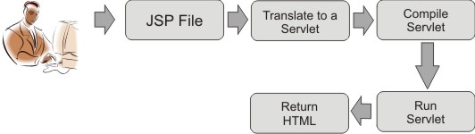
Evolution of JSP
HTML produces static web-pages, but today it is necessary for most web sites to have dynamic content. To generate the content dynamically we need something that can allow us to specify business logic and that can generate response to the request. The data can then be formatted using HTML.
This is the situation that leads to the invention of HTML documents that is given chance of embedding the java code for providing the dynamic nature to that document that which was later named and popularized as Java Server Pages (JSP).

Servlet
Servlet is a server-side running java program that accepts HTTP protocol request and gives HTTP response back to client running on web browser. In other word Servlet is a small program that runs on web server. Every Servlet application must be directly or indirectly inherited from Servlet interface. To prevent developer to implements all the 5 functions of Servlet Interface the recommended class from which Servlet can be extended is
- javax.servlet.GenericServlet
- javax.servlet.http.HttpServlet
Servlet interface contains 3 lifecycle functions:
- public void init(ServletConfig) throws ServletException
- public void service(ServletRequest, ServletResponse) throws ServletException, IOException
- public void destroy()

The Power of Servlets

So far, we have portrayed servlets as an alternative to other dynamic web content Technologies, but we haven’t really explained why we think you should use them. What makes servlets a viable choice for web development? We believe that servlets Offer a number of advantages over other approaches, including: portability, power, Efficiency, endurance, safety, elegance, integration, extensibility, and flexibility. Let’s examine each in turn.
XML (Extensible Markup Language)
XML usages include how well you can organize data structuredly? When retrieved the data from DB, we need to manage the data foe something in our application (moves across from one component-another component, may later sometimes).
The final conclusion on XML is that the only way to exchange information between various layers of MVC architecture to a platform independent/neutral manner.
JDBC (Java Database Connectivity)

A Java API that enables Java programs to execute Oracle statements. This allows Java programs to interact with any Oracle-compliant database. JDBC is similar to ODBC, but is designed specifically for Java programs, whereas ODBC is language-independent. JDBC was developed by Java Soft, a subsidiary of Sun Microsystems.

ODBC (Open Database Connectivity)

The goal of ODBC is to make it possible to access any data from any application, regardless of which database management system (DBMS) is handling the data. ODBC manages this by inserting a middle layer, called a database driver, between an application and the DBMS.

HTML (Hyper Text Markup Language)

HTML is a text formatting language for preparing web documents that runs on web browser. HTML formats hyperlinks text content and renders media content. The first version of HTML 4 was HTML 4.0, published on 18 December 1997 and revised 24 April 1998. To publish information for global distribution, one needs a universally understood language, a kind of publishing mother tongue that all computers may potentially understand. The publishing language used by the World Wide Web is HTML (Hyper Text Markup Language). The correct structure for an HTML document starts with <HTML><HEAD> (enter here what document is about)<BODY> and ends with </BODY></HTML>. All the information you'd like to include in your Web page fits in between the <BODY> and </BODY> tags.

JAVA SCRIPT

JavaScript is and Interpreted language, rather than a compiled language. JavaScript language first become in the web browser Netscape Navigator 2. Initially it was called Live Script. However, because Java was the hot technology of the time, Netscape decided that JavaScript sounded more exciting. JavaScript was designed to add interactivity to HTML pages JavaScript is a scripting language (a scripting language is a lightweight programming language). A JavaScript consists of lines of executable computer code A JavaScript is usually embedded directly into HTML pages. JavaScript is an interpreted language (means that scripts execute without preliminary compilation).

BACK END TOOL

ORACLE

Oracle is the most widely used database in the world. It runs on virtually every kind of computer. Oracle can easily be used for simple operations such as entering data and running standard reports. Oracle is an object-relational database. A relational database is an extremely simple way of thinking about and managing the data used in a business. It is nothing more than a collection of tables of data. The information stored in Oracle is kept in tables. Any programming environment used to create container, manage humane data; can be conceptualize as a database management system. Traditionally the block of humane data being managed is called the database. Hence, in very simple terms these programming environments can be conceptualized as database management system in short DBM system.
What is a Relational Database?
The word "database" can be used to describe everything from a single set of data, such as a telephone list, to a complex set of tools, such as SQL Server, and a whole lot in between. The concept of a relational database was originally developed back in 1970 by Dr. E.F. Codd. He laid down the theory of relational databases in his seminal paper entitled “A Relational Model of Data for Large Shared Data Banks,” published in Communications of the ACM (Association for Computing Machinery), Vol. 13, No. 6, June 1970.
The basic concepts of a relational database are fairly easy to understand. A relational database is a collection of related information that has been organized into tables. Each table stores data in rows; the data is arranged into columns. The tables are stored in database schemas, which are areas where users may store their own tables. A user may grant permissions to other users so they can access their tables.
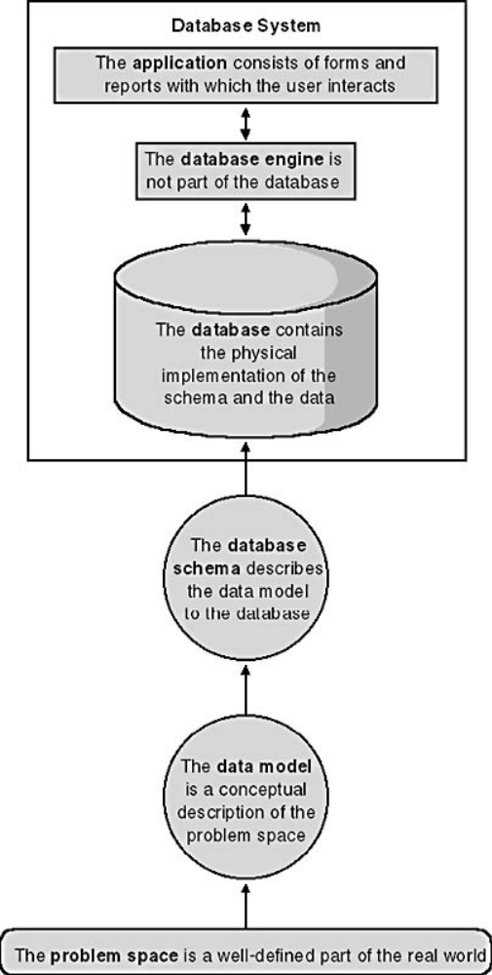

Figure: Relational Database Terminology.
Characteristic of a Relational Database Management System
- It represents complex relationship between data.
- Keeps a type control or data redundancy.
- Enforces user defined rules to ensure the integrity of table data.
- Has a centralized data dictionary for storage of information pertaining to data and its manipulation.
- Ensures that data can be shared across applications.
- Enforces data access authorization.
- Has an automatic, intelligent backup and recovery procedure for data.
- Have different interfaces via which users can manipulate data.
Introducing the Structured Query Language (SQL)
Structured Query Language (SQL) is the standard language designed to access relational databases. SQL should be pronounced as the letters “S-Q-L.”
SQL is based on the groundbreaking work of Dr. E.F. Codd, with the first implementation of SQL being developed by IBM in the mid-1970s. IBM was conducting a research project known as System R, and SQL was born from that project. Later, in 1979, a company then known as Relational Software Inc. (known today as Oracle Corporation) released the first commercial version of SQL. SQL is now fully standardized and recognized by the American National Standards Institute. SQL uses a simple syntax that is easy to learn and use. You’ll see some simple examples of its use in this chapter. There are five types of SQL statements, outlined in the following list:
Query statements retrieve rows stored in database tables. You write a query using the
SQL SELECT statement.

Data Manipulation Language (DML) statements modify the contents of tables. There are Three DML statements:
- INSERT adds rows to a table.
- UPDATE changes rows.
- DELETE removes rows.
Data Definition Language (DDL) statements define the data structures, such as tables,
that make up a database. There are five basic types of DDL statements:
- CREATE creates a database structure. For example, CREATE TABLE is used to create a table; another example is CREATE USER, which is used to create a database user.
- ALTER modifies a database structure. For example, ALTER TABLE is used to modify a table.
- DROP removes a database structure. For example, DROP TABLE is used to remove a table.
- RENAME changes the name of a table.
- TRUNCATE deletes all the rows from a table.
Transaction Control (TC) statements either permanently record any changes made to
rows, or undo those changes. There are three TC statements:
- COMMIT permanently records changes made to rows.
- ROLLBACK undoes changes made to rows.
- SAVEPOINT sets a “save point” to which you can roll back changes.
Data Control Language (DCL) statements change the permissions on database structures. There are two DCL statements:
- GRANT gives another user access to your database structures.
- REVOKE prevents another user from accessing your database structures.

TOMCAT 8.0 SERVER

Tomcat, developed by Apache, is a standard reference implementation for Java servlets and JSP. It can be used standalone as a Web server or be plugged into a Web server like Apache, Netscape Enterprise Server, or Microsoft Internet Information Server. There are many versions of Tomcat. Apache Tomcat is an open source software implementation of the java servletand javaserver pages technologies. The Java Servlet and Java Server Pages specifications are developed under the java community process. Apache Tomcat is developed in an open and participatory environment and released under the Apache. Apache Tomcat is intended to be a collaboration of the best-of-breed developers from around the world.
Starting and Stopping Tomcat
Before running the servlet, you need to start the Tomcat servlet engine. To start Tomcat, you have to first set the JAVA_HOME environment variable to the JDK home directory using the following command.
set JAVA_HOME=c:\Program Files\java\jdk1.8.0_03
The JDK home directory is where your JDK is stored. On my computer, it is c:\Program Files\jdk1.5.0. You may have a different directory. You can now start Tomcat using the
command startup from c:\jakarta-tomcat-8.0\bin as follows:
c:\jakarta-tomcat-8.0\bin>startup
By default, Tomcat runs on part 8080. An error occurs if this port is currently being used. You can change it to a different port. To do so, open c:\jakarta-tomcat-5.5.9\conf\server.xml using a text editor such as NotePad. Search for 8080 and change it to a desired port number such as 8100 in the following context.
<Connector className="org.apache.coyote.tomcat4.CoyoteConnector"
port="8080" minProcessors="5" maxProcessors="75"
enableLookups="true" redirectPort="8443"
acceptCount="100" debug="0" connectionTimeout="20000"
useURIValidationHack="false" disableUploadTimeout="true" />
To terminate Tomcat, use the shutdown command from c:\jakarta-tomcat-5.5.9\bin.
Deploying Web Application Using WAR Files
Servlets, JSPs and their supporting files are placed in the appropriate subdirectories under the webapps directory in Tomcat. For convenience, you can create all the files under the webapps directory into one compressed file. This file is known as the WAR (Web Application Archive) and ends with the .war file extension. You can deploy a Web application by placing a WAR file in the webapps directory. When a Web server begins execution, it extracts the WAR file’s contents into the appropriate webapps subdirectories.
Creating WAR Files
You can create a WAR file using a tool or the jar command. If you use NetBeans, JBuilder, or Eclipse, a WAR file is automatically created every time you build the Web project. (e.g., you can find this file under the dist node in a Web project). To create a WAR file for the examples in Tmocat type the following command:
jar –cvf project.war .
A WAR file named jportal.war is now created for all files and directories under \webapps\jportal. The file is in \webapps\jortal\jportal.war.
Deploying WAR Files
You can now deploy the WAR file to a new machine. Follow the steps below to test jportal.war:
- Place jportal.war to \webapps\jportal.war under your Tomcat home directory.
- Delete the entire directory of project under webapps if it exists.
- Start Tomcat (if it is already running, you need to shut it down first.) Tomcat automatically extracts the contents in jportal.war into the appropriate directories. You will see a new directory named project created under the webapps directory.
- Enter URL http://localhost:8080/project/FirstServlet to test the servlet.
Setting a Secured Server
You can set the Tomcat server to activate basic HTTP authentication. You need to specify a security realm, which is a term that defines authorized users. There are three types of realms: Memory, Database, and JNDI. This section introduces how to set Memory and Database realms.

SOFTWARE ENGINEERING PARADIGM APPLIED

Software Engineering is related to the development of software. Large software needs systematic development unlike simple program which can be developed in solution and there may not be any systematic approach being followed. Software engineering includes activities like cost estimation, time estimation, designing coding, documentation, maintenance, quality assurance, testing of software etc.
A software engineer or a team of software engineers must incorporate a development strategy that encompasses the processes, methods and tools layers of software engineering. This strategy is often referred to as a process model or software engineering paradigm.
Software Engineering Problem Solving Phase Cycle
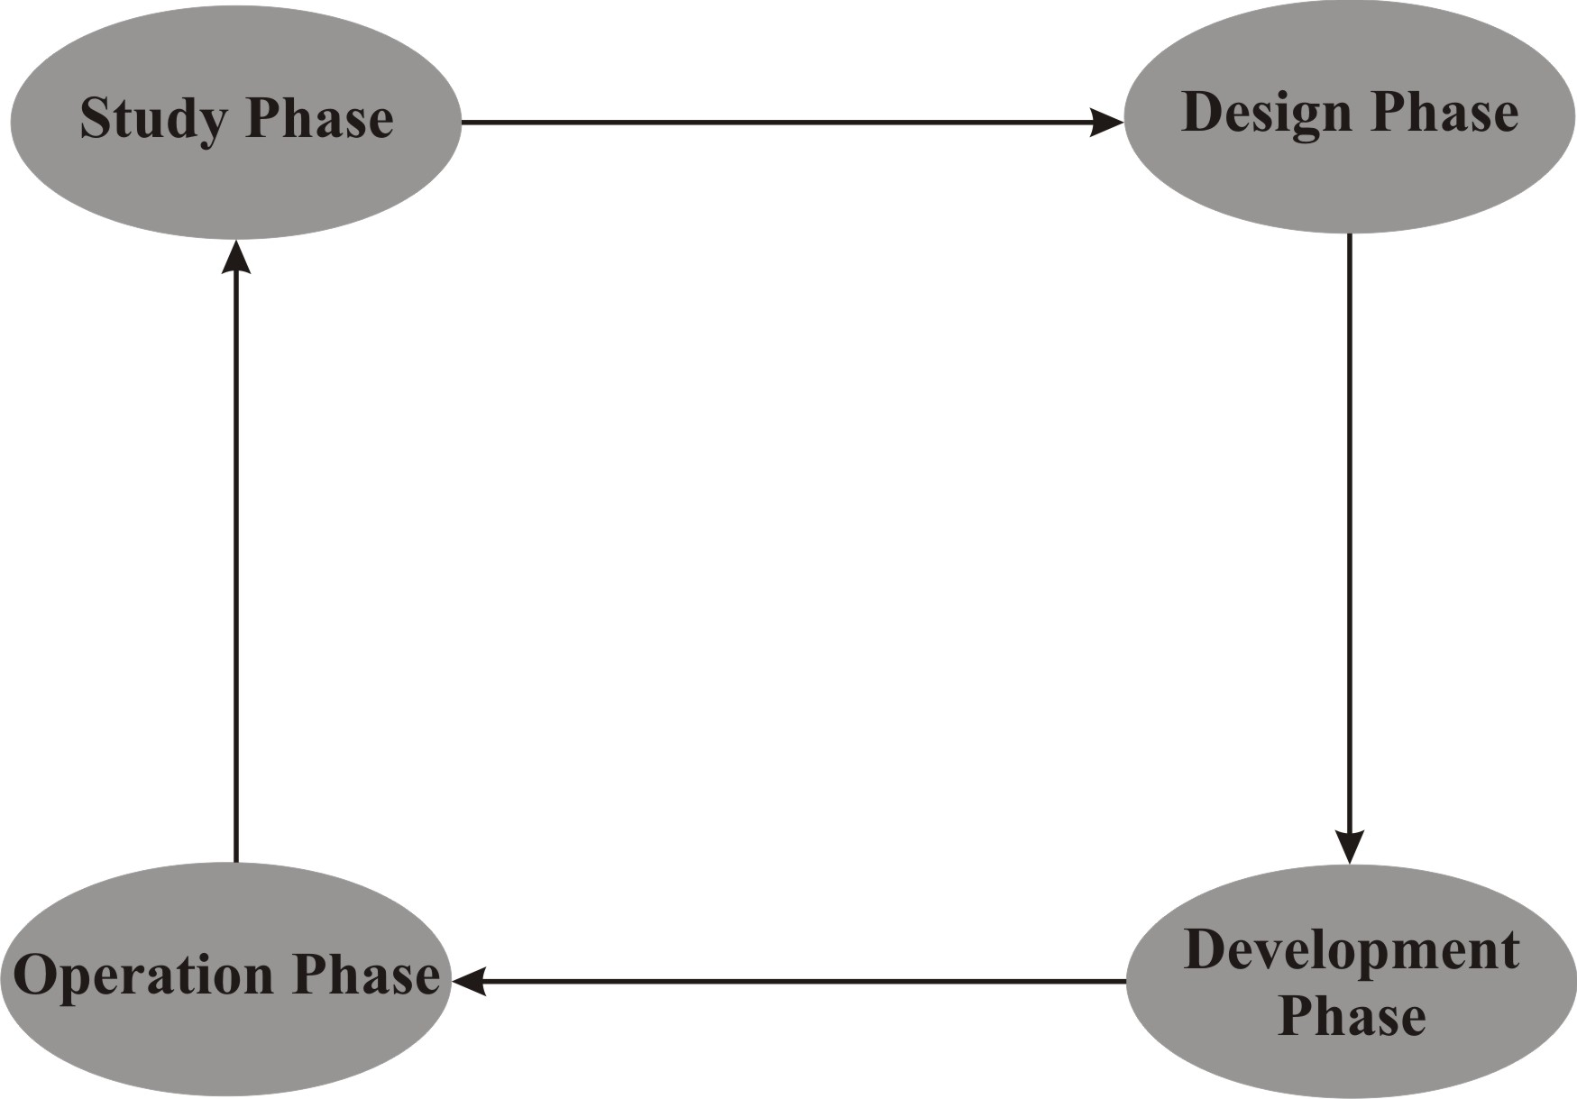

SOFTWARE ENGINEERING PARADIGMS APPLIED
Correctness: A program is functionally correct if it behaves according to the specification of the functions it should provide. The specification of the system is available and it is possible to determine unambiguously whether or not a program meets the specifications. The correctness of our project establishes the equivalence between the system and its specification.
Reliability: The system developed by us and presented here fully reliable if the user depends on it. The system application will operate as expected now and over for long period also. As Software engineering can truly be called an engineering discipline only when we can achieve software reliability comparable to the reliability of other products. Our development is perfect in this discipline.
Decomposability: In developing the project we have followed the principle of decomposability i.e. dividing the original problem top down into sub problems and then applying the decomposition to each sub problem recursively. As in developing this System we have divided first whole problem in modules such as Student, Faculty, and Admin. Finally our project assembles by taking modules and combining them to form the required application.
Modularity: The principle of modularity says to divide the big projects into simpler pieces called modules .The project has been divided into simpler pieces called modules. The system developed by us is modular because it allows the principle of separation of concerns to be applied in two phases. When dealing with the details of each module in isolation (and ignoring details of other modules) and when dealing with the overall characteristics of all modules and their relationships in order to integrate them coherent system.
Robustness: Our application is robust, it behaves reasonably even in circumstances that had been even not anticipated in the requirements specification-for example when user inputs incorrect or incomplete data then it produce a valid error message and either resumes for same operation or continues the next operation depending upon the situation. The project
performs all necessary checks before processing the input if the input is not correct then it does not process it any more and sends the error message to the user. For example if the user give string value in text box that is for numeric value then it will can’t takes and also inform the user and same for vise-versa.
User Friendliness: The application is very much user friendly, the biggest reason behind it is its GUI environment. Every user finds it easy to use. Novice programmer’s use it qualifies as user friendly by virtue of different properties than an application that is used by expert programmers. For example a nonprogrammer appreciates the use of menus, while a programmer may be comfortable with keyboard shortcuts. Both the features are provided in
system evenly. A novice user appreciates verbose messages and feels comfortable while using project; if he commits any mistake he is prompted with appropriate message to cancel the effect of mistake if possible. Same feature is quite helpful for expert user also.

DESIGN

INPUT/OUTPUT DESIGN
The design of an information system produces the details that clearly describe how a system will meet the requirements identified during systems analysis. Systems analyses begin the design process by identifying reports and other outputs system will produce. The system design also describes the data to be input, calculated or stored. Designers select the file structure and storage device, such as magnetic disk, magnetic tape or even paper files. There are three phase of system design as following:-
Design of Input: Inaccurate input data are the most common cause of errors in data processing. Errors may occur due to faulty input design. Input design is the process of converting user-originated inputs to a computer-based format.
The goal of designing input data is to make data entry easy, logical and free from errors. In entering data the operators need to know the following:
- The allocated space for each field
- Field sequence, which must match that in the source document
- The format in which data fields are entered for example the date may be of different formats but the user might be required to enter it in only one format. So it is essential for him to know the exact format in which he should enter data so that later on wrong results are not obtained after processing the data.
This Project has input screens, designed using Java Server Pages (JSP) and HTML. The forms are GUI based and are extremely user friendly. The major features of these screens are listed below:
- All fields have labels tags attached to them which is useful for the data entry operator when is using the forms for data entry.
- Appropriate error messages are provided when the user enters invalid data and gives it to the system for processing.
Design of Output: Output is the most important and direct source of information to the user. Efficient intelligent output design improves the system’s relationship with the user and helps in decision-making. As far as the project is concerned, the outputs are only the various kinds of views regarding existing users, their acceptance status for different applications.
Design of Files: Design of files is considered as the backbone of the candidate system. It is the area, which will be handling more data than any other. How well and efficiently the system is able to retrieve data, process it and put it back depends on how well the database has been structured and organized. This section and the following subsection throw light on how the database has been designed for the candidate system.
Choice of DBMS: The relational DBMS as far as implementation models are concerned, has the facility of adding and dropping indices dynamically as needed. Another advantage of relational DBMS is that it provides high-level query language interfaces as well as programming interfaces. For developing the candidate system, Oracle has been chosen as RDBMS. Besides having all the other advantages of an RDBMS, the main things which clinched issue in it’s favor is that it is a freeware and it’s connectivity with J2EE, which is being used as front end, is also very easy.

INTERACTION BETWEEN MODULE
- User
This module keeps the records of its all users i.e. their names, their qualification, their key skills,and address of residence.
- Fusion and Defusion
This module helps the user for fusing and defusing the image. User can fuse or defuse the image according to need, preferred image, client, Skills and size.
- Encryption and Decrytion
This module helps the user for encrypting and decrypting the image. User can encrypt or decrypt the image according to need, preferred image, client, Skills and size.
- Chat
This module helps the one user and othe online users to interact with each other. This module avoids the face-to-face interaction because it provides the facility of online interaction. Online interaction means one online user asks the question to the other online users by the internet from different location and others response in same manner.

DATABASE FOR ALL MODULE

Table Name: User_Info

Attributes | Field Type | Field Size | Constraints | Description
FName | Varchar2 | 15 | Not Null | It has user first name
LName | Varchar2 | 30 | Not Null | It has user last name
Gender | Varchar2 | 15 | Not null | It has user gender
Email | Varchar2 | 15 | primary key | It has user email address
Password | Varchar2 | 8 |  | It has user login password

Table Name: Group_Chat

Attributes | Field Type | Field Size | Constraints | Description
Msg_From | Varchar2 | 15 | Not Null | It has online user name
Message | Varchar2 | 15 | Not Null | It has user message
Sent_Date | Date |  |  | It has the message sent date

DATA FLOW DIAGRAM

Context Level DFD

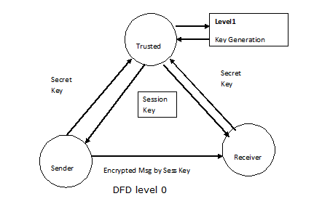

Second Level DFD

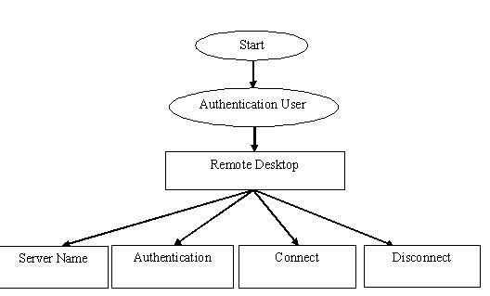

ER- DIAGRAM

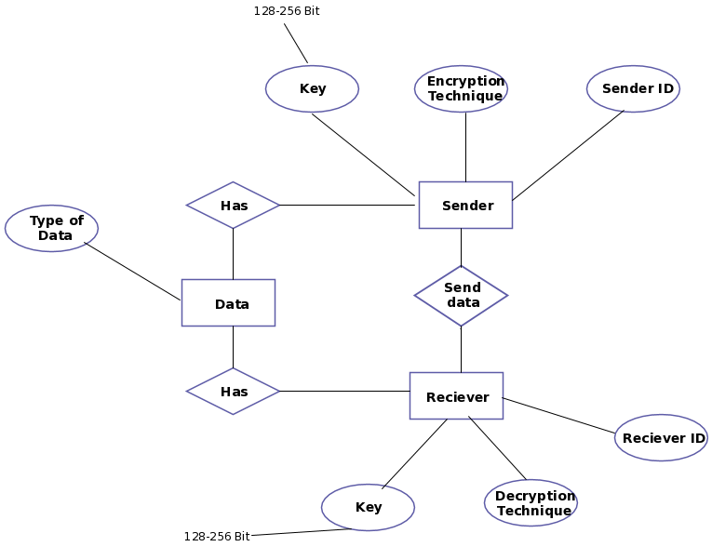

SCREEN LAYOUTS

Users Side Screen Layouts

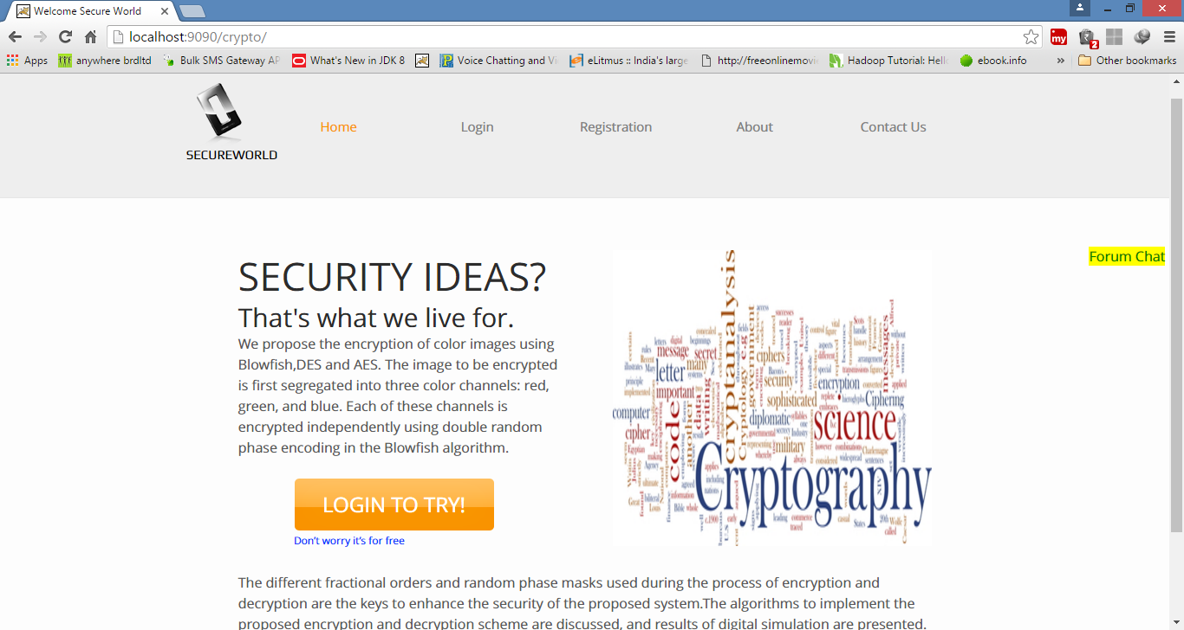

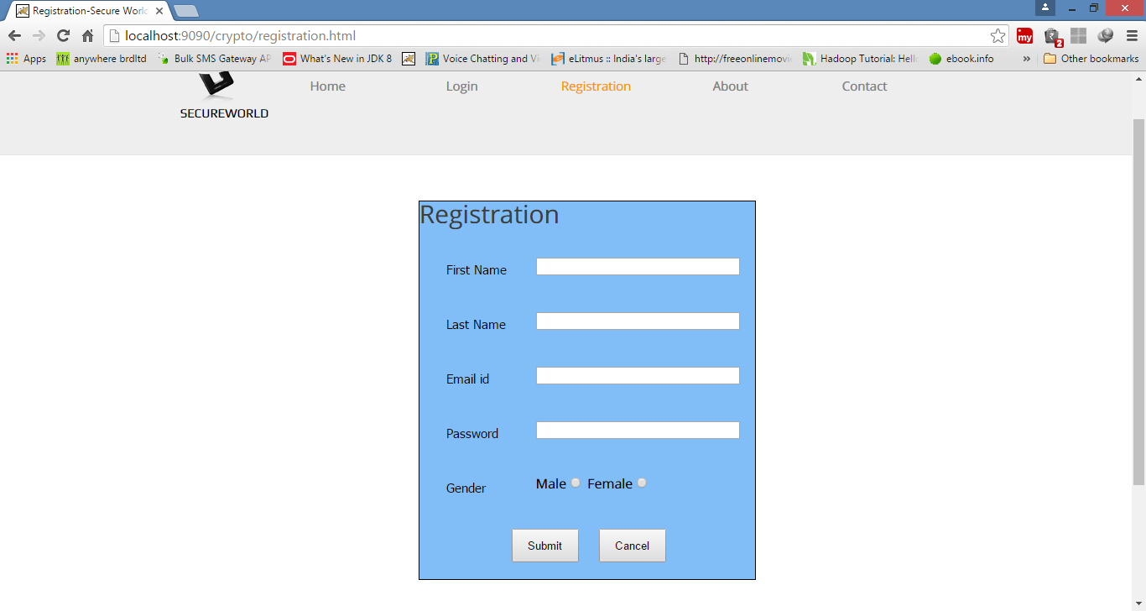

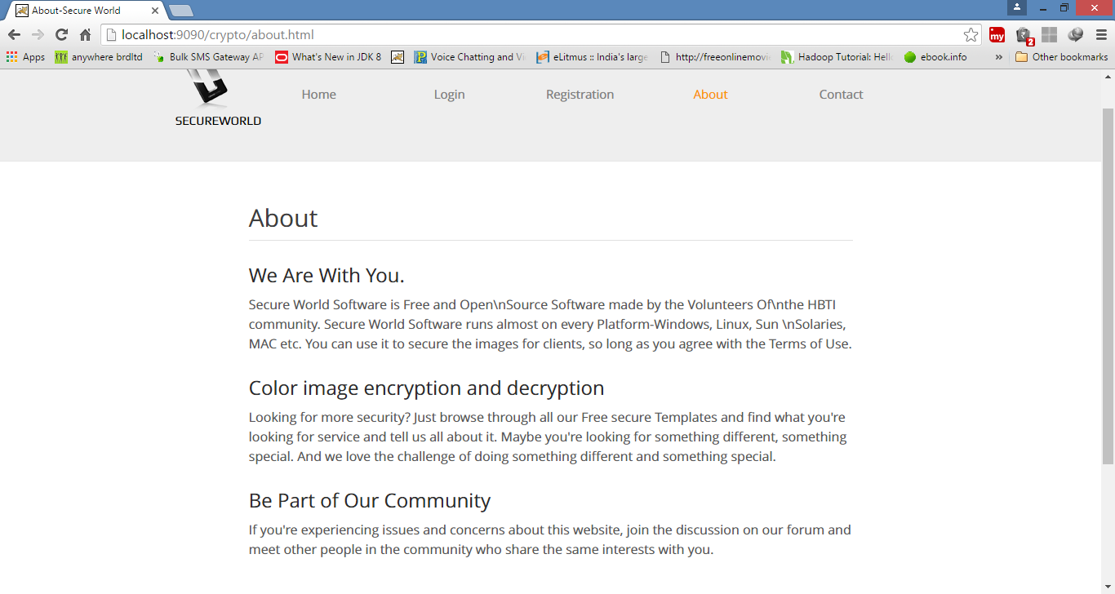
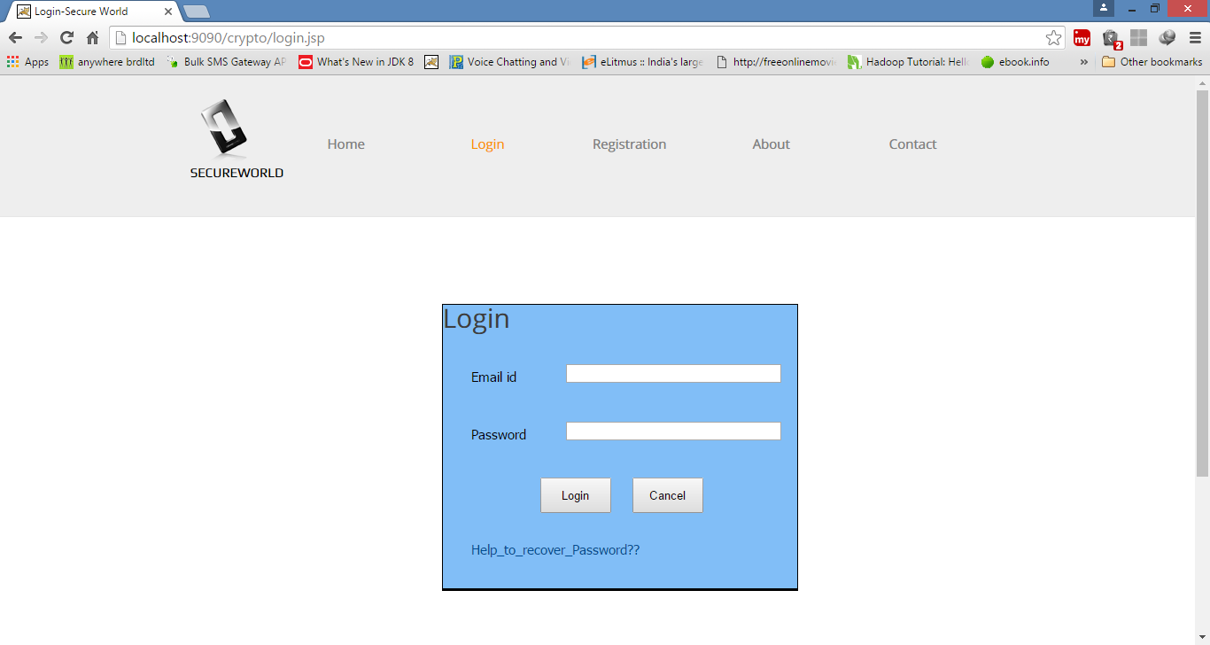
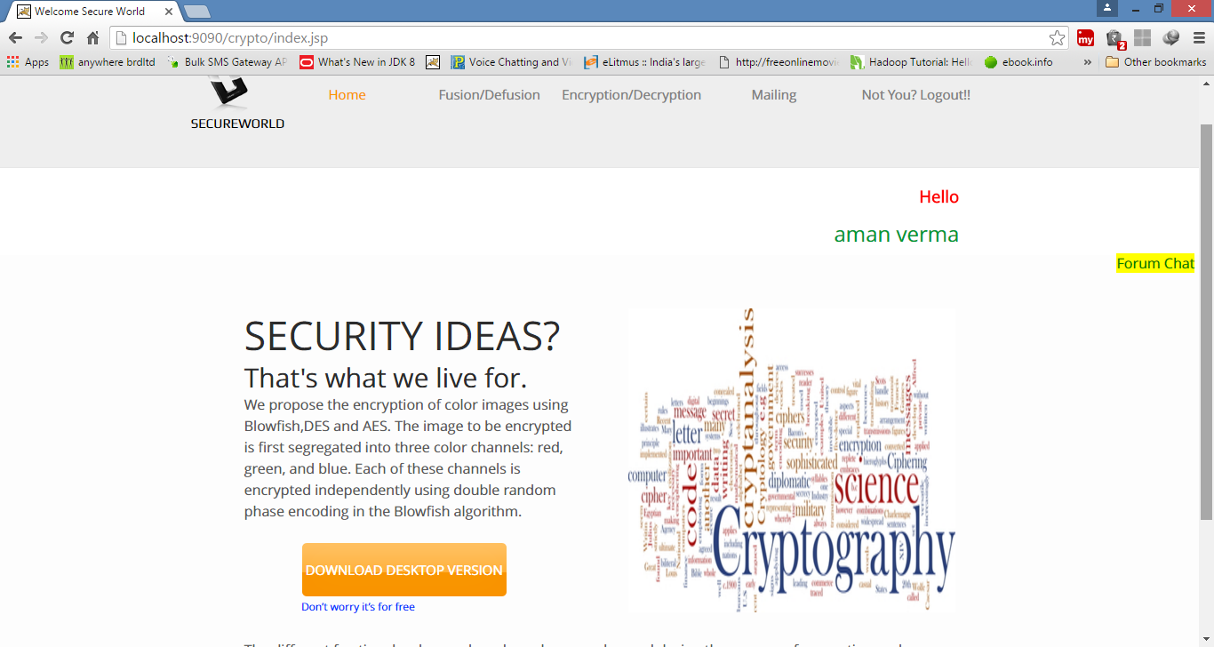
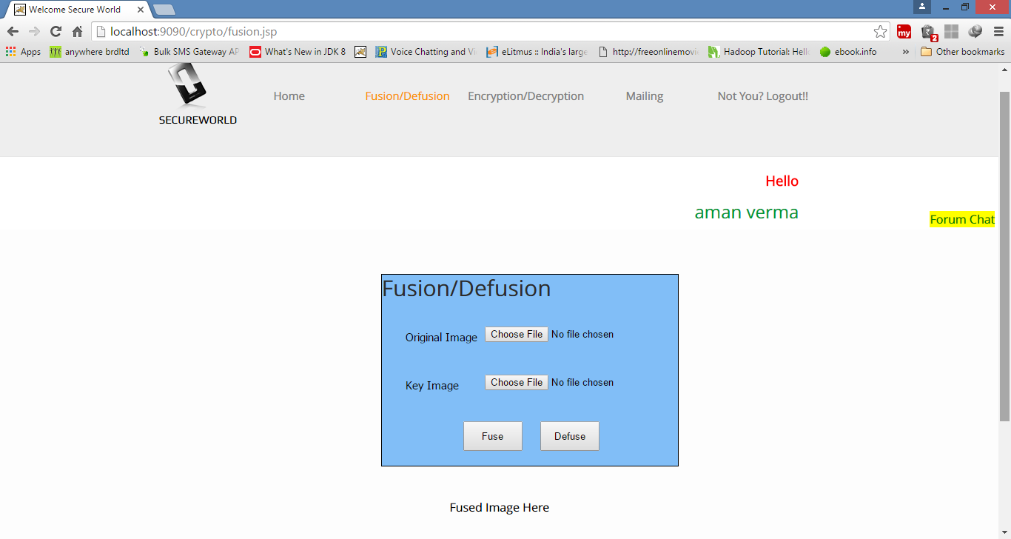

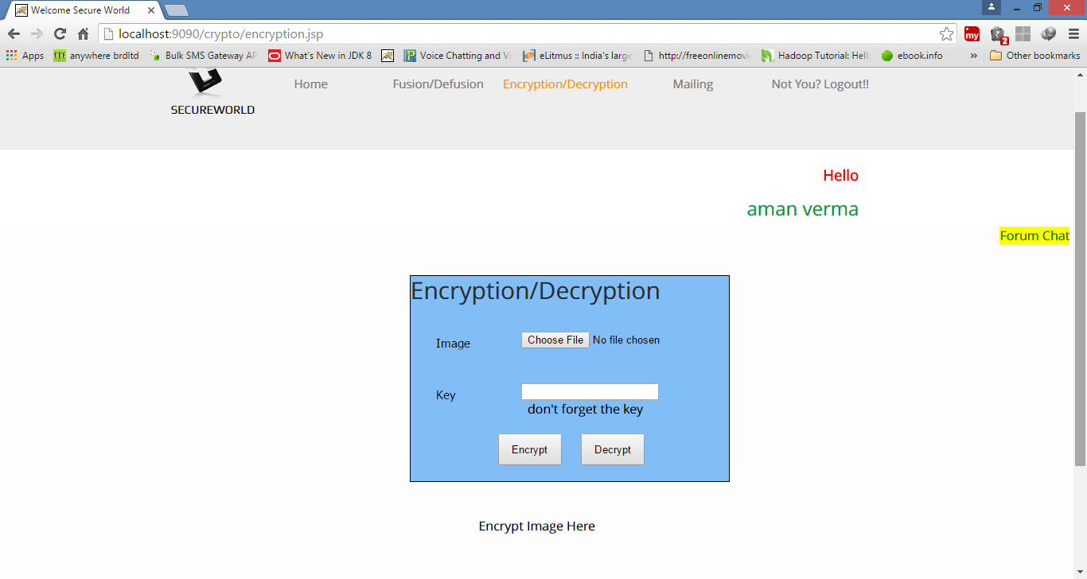
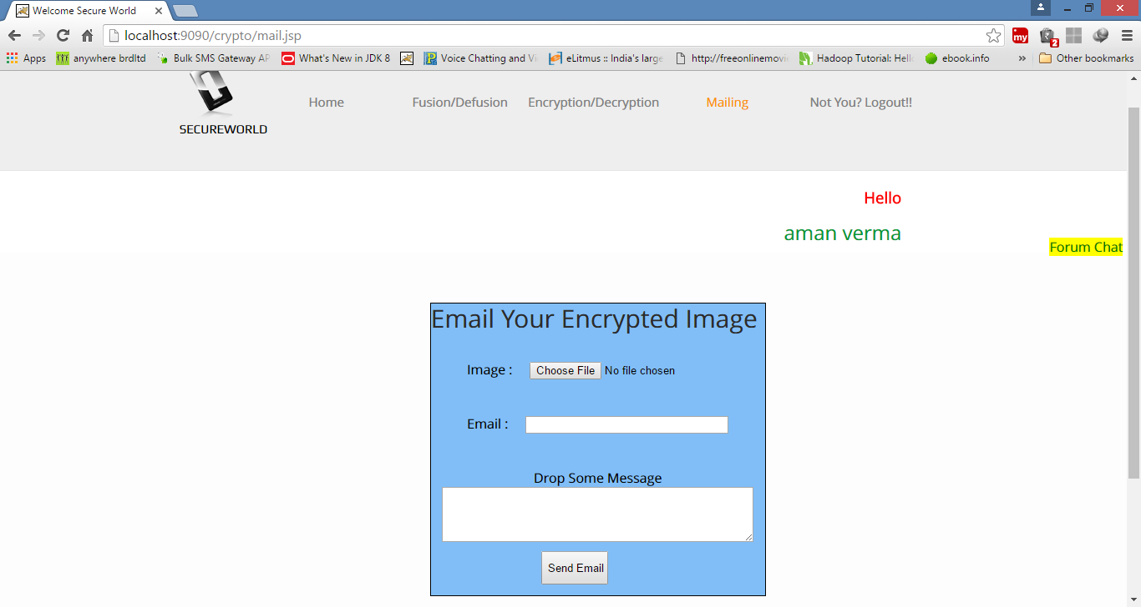

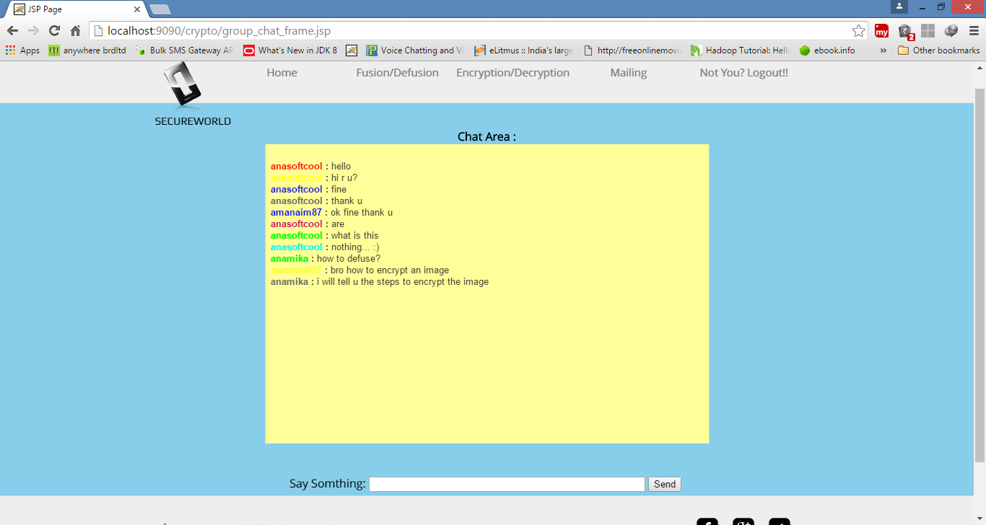

CODING

HTML and JSP CODE

Registration.html
<!DOCTYPE HTML PUBLIC "-//W3C//DTD HTML 4.0 Transitional//EN">
<!-- saved from url=(0034)http://my.jobsahead.com/login.html -->
<HTML><HEAD><TITLE>jportal-Registration</TITLE>
<META
content="Post Resume for Free at JobsAhead. Find jobs through Jobsahead.com"
name=Description>
<META
content="JobsAhead.com, jobs, job, jobs online, post resume, post CV, india jobs, indian jobs, job openings, resume submit, jobsite, job vacancies"
name=Keywords>
<META http-equiv=Content-Type content="text/html; charset=iso-8859-1">
<META http-equiv=cache-control content=no-cache>
<META http-equiv=Pragma content=no-cache><LINK
href="Hp/style1.css"
type=text/css rel=stylesheet>
<META content="MSHTML 6.00.2900.2180" name=GENERATOR>
<style type="text/css">
<!--
#Layer1 {
position:absolute;
width:200px;
height:35px;
z-index:1;
left: 4;
top: 10px;
}

#Layer14 {
position:absolute;
width:100%;
height:21px;
z-index:6;
left: 0px;
top: 1270px;
}
a:link {
color: #FF0000;
text-decoration: none;
}
a:visited {
text-decoration: none;
}
a:hover {
text-decoration: underline;
color: #FFFFFF;
}
a:active {
text-decoration: none;
}
#Layer2 {
position:absolute;
width:200px;
height:115px;
z-index:7;
left: 83px;
top: 180px;
}
.style8 {color: #3AA4FA; font-weight: bold; }
#Layer3 {
position:absolute;
width:55px;
height:23px;
z-index:8;
left: 431px;
top: 977px;
}
.style15 {
color: #3300cc;
font-size: 12px;
font-weight: bold;
}
#Layer4 {
position:absolute;
width:107px;
height:16px;
z-index:8;
left: 676px;
top: 164px;
}
.style16 {
font-family: Verdana, Geneva, Arial, san-serif;
font-size: 11px;
}
.style17 {color: #3AA4FA}
-->
</style>
<script language="javascript">
function fn()
{
if (document.frm.email.value=="")
{
alert ("Enter E-mail Id");
document.frm.email.focus();
return false;
}
else
{
s=document.frm.email.value;
n2 =s.indexOf('.');
n = s.indexOf('@');
n1 =s.lastIndexOf('@');
count1 =n
if(n != n1 || n < 0 || n == 0 || n2 < n || n2 == n+1 )
{
alert("Not a Valid E-mail Id");
document.frm.email.focus();
return false;
}
}
if(document.frm.fname.value=="")
{
alert("Enter the first name");
document.frm.fname.focus();
return false;
}
else
{
for(var i=0; i<document.frm.fname.value.length;i++)
{
var ch=document.frm.fname.value.substring(i,i+1);
if((ch >= "A" && ch <= "Z") || (ch >= "a" && ch <= "z") || (ch==" ") || (ch=="."))
{
continue;
}
else
{
alert("Enter Only A-Z,a-z and Space");
document.frm.fname.value="";
document.frm.fname.focus();
return false;
}
}
}

if(document.frm.duname.value=="")
{
alert("Enter the Desired Username");
document.frm.duname.focus();
return false;
}
if(document.frm.pass.value=="")
{
alert("Enter Password");
document.frm.pass.focus();
return false;
}
if(document.frm.pass.value!=document.frm.repass.value)
{
alert("Enter Same Password and Re-Enter Password");
document.frm.repass.focus();
return false;
}
if(document.frm.dob.value=="")
{
alert("Enter The Date of Birth");
document.frm.dob.focus();
return false;
}

if(document.frm.que.value=="")
{
alert("Select Security Question");
document.frm.que.focus();
return false;
}
if(document.frm.ans.value=="")
{
alert("Enter The Security Answer");
document.frm.ans.focus();
return false;
}

var ext = getExtension(document.frm.resume.value);
if ((document.frm.resume.value != '') && ext != 'doc' && ext != 'txt')
{
alert("Please ensure that the file you upload is a word document or a .txt file.");
document.frm.resume.focus();
return false;
}
}

function getExtension(value)
{
var mytext = value.substring(value.lastIndexOf('.') + 1,value.length);
return mytext.toLowerCase();
}
</script>
</HEAD>
<BODY bgColor=#ffffff>

<TABLE cellSpacing=0 cellPadding=0 width="100%" border=0>
<TBODY>
<TR>
<TD style="PADDING-LEFT: 7px" width=293 height=84><A
href="http://www.jobsahead.com/index.html" target=_top></A> </TD>
<TD noWrap>&nbsp;</TD>
<TD align=middle width=350>&nbsp;</TD></TR>
<TR>
<TD style="PADDING-LEFT: 5px" noWrap colSpan=3><div align="left"><A
href="homepage.jsp" target=_top> <IMG title=Home
height=27 alt=Home
src="Hp/home.gif"
width=67 border=0></A><IMG height=1
src="Hp/trans.gif"
width=2><a href="search.html"
target=_top><img title="Search Jobs" height=27 alt="Search Jobs"
src="Hp/search_jobs.gif"
width=104 border=0></a><IMG height=1
src="Hp/trans.gif"
width=2><A href="submit_resume.html"
target=_top><IMG title="Submit Resume" height=27 alt="Submit Resume"
src="Hp/submit_resume.gif"
width=126 border=0></A><A href="http://my.jobsahead.com/login.html"
target=_top></A><IMG height=1
src="Hp/trans.gif"
width=2><A href="Reg.htm"
target=_top><IMG title=Register height=27 alt=Register
src="Hp/register.gif"
width=79 border=0></A><IMG height=1
src="Hp/trans.gif"
width=2><A href="log.htm" target=_top><IMG
title=Register height=27 alt=Register
src="Hp/login.gif"
width=65 border=0></A></div></TD>
</TR></TBODY></TABLE>
<TABLE cellSpacing=0 cellPadding=0 width="100%" border=0>
<TBODY>
<TR>
<TD width=1005
height=32
background="Hp/bgr_inner_header.gif">
<TABLE cellSpacing=0 cellPadding=0 width="25%" border=0>
<TBODY>
<TR>
<TD vAlign=top align=right
background="Hp/bgr_inner_header.gif"
height=32><SPAN class=white_text><A
href="http://recruiter.jobsahead.com/"></A></SPAN></TD>
</TR></TBODY>
</TABLE></TD>
</TR></TBODY></TABLE>

<div id="Layer1"><img src="Hp/jlogo.jpg" width="268" height="73"></div>

<div id="Layer14">
<TABLE cellSpacing=0 cellPadding=0 width="100%" background="Hp/bgr_1_1.gif" border=0>
<TBODY>
<TR>
<TD height=45 noWrap style="PADDING-LEFT: 40px"><center>
Copyright &copy; 2011 <a href="homepage.jsp" target="_self">www.jportal.com</a><br>
Designed & Developed By <a href="contactus.htm" target="_blank">Dileep Kumar Singh </a>
</center>
</TD></TD>
</TR></TBODY></TABLE>
</div>

<div id="Layer2">
<form name="frm" method="post" action="/userreg.jsp">
<table width="777" style="width:700px">

<tr>
<td colspan="3" bgcolor="#53b4fb" class="style15" style="WIDTH: 165px">Get Started with jportal: </td>
</tr>
<tr>
<td style="WIDTH: 165px">&nbsp;</td>
<td style="WIDTH: 165px">&nbsp;</td>
<td>&nbsp;</td>
</tr>
<tr>
<td style="WIDTH: 165px"><div align="right">Email Address:<span class="style8">*</span></div></td>
<td style="WIDTH: 165px"><input type="text" name="email" maxlength="30" style="width:160px"></td>
<td><i>Maximum 30 Characters</i></td>
</tr>
<tr>
<td style="WIDTH: 165px"><div align="right">First Name:<span class="style8">*</span></div></td>
<td><input type="text" name="fname" maxlength="15" style="width:160px"></td>
<td><i>Maximum 15 Characters</i></td>
</tr>
<tr>
<td style="WIDTH: 165px"><div align="right">Last Name:</div></td>
<td><input type="text" name="lname" maxlength="15" style="width:160px"></td>
</tr>
<tr>
<td style="WIDTH: 165px"><div align="right">Desired Username:<span class="style8">*</span></div></td>
<td><input type="text" name="duname" maxlength="15" style="width:160px"></td>
<td><i>Desired Username Use As Login Username Maximum 15 Characters</i></td>
</tr>
<tr>
<td style="WIDTH: 165px"><div align="right">Password:<span class="style8">*</span></div></td>
<td><input type="password" name="pass" maxlength="15" style="width:160px"></td>
<td><i>Maximum 15 Characters</i></td>
</tr>
<tr>
<td style="WIDTH: 165px"><div align="right">Re-Enter Password:<span class="style8">*</span></div></td>
<td><input type="password" name="repass" maxlength="15" style="width:160px"></td>
</tr>
<tr>
<td style="WIDTH: 165px">&nbsp;</td>
<td>&nbsp;</td>
</tr>
</table>
<table style="width:700px">
<tr>
<td colspan="3" bgcolor="#5eb4fb" style="WIDTH: 165px"><span class="style15">Personal Details: </span></td>
</tr>
<tr>
<td style="WIDTH: 165px">&nbsp;</td>
<td style="WIDTH: 165px">&nbsp;</td>
</tr>
<tr>
<td style="WIDTH: 165px"><div align="right">Address:</div></td>
<td style="WIDTH: 165px"><textarea name="address" style="width:160px" style="height:50px">
</textarea></td>
</tr>
<tr>
<td style="WIDTH: 165px"><div align="right">Phone:</div></td>
<td><input type="text" name="ph" value="91" style="WIDTH: 20px" maxlength="2" readonly="">
&nbsp;&nbsp;
<input type="text" name="ph1" style="width:40px" maxlength="5">
&nbsp;&nbsp;
<input type="text" name="ph2" maxlength="7" style="width:60px"></td>
<td><i>Country Code, Area code, Phone No.</i></td>
</tr>
<tr>
<td style="WIDTH: 165px"><div align="right">Mobile Number:</div></td>
<td><input type="text" name="m" value="91" maxlength="2" style="WIDTH: 20px" maxlength="2" readonly="">
&nbsp;&nbsp;
<input type="text" name="m1" maxlength="13" style="width:108px"></td>
</tr>
<tr>
<td style="WIDTH: 165px"><div align="right">Gender:</div></td>
<td><input type="radio" name="gender" value="Male">
Male
<input type="radio" name="gender" value="female">
Female</td>
<td><i>Please Select Your Gender</i></td>
</tr>
<tr>
<td style="WIDTH: 165px"><div align="right">Date Of Birth:<span class="style8">*</span></div></td>
<td><input type="text" name="dob" style="WIDTH: 160px" maxlength="11"></td>
<td><i>DD-Mon-YYYY</i></td>
</tr>
<tr>
<td style="WIDTH: 165px"><div align="right">Security Question:<span class="style8">*</span></div></td>
<td><select name="que" style="WIDTH: 160px">
<option value="">- Select -</option>
<option value="pet">Your Pet Animal Name</option>
<option value="sch">Your First School Name</option>
<option value="tec">Your Best Teacher Name</option>
<option value="eri">Your Best Friend Name</option>
<option value="fl">Your Best Flower </option>
</select>
<td><i>Please Select Any One Security Question</i></td>
</td>
</tr>
<tr>
<td style="WIDTH: 165px"><div align="right">Answer:<span class="style8">*</span></div></td>
<td><input type="text" name="ans" style="WIDTH: 160px"></td>
<td><i>Please Give Security Answer</i></td>
</tr>
<tr>
<td style="WIDTH: 165px"><div align="right">Current Location:<span class="style8">*</span></div></td>
<td><SELECT style="WIDTH: 160px" name="cloc">
<OPTION value="">- Select -</OPTION>
<OPTION>Ahmedabad</OPTION>
<OPTION>Bangalore</OPTION>
<OPTION>Chennai</OPTION>
<OPTION>Delhi</OPTION>
<OPTION>Gurgaon</OPTION>
<OPTION>Hyderabad</OPTION>
<OPTION>Kolkata</OPTION>
<OPTION>Mumbai</OPTION>
<OPTION>Noida</OPTION>
<OPTION>Pune</OPTION>
<OPTION>Agartala</OPTION>
<OPTION>Agra</OPTION>
<OPTION>Ahmednagar</OPTION>
<OPTION>Aizawal</OPTION>
<OPTION>Ajmer</OPTION>
<OPTION>Aligarh</OPTION>
<OPTION >Allahabad</OPTION>
<OPTION>Ambala</OPTION>
<OPTION>Amritsar</OPTION>
<OPTION>Anand</OPTION>
<OPTION>Ankleshwar</OPTION>
<OPTION>Asansol</OPTION>
<OPTION>Aurangabad</OPTION>
<OPTION>Bahgalpur</OPTION>
<OPTION>Bareilly</OPTION>
<OPTION>Baroda</OPTION>
<OPTION>Belgaum</OPTION>
<OPTION>Bellary</OPTION>
<OPTION>Bharuch</OPTION>
<OPTION>Bhatinda</OPTION>
<OPTION>Bhavnagar</OPTION>
<OPTION>Bhilaigarh</OPTION>
<OPTION >Bhopal</OPTION>
<OPTION>Bhubaneshwar</OPTION>
<OPTION>Bhuj</OPTION>
<OPTION>Bidar</OPTION>
<OPTION>Bilaspur</OPTION>
<OPTION>Bokaro</OPTION>
<OPTION>Calicut</OPTION>
<OPTION>Chandigarh</OPTION>
<OPTION>Coimbatore</OPTION>
<OPTION>Cuttack</OPTION>
<OPTION>Dalhousie</OPTION>
<OPTION>Daman</OPTION>
<OPTION>Dehradun</OPTION>
<OPTION>Dhanbad</OPTION>
<OPTION>Dharamsala</OPTION>
<OPTION>Dharwad</OPTION>
<OPTION>Dispur</OPTION>
<OPTION>Durgapur</OPTION>
<OPTION>Ernakulam</OPTION>
<OPTION>Erode</OPTION>
<OPTION>Faizabad</OPTION>
<OPTION>Faridabad</OPTION>
<OPTION >Gandhinagar</OPTION>
<OPTION >Gangtok</OPTION>
<OPTION>Ghaziabad</OPTION>
<OPTION>Goa</OPTION>
<OPTION>Gorakhpur</OPTION>
<OPTION>Gulbarga</OPTION>
<OPTION>Guntur</OPTION>
<OPTION>Guwahati</OPTION>
<OPTION>Gwalior</OPTION>
<OPTION>Haldia</OPTION>
<OPTION>Hisar</OPTION>
<OPTION>Hosur</OPTION>
<OPTION>Hubli</OPTION>
<OPTION>Imphal</OPTION>
<OPTION>Indore</OPTION>
<OPTION>Itanagar</OPTION>
<OPTION>Jabalpur</OPTION>
<OPTION>Jaipur</OPTION>
<OPTION>Jaisalmer</OPTION>
<OPTION>Jalandhar</OPTION>
<OPTION>Jalgaon</OPTION>
<OPTION>Jammu</OPTION>
<OPTION>Jamnagar</OPTION>
<OPTION>Jamshedpur</OPTION>
<OPTION>Jodhpur</OPTION>
<OPTION>Kakinada</OPTION>
<OPTION>Kandla</OPTION>
<OPTION>Kannur</OPTION>
<OPTION>Kanpur</OPTION>
<OPTION>Karnal</OPTION>
<OPTION>Kavaratti</OPTION>
<OPTION>Kharagpur</OPTION>
<OPTION>Kochi</OPTION>
<OPTION>Kohima</OPTION>
<OPTION>Kolar</OPTION>
<OPTION>Kolhapur</OPTION>
<OPTION>Kollam</OPTION>
<OPTION>Kota</OPTION>
<OPTION>Kottayam</OPTION>
<OPTION>Kulu/Manali</OPTION>
<OPTION>Kurnool</OPTION>
<OPTION>Kurukshetra</OPTION>
<OPTION>Lucknow</OPTION>
<OPTION>Ludhiana</OPTION>
<OPTION>Madurai</OPTION>
<OPTION>Mangalore</OPTION>
<OPTION>Mathura</OPTION>
<OPTION>Meerut</OPTION>
<OPTION>Mohali</OPTION>
<OPTION>Moradabad</OPTION>
<OPTION>Mysore</OPTION>
<OPTION>Nagercoil</OPTION>
<OPTION>Nagpur</OPTION>
<OPTION>Nasik</OPTION>
<OPTION>Nellore</OPTION>
<OPTION>Nizamabad</OPTION>
<OPTION>Ooty</OPTION>
<OPTION>Pallakad</OPTION>
<OPTION>Panipat</OPTION>
<OPTION>Paradeep</OPTION>
<OPTION>Pathankot</OPTION>
<OPTION>Patiala</OPTION>
<OPTION>Patna</OPTION>
<OPTION>Pondicherry</OPTION>
<OPTION>Porbandar</OPTION>
<OPTION>Port Blair</OPTION>
<OPTION>Puri</OPTION>
<OPTION>Quilon</OPTION>
<OPTION>Raipur</OPTION>
<OPTION>Rajamundry</OPTION>
<OPTION>Rajkot</OPTION>
<OPTION>Ranchi</OPTION>
<OPTION>Rohtak</OPTION>
<OPTION>Roorkee</OPTION>
<OPTION>Rourkela</OPTION>
<OPTION>Salem</OPTION>
<OPTION>Shillong</OPTION>
<OPTION>Shimla</OPTION>
<OPTION>Sholapur</OPTION>
<OPTION>Silchar</OPTION>
<OPTION>Siliguri</OPTION>
<OPTION>Silvassa</OPTION>
<OPTION>Srinagar</OPTION>
<OPTION>Surat</OPTION>
<OPTION>Thanjavur</OPTION>
<OPTION>Thrissur</OPTION>
<OPTION>Tirunalveli</OPTION>
<OPTION>Tirupati</OPTION>
<OPTION>Tiruvananthapuram</OPTION>
<OPTION>Trichy</OPTION>
<OPTION>Tuticorin</OPTION>
<OPTION>Udaipur</OPTION>
<OPTION>Ujjain</OPTION>
<OPTION>Vadodara</OPTION>
<OPTION>Valsad</OPTION>
<OPTION>Vapi</OPTION>
<OPTION>Varanasi</OPTION>
<OPTION>Vellore</OPTION>
<OPTION>Vijayawada</OPTION>
<OPTION>Visakhapatnam</OPTION>
<OPTION>Warangal</OPTION>
<OPTION>Other India</OPTION>
<OPTION>Australia</OPTION>
<OPTION>Bahrain</OPTION>
<OPTION>Bangladesh</OPTION>
<OPTION>Belgium</OPTION>
<OPTION>Canada</OPTION>
<OPTION>China</OPTION>
<OPTION>Egypt</OPTION>
<OPTION>France</OPTION>
<OPTION>Germany</OPTION>
<OPTION>Gulf</OPTION>
<OPTION>Hongkong</OPTION>
<OPTION>Indonesia</OPTION>
<OPTION>Ireland</OPTION>
<OPTION>Japan</OPTION>
<OPTION>Jordan</OPTION>
<OPTION>Kuwait</OPTION>
<OPTION>Lebanon</OPTION>
<OPTION>Malaysia</OPTION>
<OPTION>Maldives</OPTION>
<OPTION>Mauritius</OPTION>
<OPTION>Mexico</OPTION>
<OPTION>Nepal</OPTION>
<OPTION>Netherlands</OPTION>
<OPTION>New Zealand</OPTION>
<OPTION>Oman</OPTION>
<OPTION>Pakistan</OPTION>
<OPTION>Philippines</OPTION>
<OPTION>Qatar</OPTION>
<OPTION>Russia</OPTION>
<OPTION>Saudi Arabia</OPTION>
<OPTION>Singapore</OPTION>
<OPTION>South Africa</OPTION>
<OPTION>South Korea</OPTION>
<OPTION>Spain</OPTION>
<OPTION>SriLanka</OPTION>
<OPTION>Sweden</OPTION>
<OPTION>Switzerland</OPTION>
<OPTION>Thailand</OPTION>
<OPTION>UK</OPTION>
<OPTION>United Arab Emirates</OPTION>
<OPTION>US</OPTION>
<OPTION>Yemen</OPTION>
<OPTION>Zimbabwe</OPTION>
<OPTION>Other International</OPTION>
</SELECT></td>
<td><i>Please Select Your Current Location</i></td>
</tr>
<tr>
<td><div align="right">Preferred Job Location:<span class="style8">*</span></div></td>
<td><SELECT name="ploc" style="width:160px">
<OPTION value="">- Select -</OPTION>
<OPTION>Anywhere</OPTION>
<OPTION>Ahmedabad</OPTION>
<OPTION>Bangalore</OPTION>
<OPTION>Chennai</OPTION>
<OPTION>Delhi</OPTION>
<OPTION>Gurgaon</OPTION>
<OPTION>Hyderabad</OPTION>
<OPTION>Kolkata</OPTION>
<OPTION>Mumbai</OPTION>
<OPTION>Noida</OPTION>
<OPTION>Pune</OPTION>
<OPTION>Agartala</OPTION>
<OPTION>Agra</OPTION>
<OPTION>Ahmednagar</OPTION>
<OPTION>Aizawal</OPTION>
<OPTION>Ajmer</OPTION>
<OPTION>Aligarh</OPTION>
<OPTION >Allahabad</OPTION>
<OPTION>Ambala</OPTION>
<OPTION>Amritsar</OPTION>
<OPTION>Anand</OPTION>
<OPTION>Ankleshwar</OPTION>
<OPTION>Asansol</OPTION>
<OPTION>Aurangabad</OPTION>
<OPTION>Bahgalpur</OPTION>
<OPTION>Bareilly</OPTION>
<OPTION>Baroda</OPTION>
<OPTION>Belgaum</OPTION>
<OPTION>Bellary</OPTION>
<OPTION>Bharuch</OPTION>
<OPTION>Bhatinda</OPTION>
<OPTION>Bhavnagar</OPTION>
<OPTION>Bhilaigarh</OPTION>
<OPTION >Bhopal</OPTION>
<OPTION>Bhubaneshwar</OPTION>
<OPTION>Bhuj</OPTION>
<OPTION>Bidar</OPTION>
<OPTION>Bilaspur</OPTION>
<OPTION>Bokaro</OPTION>
<OPTION>Calicut</OPTION>
<OPTION>Chandigarh</OPTION>
<OPTION>Coimbatore</OPTION>
<OPTION>Cuttack</OPTION>
<OPTION>Dalhousie</OPTION>
<OPTION>Daman</OPTION>
<OPTION>Dehradun</OPTION>
<OPTION>Dhanbad</OPTION>
<OPTION>Dharamsala</OPTION>
<OPTION>Dharwad</OPTION>
<OPTION>Dispur</OPTION>
<OPTION>Durgapur</OPTION>
<OPTION>Ernakulam</OPTION>
<OPTION>Erode</OPTION>
<OPTION>Faizabad</OPTION>
<OPTION>Faridabad</OPTION>
<OPTION >Gandhinagar</OPTION>
<OPTION >Gangtok</OPTION>
<OPTION>Ghaziabad</OPTION>
<OPTION>Goa</OPTION>
<OPTION>Gorakhpur</OPTION>
<OPTION>Gulbarga</OPTION>
<OPTION>Guntur</OPTION>
<OPTION>Guwahati</OPTION>
<OPTION>Gwalior</OPTION>
<OPTION>Haldia</OPTION>
<OPTION>Hisar</OPTION>
<OPTION>Hosur</OPTION>
<OPTION>Hubli</OPTION>
<OPTION>Imphal</OPTION>
<OPTION>Indore</OPTION>
<OPTION>Itanagar</OPTION>
<OPTION>Jabalpur</OPTION>
<OPTION>Jaipur</OPTION>
<OPTION>Jaisalmer</OPTION>
<OPTION>Jalandhar</OPTION>
<OPTION>Jalgaon</OPTION>
<OPTION>Jammu</OPTION>
<OPTION>Jamnagar</OPTION>
<OPTION>Jamshedpur</OPTION>
<OPTION>Jodhpur</OPTION>
<OPTION>Kakinada</OPTION>
<OPTION>Kandla</OPTION>
<OPTION>Kannur</OPTION>
<OPTION>Kanpur</OPTION>
<OPTION>Karnal</OPTION>
<OPTION>Kavaratti</OPTION>
<OPTION>Kharagpur</OPTION>
<OPTION>Kochi</OPTION>
<OPTION>Kohima</OPTION>
<OPTION>Kolar</OPTION>
<OPTION>Kolhapur</OPTION>
<OPTION>Kollam</OPTION>
<OPTION>Kota</OPTION>
<OPTION>Kottayam</OPTION>
<OPTION>Kulu/Manali</OPTION>
<OPTION>Kurnool</OPTION>
<OPTION>Kurukshetra</OPTION>
<OPTION>Lucknow</OPTION>
<OPTION>Ludhiana</OPTION>
<OPTION>Madurai</OPTION>
<OPTION>Mangalore</OPTION>
<OPTION>Mathura</OPTION>
<OPTION>Meerut</OPTION>
<OPTION>Mohali</OPTION>
<OPTION>Moradabad</OPTION>
<OPTION>Mysore</OPTION>
<OPTION>Nagercoil</OPTION>
<OPTION>Nagpur</OPTION>
<OPTION>Nasik</OPTION>
<OPTION>Nellore</OPTION>
<OPTION>Nizamabad</OPTION>
<OPTION>Ooty</OPTION>
<OPTION>Pallakad</OPTION>
<OPTION>Panipat</OPTION>
<OPTION>Paradeep</OPTION>
<OPTION>Pathankot</OPTION>
<OPTION>Patiala</OPTION>
<OPTION>Patna</OPTION>
<OPTION>Pondicherry</OPTION>
<OPTION>Porbandar</OPTION>
<OPTION>Port Blair</OPTION>
<OPTION>Puri</OPTION>
<OPTION>Quilon</OPTION>
<OPTION>Raipur</OPTION>
<OPTION>Rajamundry</OPTION>
<OPTION>Rajkot</OPTION>
<OPTION>Ranchi</OPTION>
<OPTION>Rohtak</OPTION>
<OPTION>Roorkee</OPTION>
<OPTION>Rourkela</OPTION>
<OPTION>Salem</OPTION>
<OPTION>Shillong</OPTION>
<OPTION>Shimla</OPTION>
<OPTION>Sholapur</OPTION>
<OPTION>Silchar</OPTION>
<OPTION>Siliguri</OPTION>
<OPTION>Silvassa</OPTION>
<OPTION>Srinagar</OPTION>
<OPTION>Surat</OPTION>
<OPTION>Thanjavur</OPTION>
<OPTION>Thrissur</OPTION>
<OPTION>Tirunalveli</OPTION>
<OPTION>Tirupati</OPTION>
<OPTION>Tiruvananthapuram</OPTION>
<OPTION>Trichy</OPTION>
<OPTION>Tuticorin</OPTION>
<OPTION>Udaipur</OPTION>
<OPTION>Ujjain</OPTION>
<OPTION>Vadodara</OPTION>
<OPTION>Valsad</OPTION>
<OPTION>Vapi</OPTION>
<OPTION>Varanasi</OPTION>
<OPTION>Vellore</OPTION>
<OPTION>Vijayawada</OPTION>
<OPTION>Visakhapatnam</OPTION>
<OPTION>Warangal</OPTION>
<OPTION>Other India</OPTION>
<OPTION>Australia</OPTION>
<OPTION>Bahrain</OPTION>
<OPTION>Bangladesh</OPTION>
<OPTION>Belgium</OPTION>
<OPTION>Canada</OPTION>
<OPTION>China</OPTION>
<OPTION>Egypt</OPTION>
<OPTION>France</OPTION>
<OPTION>Germany</OPTION>
<OPTION>Gulf</OPTION>
<OPTION>Hongkong</OPTION>
<OPTION>Indonesia</OPTION>
<OPTION>Ireland</OPTION>
<OPTION>Japan</OPTION>
<OPTION>Jordan</OPTION>
<OPTION>Kuwait</OPTION>
<OPTION>Lebanon</OPTION>
<OPTION>Malaysia</OPTION>
<OPTION>Maldives</OPTION>
<OPTION>Mauritius</OPTION>
<OPTION>Mexico</OPTION>
<OPTION>Nepal</OPTION>
<OPTION>Netherlands</OPTION>
<OPTION>New Zealand</OPTION>
<OPTION>Oman</OPTION>
<OPTION>Pakistan</OPTION>
<OPTION>Philippines</OPTION>
<OPTION>Qatar</OPTION>
<OPTION>Russia</OPTION>
<OPTION>Saudi Arabia</OPTION>
<OPTION>Singapore</OPTION>
<OPTION>South Africa</OPTION>
<OPTION>South Korea</OPTION>
<OPTION>Spain</OPTION>
<OPTION>SriLanka</OPTION>
<OPTION>Sweden</OPTION>
<OPTION>Switzerland</OPTION>
<OPTION>Thailand</OPTION>
<OPTION>UK</OPTION>
<OPTION>United Arab Emirates</OPTION>
<OPTION>US</OPTION>
<OPTION>Yemen</OPTION>
<OPTION>Zimbabwe</OPTION>
<OPTION>Other International</OPTION>
</SELECT></td>
<td><i>Please Select Your Preferred Job Location</i></td>
</tr>
<tr>
<td>&nbsp;</td>
<td>&nbsp;</td>
<td>&nbsp;</td>
</tr>
</table>
<table style="width:700px">
<tr>
<td colspan="2" bgcolor="#5eb4fb" style="WIDTH: 165px"><span class="style15">Professional Details: </span></td>
</tr>
<tr>
<td style="WIDTH: 165px">&nbsp;</td>
<td>&nbsp;</TD>
</tr>
<tr>
<td style="WIDTH: 165px"><div align="right">Experience:</div></td>
<td><SELECT name="exp">
<OPTION value="">- Select -</OPTION>
<OPTION value="0">0</OPTION>
<OPTION value="1">1</OPTION>
<OPTION value="2">2</OPTION>
<OPTION value="3">3</OPTION>
<OPTION value="4">4</OPTION>
<OPTION value="5">5</OPTION>
<OPTION value="6">6</OPTION>
<OPTION value="7">7</OPTION>
<OPTION value="8">8</OPTION>
<OPTION value="9">9</OPTION>
<OPTION value="10">10</OPTION>
<OPTION value="11">11</OPTION>
<OPTION value="12">12</OPTION>
<OPTION value="13">13</OPTION>
<OPTION value="14">14</OPTION>
<OPTION value="15">15</OPTION>
<OPTION value="16">16</OPTION>
<OPTION value="17">17</OPTION>
<OPTION value="18">18</OPTION>
<OPTION value="19">19</OPTION>
<OPTION value="20">20</OPTION>
<OPTION value="21">21</OPTION>
<OPTION value="22">22</OPTION>
<OPTION value="23">23</OPTION>
<OPTION value="24">24</OPTION>
<OPTION value="25">25</OPTION>
<OPTION value="26">26</OPTION>
<OPTION value="27">27</OPTION>
<OPTION value="28">28</OPTION>
<OPTION value="29">29</OPTION>
<OPTION value="30">30</OPTION>
<OPTION value="31">31</OPTION>
<OPTION value="32">32</OPTION>
<OPTION value="33">33</OPTION>
<OPTION value="34">34</OPTION>
<OPTION value="35">35</OPTION>
<OPTION value="36">36</OPTION>
<OPTION value="37">37</OPTION>
<OPTION value="38">38</OPTION>
<OPTION value="39">39</OPTION>
<OPTION value="40">40</OPTION>
<OPTION value="41">41</OPTION>
<OPTION value="42">42</OPTION>
<OPTION value="43">43</OPTION>
<OPTION value="44">44</OPTION>
<OPTION value="45">45</OPTION>
<OPTION value="46">46</OPTION>
<OPTION value="47">47</OPTION>
<OPTION value="48">48</OPTION>
<OPTION value="49">49</OPTION>
<OPTION value="50">50</OPTION>
</SELECT>
Years </TD>
</tr>
</table>
<table style="width:700px">
<tr>
<td style="WIDTH: 165px"><div align="right">Job Category:<span class="style8">*</span></div></td>
<td style="WIDTH: 165px"><select name="jobcat" style="width:300">
<option value="">- Select -</option>
<option >Software, Hardware, EDP</option>
<option>Sales</option>
<option>Marketing &amp; Communications</option>
<option>Advertising, DM, PR, MR and Event Management</option>
<option>Entertainment / Media / Journalism</option>
<option>Human Resource, Admin &amp;Recruitment</option>
<option>Purchase/Supply Chain</option>
<option>Finance&amp;Accounts</option>
<option>Banking</option>
<option>Insurance</option>
<option>Financial Services</option>
<option>Legal/ Law</option>
<option>Production/ Engg/ R&amp;D</option>
<option>Pharmaceutical/ Biotechnology</option>
<option>Call Centre, BPO, Customer Service</option>
<option>Telecom/ ISP</option>
<option>Health Care</option>
<option>Hotels/ restaurants</option>
<option>Travel/ Airlines</option>
<option>Retail Chains</option>
<option>Distribution &amp; Delivery/ Courier</option>
<option>Export/ Import</option>
<option>Senior Management</option>
<option>Oil &amp;Gas</option>
<option>Construction</option>
<option>Real Estate/Property</option>
<option>Others</option>
</select> </td>
<td><i>Please Select Your Job Category</i></td>
</tr>
<tr>
<td style="width:165px"><div align="right">Key Skills:</div></td>
<td><input type="text" name="keyskill" style="width:160px" maxlength="35"></td>
<td><i>Please Enter Work Related Skills</i></td>
</tr>
<tr>
<td style="width:165px">&nbsp;</td>
<td>&nbsp;</td>
<td>&nbsp;</td>
</tr>
</table>
<table style="width:700px">

<tr>
<td colspan="2" bgcolor="#53b4fb" style="width:165px"><span class="style15">Educational Details: </span></td>
</tr>
<tr>
<td style="width:165px">&nbsp;</td>
<td>&nbsp;</td>
</tr>
<tr>
<td style="width:165px"><div align="right">Highest Qualification:<span class="style8">*</span></div></td>
<td><SELECT name="hq" style="width:160px">
<OPTION value="">- Select -</OPTION>
<OPTION>Aviation</OPTION>
<OPTION >B.A</OPTION>
<OPTION>B.Arch</OPTION>
<OPTION>B.B.A</OPTION>
<OPTION>BCA</OPTION>
<OPTION>B.Com</OPTION>
<OPTION >BDS</OPTION>
<OPTION>B.E/B.Tech</OPTION>
<OPTION>B.Ed</OPTION>
<OPTION >BHM</OPTION>
<OPTION>BL/LLB</OPTION>
<OPTION>B.Pharm</OPTION>
<OPTION>B.Sc</OPTION>
<OPTION >CA</OPTION>
<OPTION>Class 12</OPTION>
<OPTION>CS</OPTION>
<OPTION >Diploma</OPTION>
<OPTION>ICWA</OPTION>
<OPTION >M.A</OPTION>
<OPTION>M.Arch</OPTION>
<OPTION >MBA</OPTION>
<OPTION>MBBS</OPTION>
<OPTION>MCA</OPTION>
<OPTION>M.Com</OPTION>
<OPTION>MD/MS</OPTION>
<OPTION >M.Ed</OPTION>
<OPTION>M.E/M.Tech/MS</OPTION>
<OPTION>ML/LLM</OPTION>
<OPTION>M.Pharm</OPTION>
<OPTION>Mphil</OPTION>
<OPTION>M.Sc</OPTION>
<OPTION>PGDCA</OPTION>
<OPTION >PG Diploma</OPTION>
<OPTION >PGDM</OPTION>
<OPTION>Phd</OPTION>
<OPTION >Other</OPTION>
</SELECT> </td>
</tr>
<tr>
<td style="width:165px"><div align="right">Specialization:</div></td>
<td><input type="text" name="sp" style="width:160px" maxlength="50"></td>
</tr>
<tr>
<td style="width:165px"><div align="right">Institute:</div></td>
<td><SELECT name="institute">
<OPTION value="">- Select -</OPTION>
<OPTION>Agra University</OPTION>
<OPTION>AIMA</OPTION>
<OPTION>Aligarh Muslim University</OPTION>
<OPTION>Allahabad University</OPTION>
<OPTION>Amaravati University</OPTION>
<OPTION>Amity Business School</OPTION>
<OPTION>Andhra University</OPTION>
<OPTION>Anna University</OPTION>
<OPTION>Annamalai University</OPTION>
<OPTION>Apeejay School of Marketing</OPTION>
<OPTION>APTECH</OPTION>
<OPTION>Banaras Hindu University</OPTION>
<OPTION>Bangalore University</OPTION>
<OPTION>Barkatullah University</OPTION>
<OPTION>Berhampur University</OPTION>
<OPTION>Bharathiar University</OPTION>
<OPTION>Bharathidasan University</OPTION>
<OPTION>BITS (Mesra)</OPTION>
<OPTION >BITS(Pilani)</OPTION>
<OPTION>Board of Technical Education</OPTION>
<OPTION>Calcutta University</OPTION>
<OPTION>Calicut University</OPTION>
<OPTION>CDAC</OPTION>
<OPTION>Chennai University</OPTION>
<OPTION>DAVV, Indore</OPTION>
<OPTION>Delhi College of Engineering</OPTION>
<OPTION>Delhi University</OPTION>
<OPTION>Devi Ahilya University</OPTION>
<OPTION>DOEACC</OPTION>
<OPTION>FMS,Delhi</OPTION>
<OPTION>Fore School of Management</OPTION>
<OPTION>Goa Institute of Management</OPTION>
<OPTION>Goa University</OPTION>
<OPTION>Gujarat University</OPTION>
<OPTION>Gulbarga University</OPTION>
<OPTION>Hyderabad University</OPTION>
<OPTION>ICFAI</OPTION>
<OPTION>ICSI</OPTION>
<OPTION>ICWA</OPTION>
<OPTION>IGNOU</OPTION>
<OPTION>IIM,Ahmedabad</OPTION>
<OPTION>IIM,Bangalore</OPTION>
<OPTION>IIM,Calcutta</OPTION>
<OPTION>IIM,Indore</OPTION>
<OPTION>IIM,Kozhikode</OPTION>
<OPTION>IIM,Lucknow</OPTION>
<OPTION>IIPM</OPTION>
<OPTION>IISWBM, Calcutta</OPTION>
<OPTION>IIT,Chennai</OPTION>
<OPTION>IIT,Delhi</OPTION>
<OPTION>IIT,Guwahati</OPTION>
<OPTION>IIT,Kanpur</OPTION>
<OPTION>IIT,Kharagpur</OPTION>
<OPTION>IIT,Mumbai</OPTION>
<OPTION>IIT,Roorkee</OPTION>
<OPTION>IMI,Delhi</OPTION>
<OPTION>IMT,Ghaziabad</OPTION>
<OPTION>Indian Institute of Foreign Trade</OPTION>
<OPTION>Indian Institute of Science</OPTION>
<OPTION>Indian Statistical Institute</OPTION>
<OPTION>Institute of Chartered Accountants of India</OPTION>
<OPTION>IRM, Anand</OPTION>
<OPTION>IT,BHU</OPTION>
<OPTION>Jadavpur University</OPTION>
<OPTION>Jamia Millia Islamia</OPTION>
<OPTION>Jawaharlal Nehru University</OPTION>
<OPTION>Jiwaji University</OPTION>
<OPTION>JNTU,Hyderabad</OPTION>
<OPTION>kakatiya university</OPTION>
<OPTION>kanpur university</OPTION>
<OPTION>Karanataka University</OPTION>
<OPTION>Kerala University</OPTION>
<OPTION>Kurukshetra University</OPTION>
<OPTION>Kuvempu University</OPTION>
<OPTION>Lucknow University</OPTION>
<OPTION>Madurai Kamaraj University</OPTION>
<OPTION>Mahatma Gandhi University</OPTION>
<OPTION>Mangalore University</OPTION>
<OPTION>MDI,Gurgaon</OPTION>
<OPTION>Meerut University</OPTION>
<OPTION>Mumbai University</OPTION>
<OPTION>Nagarjuna University</OPTION>
<OPTION>Nagpur University</OPTION>
<OPTION>NIFT</OPTION>
<OPTION >NIIT</OPTION>
<OPTION>NMIMS,Mumbai</OPTION>
<OPTION>North Maharashtra University</OPTION>
<OPTION>OSMANIA UNIVERSITY</OPTION>
<OPTION>Panjab University</OPTION>
<OPTION>Pondicherry University</OPTION>
<OPTION>Pune University</OPTION>
<OPTION>Punjab Technical University</OPTION>
<OPTION>Rajasthan University</OPTION>
<OPTION>Ranchi University</OPTION>
<OPTION>RECs</OPTION>
<OPTION>Sambalpur University</OPTION>
<OPTION>Saurashtra University</OPTION>
<OPTION>Shivaji University</OPTION>
<OPTION>South Gujarat University,Surat</OPTION>
<OPTION>SP Jain Institute of Management Studies</OPTION>
<OPTION >Sri Venkateshwara University</OPTION>
<OPTION>Symbiosis,Pune</OPTION>
<OPTION>TA Pai Management Institute</OPTION>
<OPTION>Tata Institute of Social Sciences</OPTION>
<OPTION>University of Mysore</OPTION>
<OPTION>Utkal University</OPTION>
<OPTION>Visveshwaraiah University</OPTION>
<OPTION>XIM,Bhubaneswar</OPTION>
<OPTION>XISS,Ranchi</OPTION>
<OPTION>XLRI,Jamshedpur</OPTION>
<OPTION>YMCA</OPTION>
<OPTION>Other</OPTION>
</SELECT> </td>
</tr>
<tr>
<td style="width:165px">&nbsp;</td>
<td>&nbsp;</td>
</tr>
</table>
<table style="width:700px">

<tr>
<td colspan="3" bgcolor="#53b4fb" style="WIDTH: 165px"><span class="style15">Working Experience: </span></td>
</tr>
<td style="WIDTH: 165px">&nbsp;</td>
<td>&nbsp;</td>
</tr>
<tr>
<td style="WIDTH: 165px"><div align="right">Role:</div></td>
<td><SELECT name="role">
<OPTION value="">- Select -</OPTION>
<OPTION >Fresher</OPTION>
<OPTION>Fresher</OPTION>
<OPTION>Graduate Trainee/ Management Trainee</OPTION>
<OPTION>Trainee</OPTION>
<OPTION>Software Engineer/ Programmer</OPTION>
<OPTION>Book Keeper/Accounts Assistant</OPTION>
<OPTION>Accountant</OPTION>
<OPTION>Team Leader/Technical Leader</OPTION>
<OPTION>System Analyst/Tech Architect</OPTION>
<OPTION>Cost Accountant/ICWA</OPTION>
<OPTION>Accounts Head/GM-Accounts</OPTION>
<OPTION>Database Architect/Designer</OPTION>
<OPTION>Finance Assistant</OPTION>
<OPTION>Project Leader/Project Manager</OPTION>
<OPTION>Manager-Financial Planning/Budgeting</OPTION>
<OPTION>Delivery Manager</OPTION>
<OPTION>Program Manager</OPTION>
<OPTION>Treasury Manager</OPTION>
<OPTION>Taxation-Manager</OPTION>
<OPTION>Database Administrator(DBA)</OPTION>
<OPTION>System Administrator</OPTION>
<OPTION>Finance Manager</OPTION>
<OPTION>Network Administrator</OPTION>
<OPTION>Commercial Executive/Manager</OPTION>
<OPTION>Network Designer</OPTION>
<OPTION>Chartered Accountant(CPA)</OPTION>
<OPTION>Company Secretary</OPTION>
<OPTION>System Security Engineer</OPTION>
<OPTION>Security Analyst</OPTION>
<OPTION>Business/Strategic Planning Manager</OPTION>
<OPTION>Credit Control Collections</OPTION>
<OPTION>Software Test Engineer</OPTION>
<OPTION>Internal Auditor</OPTION>
<OPTION>System Integrator</OPTION>
<OPTION>External Auditor</OPTION>
<OPTION>Technical Support Engineer</OPTION>
<OPTION>Foreign Exchange Officer</OPTION>
<OPTION>S/W Installation/Maintenance Engg</OPTION>
<OPTION>Product Manager</OPTION>
<OPTION>Shares Services Executive</OPTION>
<OPTION>Financial Controller</OPTION>
<OPTION>Business Analyst</OPTION>
<OPTION>Datawarehousing Consultants</OPTION>
<OPTION>Financial/Business Analyst</OPTION>
<OPTION>Payroll/Compensation Executive</OPTION>
<OPTION>ERP,CRM Technical Consultant</OPTION>
<OPTION>Payroll/Compensation Manager / Head</OPTION>
<OPTION>ERP,CRM Functional Consultant</OPTION>
<OPTION>GM/Head/VP Corporate Planning/Strategy</OPTION>
<OPTION>ERP, CRM - Support Engineer</OPTION>
<OPTION>Head / GM - Finance</OPTION>
<OPTION>Graphic Designer/ Animator</OPTION>
<OPTION>VP Finance/ CFO</OPTION>
<OPTION>Configuration Mgr/ Release Manager</OPTION>
<OPTION>External Consultant</OPTION>
<OPTION>Web Master/ Web Site Manager</OPTION>
<OPTION>Hardware Design Engineer</OPTION>
<OPTION>Other Finance &amp; Accounts</OPTION>
<OPTION>Hardware Design Technical Leader</OPTION>
<OPTION>H/W Installation/ Maintenance Engg</OPTION>
<OPTION>Quality Assurance Executive</OPTION>
<OPTION>Quality Assurance - Manager</OPTION>
<OPTION>VP/ GM - Quality</OPTION>
<OPTION>Computer Operator/ Data Entry</OPTION>
<OPTION>Technical Writer</OPTION>
<OPTION>Instructional Designer</OPTION>
<OPTION>Trainer/ Faculty</OPTION>
<OPTION>EDP Analyst</OPTION>
<OPTION>IT/ Networking (EDP) - Manager</OPTION>
<OPTION>Information Systems (MIS) - Manager</OPTION>
<OPTION>Chief Technology Officer</OPTION>
<OPTION>Chief Information Officer</OPTION>
<OPTION>VP/ Head - Technology (IT)</OPTION>
<OPTION>VP - Operations/ COO</OPTION>
<OPTION>SBU Head /Profit Centre Head</OPTION>
<OPTION>CEO/ MD/ Country Manager</OPTION>
<OPTION>Director on Board</OPTION>
<OPTION>External Consultant</OPTION>
<
OPTION>Other Software/Hardware/EDP
</OPTION>
</SELECT></td>
</tr>
<tr>
<td style="width:165px"><div align="right">Current Employer:</div></td>
<td><input type="text" name="cm" style="width:160px" maxlength="50"></td>
</tr>
<tr>
<td style="width:165px"><div align="right">Previous Employer:</div></td>
<td><input type="text" name="pm" style="width:160px" maxlength="50"></td>
</tr>
<tr>
<td style="width:165px"><div align="right">Resume (doc/txt format):</div></td>
<td style="WIDTH: 165px"><input type="file" name="resume" style="width:243px">
<center></td>
<td><p align="justify"><i>To Attach your resume: Click 'Browse' and find your resume in Microsoft Word format on your computer.</i></p></td>
</tr>
<tr>
<td>&nbsp;</td>
</tr>
<tr>
<td></td>
<td> <div align="left">
<input name="Submit" type="Submit" onClick="return fn()" Value="Register">
</div></td>
</tr>
</table>
</form>
</div>
<div class="style16" id="Layer4"><span class="style17">*</span> &nbsp;Required fields </div>
</BODY>
</HTML>

log.htm

<!DOCTYPE HTML PUBLIC "-//W3C//DTD HTML 4.0 Transitional//EN">
<HTML><HEAD><TITLE>Login</TITLE>
<LINK href="Hp/style1.css" type=text/css rel=stylesheet>
<style type="text/css">
<!--
#Layer1 {
position:absolute;
width:247px;
height:55px;
z-index:1;
left: 4px;
top: 10px;
}
#Layer2 {
position:absolute;
width:277px;
height:109px;
z-index:2;
left: 391px;
top: 226px;
background-color: #FFFFFF;
}
.style4 {font-size: 12px; font-weight: bold; }
#Layer14 {
position:absolute;
width:100%;
height:21px;
z-index:6;
left: 0px;
top: 630px;
}
a:link {
color: #FF0000;
text-decoration: none;
}
a:visited {
text-decoration: none;
}
a:hover {
text-decoration: underline;
color: #0000CC;
}
a:active {
text-decoration: none;
}
.style5 {color: #000000}
.style6 {color: #3AA4FA}
#Layer3 {
position:absolute;
width:247px;
height:194px;
z-index:7;
left: 104px;
top: 215px;
}
-->
</style>
<script language="javascript">
function check()
{
if(document.frm.un.value=="")
{
alert("Enter The Username");
document.frm.un.focus();
return false;
}
if(document.frm.pass.value=="")
{
alert("Enter The Password");
document.frm.pass.focus();
return false;
}
}
</script>
</HEAD>
<BODY bgColor=#ffffff leftMargin=0 topMargin=0 marginwidth="0" marginheight="0">
<div id="Layer3"><img src="Hp/img_login.jpg" alt="Login" width="256" height="196"></div>
<TABLE cellSpacing=0 cellPadding=0 width="100%" border=0>
<TBODY>
<TR>
<TD style="PADDING-LEFT: 7px" width=293 height=84></TD>
<TD noWrap>&nbsp;</TD>
<TD align=middle width=350>&nbsp;</TD></TR>
<TR>
<TD style="PADDING-LEFT: 5px" noWrap colSpan=3><A
href="homepage.jsp" target=_top><IMG title=Home
height=27 alt=Home
src="Hp/home.gif"
width=67 border=0></A><IMG height=1
src="Hp/trans.gif"
width=2><A href="search.html"
target=_top><IMG title="Search Jobs" height=27 alt="Search Jobs"
src="Hp/search_jobs.gif"
width=104 border=0></A><IMG height=1
src="Hp/trans.gif"
width=2><A href="submit_resume.html"
target=_top><IMG title="Submit Resume" height=27 alt="Submit Resume"
src="Hp/submit_resume.gif"
width=126 border=0></A><IMG height=1 src="Hp/trans.gif"
width=2><A href="Reg.htm"
target=_top><IMG title=Register height=27 alt=Register
src="Hp/register.gif"
width=79 border=0></A><IMG height=1
src="Hp/trans.gif"
width=2><A href="log.htm" target=_top><IMG
title=Register height=27 alt=Login
src="Hp/login.gif"
width=65 border=0></A></TD>
</TR></TBODY></TABLE>
<TABLE cellSpacing=0 cellPadding=0 width="100%" border=0>
<TBODY>
<TR>
<TD
height=32
background="Hp/bgr_inner_header.gif">&nbsp;</TD>
</TR></TBODY></TABLE>

<div id="Layer1"><img src="Hp/jlogo.jpg" width="268" height="73"></div>
<div id="Layer2">
<form method="post" action="userlogin.jsp" name="frm">
<table width="283" style="border:solid #3AA4FA">

<tr>
<td>&nbsp;</td>
<td>&nbsp;</td>
<td>&nbsp;</td>
<td>&nbsp;</td>
</tr>
<tr>
<td>&nbsp;</td>
<td><div align="left"><span class="style4">Username</span></div></td>
<td><input type="text" name="un"></td>
<td>&nbsp;</td>
</tr>
<tr>
<td>&nbsp;</td>
<td><div align="left"><span class="style4">Password</span></div></td>
<td><center>
<input type="password" name="pass">
</center></td>
<td>&nbsp;</td>
</tr>
<tr>
<td>&nbsp;</td>
<td>&nbsp;</td>
<td><a href="#">
<center>
<input type="submit" name="Submit" value="Sign in" onClick="return check()">
</center>
</a></td>
<td>&nbsp;</td>
</tr>
<tr>
<td>&nbsp;</td>
<td><center>
<a href="forgetuname.html" class="style6" target="blank">Forgot Username</a>
</center></td>
<td><center>
<a href="forgetpass.html" class="style6" target="blank">Forgot Password</a>
</center></td>
<td>&nbsp;</td>
</tr>
</table>
</form>
</div>
<div id="Layer14">
<TABLE cellSpacing=0 cellPadding=0 width="100%" background="Hp/bgr_1_1.gif" border=0>
<TBODY>
<TR>
<TD height=45 noWrap style="PADDING-LEFT: 40px"><center>
Copyright &copy; 2011 <a href="Home Page.htm" target="_self" class="style5">www.jportal.com</a><br>
Designed & Developed By <a href="contactus.htm" target="_blank" class="style5">Dileep Kumar Singh </a>
</center>
</TD></TD>
</TR></TBODY></TABLE>
</div>

</BODY></HTML>

Login.jsp

<!DOCTYPE html PUBLIC "-//W3C//DTD XHTML 1.0 Transitional//EN" "http://www.w3.org/TR/xhtml1/DTD/xhtml1-transitional.dtd">
<html xmlns="http://www.w3.org/1999/xhtml">
<head>
<meta http-equiv="Content-Type" content="text/html; charset=iso-8859-1" />
<title>Admin Login</title>
<style type="text/css">
<!--
#Layer1 {
position:absolute;
width:100%;
height:32px;
z-index:1;
left: -1px;
top: 85px;
}
#Layer2 {
position:absolute;
width:200px;
height:52px;
z-index:2;
left: 4px;
top: 10px;
}
#Layer3 {
position:absolute;
width:253px;
height:134px;
z-index:3;
left: 405px;
top: 215px;
}
#Layer4 {
position:absolute;
width:991px;
height:45px;
z-index:4;
left: -1px;
top: 652px;
}
#Layer5 {
position:absolute;
width:157px;
height:133px;
z-index:5;
left: 250px;
top: 232px;
}
.style6 {color: #FF0000}
#Layer14 { position:absolute;
width:100%;
height:21px;
z-index:6;
left: 0px;
top: 600px;
}
.style7 {
font-family: Verdana, Arial, Helvetica, sans-serif;
font-size: 11px;
}
a:link {
color: #FF0000;
}
a:hover {
color: #FFFFFF;
}
-->
</style>
<script language="javascript">
function acheck()
{
if(document.frm.aid.value=="")
{
alert("Enter The Username");
document.frm.aid.focus();
return false;
}
if(document.frm.apass.value=="")
{
alert("Enter The Password");
document.frm.apass.focus();
return false;
}
}
</script>
</head>

<body>
<div id="Layer1"><img src="Hp/bgr_inner_header.gif" width="100%" height="32" /></div>
<div id="Layer2"><a href="homepage.jsp"><img src="Hp/jlogo.jpg" width="268" height="73" border="0" /></a></div>
<form name="frm" method="post" action="/adminlog.jsp">
<div id="Layer3">

<table width="252" height="132" style="border:solid #3AA4FA">
<tr bgcolor="#3AA4FA"><b>&nbsp;&nbsp;&nbsp;&nbsp;&nbsp;&nbsp;&nbsp;&nbsp;&nbsp;&nbsp;&nbsp;&nbsp;&nbsp;&nbsp;&nbsp;&nbsp;&nbsp;&nbsp;&nbsp;&nbsp;&nbsp;&nbsp;&nbsp;&nbsp;&nbsp;Login</b></tr>
<tr>
<td width="86">&nbsp;</td>
<td width="144">&nbsp;</td>
</tr>
<tr>
<td><strong>Admin Id : </strong></td>
<td><input type="text" name="aid" /></td>
</tr>
<tr>
<td><strong>Password : </strong></td>
<td><input type="password" name="apass" /></td>
</tr>
<tr>
<td height="28">&nbsp;</td>
<td>

<div align="center">
<input type="submit" name="Submit" value="Login" onClick="return acheck()"/>
</div></td></tr>
</table>
</div>
</form>
<div id="Layer5"><img src="Hp/users.jpg" alt="Login" width="128" height="128" /></div>
<div id="Layer14">
<table cellspacing="0" cellpadding="0" width="100%" background="Hp/bgr_1_1.gif" border="0">
<tbody>
<tr>
<td height="45" nowrap="nowrap" style="PADDING-LEFT: 40px"><center>
<span class="style7">Copyright &copy; 2011 <a href="homepage.jsp" target="_self" class="style6">www.jportal.com</a><br />
Designed &amp; Developed By <a href="contactus.htm" target="_blank" class="style6">Dileep Kumar Singh </a></span>
</center>
</td></td>
</tr>
</tbody>
</table>
</div>
</body>
</html>

Group_chat.jsp

<!DOCTYPE html PUBLIC "-//W3C//DTD XHTML 1.0 Transitional//EN" "http://www.w3.org/TR/xhtml1/DTD/xhtml1-transitional.dtd">
<html xmlns="http://www.w3.org/1999/xhtml">
<head>
<meta http-equiv="Content-Type" content="text/html; charset=iso-8859-1" />
<title></title>
<style type="text/css">
<!--
#Layer2 {
position:absolute;
width:11px;
height:244px;
z-index:18;
left: 164px;
top: 2px;
}
#Layer3 {
position:absolute;
width:179px;
height:29px;
z-index:19;
left: 2px;
top: 246px;
}
#Layer37 {
position:absolute;
width:41px;
height:40px;
z-index:20;
left: 138px;
top: 246px;
}
#Layer54 {
position:absolute;
width:200px;
height:96px;
z-index:29;
left: 5px;
top: 0px;
}
a:link {
color: #FF0000;
text-decoration: none;
}
a:visited {
text-decoration: none;
}
a:hover {
text-decoration: none;
color: #0000CC;
}
a:active {
text-decoration: none;
}
body,td,th {
font-size: 12px;
}
.style7 {
font-size: 12px;
font-family: Verdana, Arial, Helvetica, sans-serif;
color: #FF0000;
}
-->
</style></head>

<body>
<div id="Layer54">
<table width="200" height="96">
<tr>
<td width="17" height="21"><img src="Hp/anibul14.gif" width="17" height="17" /></td>
<td width="171"><a href="adminreg.html" target="mainFrame" class="style7">Register New Admin</a></td>
</tr>
<tr>
<td height="21"><img src="Hp/anibul14.gif" width="17" height="17" /></td>
<td><a href="adminupdate.html" target="mainFrame" class="style7">Update Admin Detail</a></td>
</tr>
<tr>
<td height="21"><img src="Hp/anibul14.gif" width="17" height="17" /></td>
<td><a href="admindelet.html" target="mainFrame" class="style7">Delete Admin Detail </a></td>
</tr>
<tr>
<td height="21"><img src="Hp/anibul14.gif" width="17" height="17" /></td>
<td><a href="apchg.html" target="mainFrame" class="style7">Change Password </a></td>
</tr>
</table>
</div>
<div id="Layer3"><img src="Hp/k.jpg" width="180" height="39" /></div>
<div id="Layer37"><img src="Hp/kkk.jpg" width="37" height="39" /></div>
<div id="Layer2"><img src="Hp/kk.jpg" width="11" height="262" /></div>
</body>
</html>

adminreg.html

<!DOCTYPE html PUBLIC "-//W3C//DTD XHTML 1.0 Transitional//EN" "http://www.w3.org/TR/xhtml1/DTD/xhtml1-transitional.dtd">
<html xmlns="http://www.w3.org/1999/xhtml">
<head>
<meta http-equiv="Content-Type" content="text/html; charset=iso-8859-1" />
<title>Untitled Document</title>
<style type="text/css">
<!--
#Layer1 {
position:absolute;
width:590px;
height:115px;
z-index:1;
left: 150px;
top: 10px;
}
body,td,th {
font-size: 12px;
}

#Layer3 {
position:absolute;
width:808px;
height:558px;
z-index:1;
left:1px;
top: 0px;
}
.style1 {font-family: Verdana, Arial, Helvetica, sans-serif}
-->
</style>
</head>

<body>
<form method="post" action="/adminreg.jsp">
<div id="Layer3"><img src="Hp/BG_OVR.JPG" width="807" height="546" /></div>
<div id="Layer1">
<table>
<tr>
<td style="width:180px"><div align="right"><span class="style1">Admin Id : </span></div></td>
<td style="width:180px" ><input name="aid" type="text" style="width:176px" maxlength="15"/></td>
<td><span class="style1"><i>Maximum 15 Characters</i></span></td>
</tr>
<tr>
<td><div align="right"><span class="style1">First name : </span></div></td>
<td><input name="fname" type="text" style="width:176px" maxlength="15"/></td>
<td><span class="style1"><i>Maximum 15 Characters</i></span></td>
</tr>
<tr>
<td><div align="right"><span class="style1">Last name : </span></div></td>
<td><input name="lname" type="text" style="width:176px" maxlength="15"/></td>
<td><span class="style1"><i>Maximum 15 Characters</i></span></td>
</tr>
<tr>
<td><div align="right"><span class="style1">Permanent Address : </span></div></td>
<td><span class="style1">
<textarea name="paddress"></textarea>
</span></td>
</tr>
<tr>
<td><div align="right"><span class="style1">City : </span></div></td>
<td><input name="city" type="text" style="width:176px" maxlength="20"/></td>
</tr>
<tr>
<td><div align="right"><span class="style1">State : </span></div></td>
<td><input name="state" type="text" style="width:176px" maxlength="30"/></td>
</tr>
<tr>
<td><div align="right"><span class="style1">Pincode</span></div></td>
<td><input name="pin" type="text" style="width:176px" maxlength="6"/></td>
</tr>
<tr>
<td><div align="right"><span class="style1">Correspondence Address : </span></div></td>
<td><span style="font-family: Verdana, Arial, Helvetica, sans-serif">
<textarea name="caddress"style="height:40px"></textarea>
</span></td>
</tr>
<tr>
<td><div align="right"><span class="style1">City : </span></div></td>
<td><input name="ccity" type="text" style="width:176px" maxlength="20"/></td>
</tr>
<tr>
<td><div align="right"><span class="style1">State : </span></div></td>
<td><input name="cstate" type="text" style="width:176px" maxlength="30"/></td>
</tr>
<tr>
<td><div align="right"><span class="style1">Pincode : </span></div></td>
<td><input name="cpin" type="text" style="width:176px" maxlength="6"/></td>
</tr>
<tr>
<td><div align="right"><span class="style1">Sex : </span></div></td>
<td><span class="style1">
<input type="radio" name="sex" checked="checked" value="male"/>
Male
<input type="radio" name="sex" value="female"/>
Female</span></td>
</tr>
<tr>
<td><div align="right"><span class="style1">Phone : </span></div></td>
<td><input name="phone" type="text" style="width:176px" maxlength="13"/></td>
</tr>
<tr>
<td><div align="right"><span class="style1">Mobile : </span></div></td>
<td><input name="mobile" type="text" style="width:176px" maxlength="13"/></td>
</tr>
<tr>
<td><div align="right"><span class="style1">E-mail Id : </span></div></td>
<td><input name="mail" type="text" style="width:176px" maxlength="30"/></td>
<td><span class="style1"><i>Maximum 30 Characters</i></span></td>
</tr>
<tr>
<td><div align="right"><span class="style1">Password : </span></div></td>
<td><input name="pass" type="password" style="width:176px" maxlength="15"/></td>
<td><span class="style1"><i>Maximum 15 Characters</i></span></td>
</tr>
<tr>
<td><div align="right"><span class="style1">Fax No. : </span></div></td>
<td><input type="text" name="fax" style="width:176px" maxlength="13"/></td>
</tr>
<tr>
<td>&nbsp;</td>
<td><center>
<input name="submit" type="submit" value="Register" />
<input name="reset" type="reset" value="Reset" />
</center></td>
</tr>
</table>
</div>
</form>
</body>
</html>

Fusion.jsp

<!DOCTYPE html PUBLIC "-//W3C//DTD XHTML 1.0 Transitional//EN" "http://www.w3.org/TR/xhtml1/DTD/xhtml1-transitional.dtd">
<html xmlns="http://www.w3.org/1999/xhtml">
<head>
<meta http-equiv="Content-Type" content="text/html; charset=iso-8859-1" />
<title>Untitled Document</title>
<style type="text/css">
<!--
#Layer1 {
position:absolute;
width:519px;
height:115px;
z-index:1;
left: 150px;
top: 10px;
}
body,td,th {
font-size: 12px;
}
.style1 {font-family: Verdana, Arial, Helvetica, sans-serif}
-->
</style>
</head>

<body>
<form method="post" action="/adminupdate.jsp">
<div id="Layer1">
<table>
<tr>
<td><div align="right" class="style1">Admin Id : </div></td>
<td><input name="ad" type="text" style="width:176px" maxlength="15"/></td>
<td><span class="style1"><i>Maximum 15 Characters</i></span></td>
</tr>
<tr>
<td><div align="right"><span class="style1">First name : </span></div></td>
<td><input name="fname" type="text" style="width:176px" maxlength="15"/></td>
<td><span class="style1"><i>Maximum 15 Characters</i></span></td>
</tr>
<tr>
<td><div align="right"><span class="style1">Last name : </span></div></td>
<td><input name="lname" type="text" style="width:176px" maxlength="15"/></td>
<td><span class="style1"><i>Maximum 15 Characters</i></span></td>
</tr>
<tr>
<td><div align="right"><span class="style1">Permanent Address : </span></div></td>
<td><span class="style1">
<textarea name="paddress"></textarea>
</span></td>
</tr>
<tr>
<td><div align="right"><span class="style1">City : </span></div></td>
<td><input name="city" type="text" style="width:176px" maxlength="15"/></td>
</tr>
<tr>
<td><div align="right"><span class="style1">State : </span></div></td>
<td><input name="state" type="text" style="width:176px" maxlength="20"/></td>
</tr>
<tr>
<td><div align="right"><span class="style1">Pincode</span></div></td>
<td><input name="pin" type="text" style="width:176px" maxlength="6"/></td>
</tr>
<tr>
<td><div align="right"><span class="style1">Correspondence Address : </span></div></td>
<td><span style="font-family: Verdana, Arial, Helvetica, sans-serif">
<textarea name="caddress"style="height:40px"></textarea>
</span></td>
</tr>
<tr>
<td><div align="right"><span class="style1">City : </span></div></td>
<td><input name="ccity" type="text" style="width:176px" maxlength="15"/></td>
</tr>
<tr>
<td><div align="right"><span class="style1">State : </span></div></td>
<td><input name="cstate" type="text" style="width:176px" maxlength="20"/></td>
</tr>
<tr>
<td><div align="right"><span class="style1">Pincode : </span></div></td>
<td><input name="cpin" type="text" style="width:176px" maxlength="6"/></td>
</tr>
<tr>
<td><div align="right"><span class="style1">Sex : </span></div></td>
<td><span class="style1">
<input type="radio" name="sex" checked="checked" value="male"/>
Male
<input type="radio" name="sex" value="female"/>
Female</span></td>
</tr>
<tr>
<td><div align="right"><span class="style1">Phone : </span></div></td>
<td><input name="phone" type="text" style="width:176px" maxlength="13"/></td>
</tr>
<tr>
<td><div align="right"><span class="style1">Mobile : </span></div></td>
<td><input name="mobile" type="text" style="width:176px" maxlength="13"/></td>
</tr>
<tr>
<td><div align="right"><span class="style1">E-mail Id : </span></div></td>
<td><input name="mail" type="text" style="width:176px" maxlength="30"/></td>
<td><span class="style1"><i>Maximum 30 Characters</i></span></td>
</tr>
<tr>
<td><div align="right"><span class="style1">Fax No.</span> : </div></td>
<td><input type="text" name="fax" style="width:176px" maxlength="13"/></td>
</tr>
<tr>
<td>&nbsp;</td>
<td><center>
<input name="submit" type="submit" value="Update" />
<input name="reset" type="reset" value="Reset" />
</center></td>
</tr>
</table>
</div>
</form>
</body>
</html>

Encryption.jsp

<!DOCTYPE html PUBLIC "-//W3C//DTD XHTML 1.0 Transitional//EN" "http://www.w3.org/TR/xhtml1/DTD/xhtml1-transitional.dtd">
<html xmlns="http://www.w3.org/1999/xhtml">
<head>
<meta http-equiv="Content-Type" content="text/html; charset=iso-8859-1" />
<title>Admin Option</title>
<style type="text/css">
<!--
#Layer1 {
position:absolute;
width:328px;
height:142px;
z-index:1;
left: 100px;
top: 0px;
}
body,td,th {
font-family: Verdana, Arial, Helvetica, sans-serif;
font-size: 12px;
}
-->
</style>
<script language="javascript">
function ch()
{
if(document.frm.npass.value!=document.frm.rpass.value)
{
alert("Enter Same New And Re-enter Password");
document.frm.npass.focus();
document.frm.npass.value="";
document.frm.rpass.value="";
return false;
}

}
</script>
</head>

<body>
<form name="frm" method="post" action="adchangepass.jsp">
<div id="Layer1">
<table width="400" height="134" style="border: solid #0000CC">
<tr bgcolor="#0000CC"><font color="#FFFFFF">Change Password</font></tr>
<tr>
<td><div align="right">Admin Id : </div></td>
<td><input type="text" name="aid" /></td>
<td>&nbsp; </td>
</tr>
<tr>
<td><div align="right">Old Password : </div></td>
<td><input type="password" name="opass" /></td>
<td>&nbsp;</td>
</tr>
<tr>
<td><div align="right">Password : </div></td>
<td><input type="password" name="npass" /></td>
<td>&nbsp;</td>
</tr>
<tr>
<td><div align="right">Re-Enter Password : </div></td>
<td><input type="password" name="rpass" /></td>
<td>&nbsp;</td>
</tr>
<tr>
<td>&nbsp;</td>
<td> <div align="left">
<input type="submit" name="Submit" value="Submit" onclick="return ch()"/>
</div></td><td>&nbsp;</td>
</tr>
</table>
</div>
</form>
</body>
</html>

Main.jsp

<!DOCTYPE html PUBLIC "-//W3C//DTD XHTML 1.0 Transitional//EN" "http://www.w3.org/TR/xhtml1/DTD/xhtml1-transitional.dtd">
<html xmlns="http://www.w3.org/1999/xhtml">
<head>
<meta http-equiv="Content-Type" content="text/html; charset=iso-8859-1" />
<title>Untitled Document</title>
<style type="text/css">
<!--
#Layer1 {
position:absolute;
width:425px;
height:65px;
z-index:1;
left: 100px;
top: 0px;
}
body,td,th {
font-size: 12px;
}
.style1 {
font-family: Verdana, Arial, Helvetica, sans-serif;
font-style: italic;
}
.style2 {font-family: Verdana, Arial, Helvetica, sans-serif}
-->
</style>
</head>

<body>
<form method="post" action="/admin">
<div id="Layer1">
<table width="426" height="68" style="border:solid #0000CC">
<tr bgcolor="#0000CC">
<font color="#FFFFFF">Delete Admin Detail</font></tr>
</tr>

<tr>
<td><span class="style2">Admin Id :</span> </td>
<td><input type="text" name="aid" /></td>
<td><span class="style1">Please Enter The Admin Id</span></td>
</tr>
<tr>
<td>&nbsp;</td>
<td><center><input type="submit" name="Submit" value="Submit" /></center></td>
</tr>
</table>
</div>
</form>
</body>
</html>

Change_password_form.jsp

<!DOCTYPE html PUBLIC "-//W3C//DTD XHTML 1.0 Transitional//EN" "http://www.w3.org/TR/xhtml1/DTD/xhtml1-transitional.dtd">
<html xmlns="http://www.w3.org/1999/xhtml">
<head>
<meta http-equiv="Content-Type" content="text/html; charset=iso-8859-1" />
<style type="text/css">
<!--
#Layer1 {
position:absolute;
width:440px;
height:65px;
z-index:1;
left: 100px;
top: 0px;
}
body,td,th {
font-family: Verdana, Arial, Helvetica, sans-serif;
font-size: 12px;
}
-->
</style>
</head>

<body>
<form method="post" action="/adminsrc.jsp">
<div id="Layer1">
<table width="440" height="68" style="border:solid #0000CC">
<tr bgcolor="#0000CC">
<font color="#FFFFFF">Admin Detail</font></tr>
</tr>

<tr>
<td>Admin Id : </td>
<td><input name="id" type="text" maxlength="15"/> </td>
<td><i>Please Enter Admin Id</i></td>
</tr>
<tr>
<td>&nbsp;</td>
<td><center><input type="submit" name="Submit" value="Submit" /></center></td>
</tr>
</table>
</div>
</form>
</body>
</html>

SERVLET CODE

CheckReg.java
package com;
import org.hibernate.Session;
import org.hibernate.SessionFactory;
import org.hibernate.Transaction;
import org.hibernate.cfg.Configuration;
import org.hibernate.Query;
import java.util.List;
import java.util.Iterator;
public class CheckReg
{
public static int main(String email)
{
int i=-1;
Configuration cfg=new Configuration();
cfg.configure();
SessionFactory factory=cfg.buildSessionFactory();
Session session=factory.openSession();
Transaction t=session.beginTransaction();
Query query=session.createQuery("from User where email=:e");
query.setParameter("e",email);
List list=query.list();
Iterator itr=list.iterator();
if(itr.hasNext())
i=1;
return i;
}
}

ConnectionDao.java
import java.sql.Connection;
import java.sql.DriverManager;
import javax.servlet.ServletContextListener;
import javax.servlet.ServletContext;
import javax.servlet.ServletContextEvent;
public class ConnectionDao implements ServletContextListener
{
public void contextInitialized(ServletContextEvent e)
{
try
{
Class.forName("oracle.jdbc.driver.OracleDriver");
Connection c=DriverManager.getConnection("jdbc:oracle:thin:@localhost:1521:xe","crypto","crypto");
ServletContext ctx=e.getServletContext();
ctx.setAttribute("connection",c);
}
catch(Exception ee){ee.printStackTrace();}
}
public void contextDestroyed(ServletContextEvent e)
{}
}

Login.java

package com;
import org.hibernate.Session;
import org.hibernate.SessionFactory;
import org.hibernate.Transaction;
import org.hibernate.cfg.Configuration;
import org.hibernate.Query;
import java.util.List;
import java.util.Iterator;
public class Login
{
public static User main(String email,String password)
{
User u=null;
Configuration cfg=new Configuration();
cfg.configure();
SessionFactory factory=cfg.buildSessionFactory();
Session session=factory.openSession();
Transaction t=session.beginTransaction();
Query query=session.createQuery("from User where email=:e and password=:p");
query.setParameter("e",email);
query.setParameter("p",password);
List list=query.list();
Iterator itr=list.iterator();
if(itr.hasNext())
{
u=(User)itr.next();
}
return u;
}
}

Update.java

package com;
import org.hibernate.Session;
import org.hibernate.SessionFactory;
import org.hibernate.Transaction;
import org.hibernate.cfg.Configuration;
import org.hibernate.Query;
import java.util.List;
import java.util.Iterator;
public class Update
{
public static int main(String pass,String email)
{
int i=-1;
Configuration cfg=new Configuration();
cfg.configure();
SessionFactory factory=cfg.buildSessionFactory();
Session session=factory.openSession();
Transaction t=session.beginTransaction();
Query query=session.createQuery("update User set password=:p where email=:e");
query.setParameter("p",pass);
query.setParameter("e",email);
i=query.executeUpdate();
t.commit();
return i;
}
}

User.java

package com;
public class User
{
private String fname;
private String lname;
private String gender;
private String email;
private String password;
public void setFname(String fname)
{
this.fname=fname;
}
public String getFname()
{
return fname;
}
public void setLname(String lname)
{
this.lname=lname;
}
public String getLname()
{
return lname;
}
public void setGender(String gender)
{
this.gender=gender;
}
public String getGender()
{
return gender;
}
public void setEmail(String email)
{
this.email=email;
}
public String getEmail()
{
return email;
}
public void setPassword(String password)
{
this.password=password;
}
public String getPassword()
{
return password;
}
}

UserReg.java

package com;
import org.hibernate.Session;
import org.hibernate.SessionFactory;
import org.hibernate.Transaction;
import org.hibernate.cfg.Configuration;
public class UserReg
{
public static String main(User user)
{
String s=null;
Configuration cfg=new Configuration();
cfg.configure();
SessionFactory factory=cfg.buildSessionFactory();
Session session=factory.openSession();
Transaction t=session.beginTransaction();
s=(String)session.save(user);
t.commit(); //
session.close();
return s;
}
}

JSP CODE

index.jsp

<%@ page contentType="text/html; charset=iso-8859-1" language="java" import="java.util.*, java.text.*" errorPage="" %>

<%
DateFormat df=new SimpleDateFormat("EEEE, dd MMMM, yyyy");
String date=df.format(new Date());
%>

<!DOCTYPE HTML PUBLIC "-//W3C//DTD HTML 4.0 Transitional//EN">
<HTML xmlns="http://www.w3.org/1999/xhtml"><HEAD><TITLE>jportal-Home</TITLE>
<META http-equiv=Content-Type content="text/html; charset=iso-8859-1">
<META content="index, follow" name=robots><LINK href="Hp/style.css" type=text/css rel=stylesheet>
<style type="text/css">
<!--
#Layer1 {
position:absolute;
width:36px;
height:23px;
z-index:1;
left: 227px;
top: 342px;
}
#Layer2 {
position:absolute;
width:290px;
height:90px;
z-index:1;
left: 10px;
top: 237px;
background-color: #FFFFFF;
}
#Layer3 {
position:absolute;
width:2px;
height:202px;
z-index:1;
left:533px;
top: 220px;
}
#Layer4 {
position:absolute;
width:227px;
height:174px;
z-index:1;
left: 35px;
top: 150px;
background-color: #CCCCCC;
}
#Layer6 {
position:absolute;
width:36px;
height:23px;
z-index:1;
left: 264px;
top: 197px;
}
#Layer5 {
position:absolute;
width:36px;
height:23px;
z-index:1;
left: 12px;
top: 172px;
}
#Layer7 {
position:absolute;
width:36px;
height:23px;
z-index:1;
left: 12px;
top: 237px;
}
#Layer8 {
position:absolute;
width:70px;
height:23px;
z-index:1;
left: 930px;
top: 140px;
}
a:link {
text-decoration: none;
color: #FF0000;
}
a:visited {
text-decoration: none;
}
a:hover {
text-decoration: underline;
color: #FFFFFF;
}
a:active {
text-decoration: none;
}
#Layer9 {
position:absolute;
width:249px;
height:331px;
z-index:2;
left: 729px;
top: 197px;
}
#Layer10 {
position:absolute;
width:262px;
height:54px;
z-index:2;
left: 550px;
top: 221px;
}
#Layer11 {
position:absolute;
width:269px;
height:274px;
z-index:3;
left: 549px;
top: 281px;
}
#Layer12 {
position:absolute;
width:311px;
height:55px;
z-index:4;
left: 658px;
top: 159px;
}
#Layer13 {
position:absolute;
width:120px;
height:54px;
z-index:5;
left: 533px;
top: 159px;
}
#Layer14 {
position:absolute;
width:100%;
height:21px;
z-index:6;
left: 0;
top: 640px;
}
#Layer15 {
position:absolute;
width:260px;
height:3px;
z-index:7;
left: 533px;
top: 624px;
}
#Layer16 {
position:absolute;
width:318px;
height:28px;
z-index:8;
left: 548px;
top: 97px;
}
#Layer17 {
position:absolute;
width:501px;
height:178px;
z-index:9;
left: 13px;
top: 245px;
background-color: #FFFFFF;
}
#Layer18 {
position:absolute;
width:282px;
height:295px;
z-index:10;
left: 8px;
top: 372px;
}
.style4 {color: #0066FF}
.style5 {
color: #000000;
font-weight: bold;
}
#Layer19 {
position:absolute;
width:505px;
height:144px;
z-index:10;
left: 14px;
top: 481px;
}
#Layer20 {
position:absolute;
width:148px;
height:115px;
z-index:11;
left: 821px;
top: 222px;
}
#Layer21 {
position:absolute;
width:139px;
height:103px;
z-index:12;
left: 824px;
top: 345px;
}
.style6 {color: #FF0000}
#Layer22 {
position:absolute;
width:151px;
height:51px;
z-index:13;
left: 381px;
top: 115px;
}
#Layer23 {
position:absolute;
width:67px;
height:44px;
z-index:13;
left: 315px;
top: 185px;
}
#Layer24 {
position:absolute;
width:44px;
height:14px;
z-index:13;
left: 956px;
top: 121px;
}
#Layer25 {
position:absolute;
width:176px;
height:19px;
z-index:14;
left: 827px;
top: 91px;
}
#Layer26 {
position:absolute;
width:268px;
height:35;
z-index:1;
left: 4px;
top: 10;
}
#Layer27 {
position:absolute;
width:119px;
height:54px;
z-index:15;
left: 187px;
top: 146px;
}
#Layer28 {
position:absolute;
width:238px;
height:290px;
z-index:15;
left: 27px;
top: 159px;
}
#Layer29 {
position:absolute;
width:512px;
height:95px;
z-index:15;
left: 10px;
top: 150px;
}
#Layer30 {
position:absolute;
width:362px;
height:56px;
z-index:16;
left: 68px;
top: 175px;
}
-->
</style>
</HEAD>
<BODY>
<form method="post">
<div id="Layer25">
<table width="176">
<tr>
<td width="152"><div align="right"><font color="#FF0000"><%=date%></font></div></td>
</tr>
</table>
</div>
<div id="Layer24"><a href="adminlog.html" target="_blank"><FONT color="#FF0000">ADMIN</FONT></a></div>
<div id="Layer21"><img src="Hp/50.jpg" width="141" height="101"></div>
<div id="Layer10"><img src="Hp/delhicity_bnr.gif" width="261" height="54"></div>
<TABLE cellSpacing=0 cellPadding=0 width="100%" border=0>
<TBODY>

<TR>
<TD style="PADDING-LEFT: 7px" width=293 height=84><div id="Layer26"><img src="Hp/jlogo.jpg" width="268" height="73"></div>
<p>&nbsp;</p></TD>
</TR>

<TR>
<TD style="PADDING-LEFT: 5px" noWrap colSpan=3><A
href="homepage.jsp" target=_top><IMG title=Home
height=27 alt=Home
src="Hp/home.gif"
width=67 border=0></A><IMG height=1
src="Hp/trans.gif"
width=2><A href="search.html"
target=_top><IMG title="Search Jobs" height=27 alt="Search Jobs"
src="Hp/search_jobs.gif"
width=104 border=0></A><IMG height=1
src="Hp/trans.gif"
width=2><A href="submit_resume.html"
target=_top><IMG title="Submit Resume" height=27 alt="Submit Resume"
src="Hp/submit_resume.gif"
width=126 border=0></A><IMG height=1 src="Hp/trans.gif"
width=2><A href="Reg.htm"
target=_top><IMG title=Register height=27 alt=Register
src="Hp/register.gif"
width=79 border=0></A><IMG height=1
src="Hp/trans.gif"
width=2><A href="log.htm" target=_top><IMG
title=Register height=27 alt=Login
src="Hp/login.gif"
width=65 border=0></A></TD>
</TR></TBODY></TABLE>
<!-- Header Ends Here -->
<div id="Layer3"><img src="Hp/bgr_1_1.gif" alt="Search" width="1" height="405"></div>
<div id="Layer11">
<table width="269" height="272" border="0">
<tr>
<td width="120"><img src="Hp/army_banner-1.gif" width="115" height="35"></td>
<td width="106"><img src="Hp/12.jpg" width="109" height="34"></td>
</tr>
<tr>
<td><img src="Hp/20.jpg" width="100" height="43"></td>
<td><img src="Hp/cedar_banner.gif" width="115" height="35"></td>
</tr>
<tr>
<td><img src="Hp/btnbnr_marathon.gif" width="115" height="35"></td>
<td><img src="Hp/35.jpg" width="105" height="34"></td>
</tr>
<tr>
<td><img src="Hp/smarthire_btnbnr.gif" width="115" height="35"></td>
<td><img src="Hp/tcs_banner_final.gif" width="115" height="35"></td>
</tr>
<tr>
<td><img src="Hp/syncron_banner.gif" width="115" height="35"></td>
<td><img src="Hp/rbs_ban.gif" width="115" height="35"></td>
</tr>
<tr>
<td><img src="Hp/premium_pack.gif" width="108" height="42"></td>
<td><img src="Hp/mba_london.gif" width="115" height="35"></td>
</tr>
<tr>
<td><img src="Hp/varian_banner.gif" width="115" height="35"></td>
<td><img src="Hp/thomson_ban.gif" width="115" height="35"></td>
</tr>
<tr>
<td><img src="Hp/banner-ntpc.gif" width="115" height="35"></td>
<td><img src="Hp/23.jpg" width="127" height="47"></td>
</tr>
</table>
</div>
<div id="Layer12"><img src="Hp/smarthire_topbnr.gif" width="311" height="55"></div>
<div id="Layer13"><img src="Hp/banner-hcl.gif" width="120" height="54"></div>
<div id="Layer14">
<TABLE cellSpacing=0 cellPadding=0 width="100%" background="Hp/bgr_1_1.gif" border=0>
<TBODY>
<TR>
<TD height=45 noWrap style="PADDING-LEFT: 40px"><div align="center">Copyright &copy; 2011 <a href="homepage.jsp" target="_self" class="style6">www.jportal.com</a><br>
Designed & Developed By <a href="contactus.htm" target="_blank">Dileep Kumar Singh </a>
</div></TD></TD>
</TR></TBODY></TABLE>
</div>
<div id="Layer15"><img src="Hp/bgr_1_1.gif" width="260" height="1"></div>
<div id="Layer17">
<p align="justify" class="style4"><span class="style5">&nbsp;&nbsp;&nbsp;&nbsp;&nbsp;&nbsp;<em>jportal.com</em></span> <em>has been created keeping in view of the IT-professionals. This site will help you "Professionals" to quickly and efficiently locate many opportunities that exist. It's user friendly tool to help you match your own Specifications, Qualifications and Requirements.<br>
<br>
&nbsp;&nbsp;&nbsp;&nbsp;&nbsp;&nbsp;<span class="style5">jportal.com</span></em> <em>has speed, convnience and flexibility which are the most important key factors.Looking for the one which matches your qualifications and requirements, join us and browse.<br>
<br>
&nbsp;&nbsp;&nbsp;&nbsp;&nbsp;&nbsp;<span class="style5">jportal.com</span></em> <em>and If you would like to submit your resume then register on our site and proceed to select best of your career.</em></p>
</div>
<div id="Layer19"><img src="Hp/home_find_jobs_career.jpg" width="503" height="143"></div>
<div id="Layer20"><img src="Hp/pl_directory.gif" width="148" height="112"></div>
<TABLE cellSpacing=0 cellPadding=0 width="100%" border=0>
<TBODY>
<TR>
<TD width=100%
height=32
background="Hp/bgr_inner_header.gif">&nbsp;</TD>
</TR>
</TBODY>
</TABLE>
<div id="Layer29"><img src="Hp/Untitled-3.jpg" width="504" height="82"></div>
<div id="Layer30">
<table width="371" border="0">
<tr>
<td width="78" class="style5">Search Job </td>
<td width="151"><input type="text" name="skil" style="width:150"></td>
<td width="128"><input name="submit" type="submit" onClick="this.form.action='/skillsearch.jsp'" value="GO"></td>
</tr>
<tr>
<td>&nbsp;</td>
<td><a href="search.html" class="red_textbold">Advanced Search </a></td>
<td>&nbsp;</td>
</tr>
</table>

</div>
</Form>
</BODY>
</HTML>

Check_encryption.jsp

<%@ page language="java" import="java.sql.*"%>
<html>
<body>
<form method="post" action="Reg.htm">
<%!
Connection con=null;
Statement st=null;
int a,b,c,d;
%>
<%
try
{
Class.forName("sun.jdbc.odbc.JdbcOdbcDriver");
con=DriverManager.getConnection("jdbc:odbc:ora","scott","tiger");
st=con.createStatement();
String mail=request.getParameter("email");
String Fname=request.getParameter("fname");
String Lname=request.getParameter("lname");
String id=request.getParameter("duname");
String password=request.getParameter("pass");
String addr=request.getParameter("address");
String pc=request.getParameter("ph");
String pa=request.getParameter("ph1");
String pn=request.getParameter("ph2");
long phone=Long.parseLong(pc+pa+pn);
String mc=request.getParameter("m");
String mn=request.getParameter("m1");
long mobile=Long.parseLong(mc+mn);
String sex=request.getParameter("gender");
String Dob=request.getParameter("dob");
String sans=request.getParameter("ans");
String clocj=request.getParameter("cloc");
String pjloc=request.getParameter("ploc");
String jexp=request.getParameter("exp");
String jcat=request.getParameter("jobcat");
String skill=request.getParameter("keyskill");
String Hg=request.getParameter("hq");
String Sp=request.getParameter("sp");
String ins=request.getParameter("institute");
String urole=request.getParameter("role");
String cemp=request.getParameter("cm");
String pemp=request.getParameter("pm");
a=st.executeUpdate("insert into user_login values('"+id+"','"+password+"')");
b=st.executeUpdate("insert into user_detail values ('"+id+"','"+Fname+"','"+Lname+"','"+mail+"','"+addr+"',"+phone+","+mobile+",'"+sex+"','"+Dob+"','"+sans+"','"+clocj+"','"+pjloc+"','"+jexp+"','"+jcat+"','"+Hg+"','"+Sp+"','"+ins+"','"+urole+"','"+cemp+"','"+pemp+"')");

c=st.executeUpdate("insert into user_skills values('"+id+"','"+skill+"')");
st.executeUpdate("insert into resume values('"+id+"','')");
if(a==1 && b==1 && c==1)
{
%>
<jsp:forward page="rsucess.jsp"/>
<%
}
else
{
%>
<%=Fname%><%=mail%><%=Lname%><%=id%><%=password%><%=phone%><%=mobile%><%=sex%><%=Dob%><%=sans%><%=clocj%><%=pjloc%><%=jexp%><%=jcat%><%=skill%><%=Hg%><%=Sp%><%=ins%><%=urole%><%=cemp%><%=pemp%>
<%
}
}
catch(Exception e)
{
%>
<%="An error occured. Please try again."%>
<%
}
finally
{
st.close();
con.close();
}
%>
</form>
</body>
</html>

Login_validate.jsp

<%@ page language="java" import="java.sql.*"%>

<%! Connection con=null;
Statement st=null;
ResultSet rs=null;

%>
<%
try
{

Class.forName("sun.jdbc.odbc.JdbcOdbcDriver");
con=DriverManager.getConnection("jdbc:odbc:ora","scott","tiger");
st=con.createStatement();
String id=request.getParameter("un");
String pass1=request.getParameter("pass");
HttpSession hs=request.getSession(true);
hs.setAttribute("uid",id);
rs=st.executeQuery("select * from user_login where user_id='"+id+"' and user_password='"+pass1+"'");
String dun="",p="";
if(rs.next())
{
dun=rs.getString(1);
p=rs.getString(2);
}
if(dun.equals(id) && p.equals(pass1))
{
%>
<jsp:forward page="ulog.jsp"/>
<%
}
else
{
%>
<jsp:forward page="failed1.html"/>
<%
}
}
catch(Exception e)
{
System.out.println(e);
%>
<jsp:forward page="failed1.html"/>
<%
}
finally
{
rs.close();
st.close();
con.close();
}
%>

login.jsp

<%@ page contentType="text/html; charset=iso-8859-1" language="java" import="java.util.*, java.text.*,java.sql.*"%>

<!DOCTYPE HTML PUBLIC "-//W3C//DTD HTML 4.0 Transitional//EN">
<HTML>
<HEAD><TITLE>User Account</TITLE>
<META content="text/html; charset=iso-8859-1" http-equiv=Content-Type>
<LINK rel=stylesheet type=text/css href="Hp/ul.css">
<style type="text/css">
<!--
#Layer1 {
position:absolute;
width:200px;
height:38px;
z-index:1;
}
.style1 {color: #FF0000}
a:link {
color: #FF0000;
text-decoration: none;
}
a:visited {
text-decoration: none;
}
a:hover {
text-decoration: underline;
color: #0000CC;
}
a:active {
text-decoration: none;
}
#Layer2 {
position:absolute;
width:950px;
height:405px;
z-index:1;
left: 15px;
top: 186px;
}
#Layer3 {
position:absolute;
width:475px;
height:115px;
z-index:2;
left: 26px;
top: 186px;
}
body,td,th {
font-family: Times New Roman, Times, serif;
font-size: 12px;
}
#Layer4 {
position:absolute;
width:243px;
height:53px;
z-index:3;
left: 741px;
top: 173px;
}
#Layer5 {
position:absolute;
width:100%;
height:48px;
z-index:4;
left: 0px;
top: 615px;
}
a {
font-family: verdana, tahoma, geneva, arial, helvetica, sans-serif;
font-size: 12px;
}
.style5 {color: #000000}
#Layer6 {
position:absolute;
width:200px;
height:115px;
z-index:5;
left: 591px;
top: 360px;
}
#Layer7 {
position:absolute;
width:113px;
height:122px;
z-index:6;
left: 780px;
top: 439px;
}
#Layer8 {
position:absolute;
width:121px;
height:107px;
z-index:7;
left: 585px;
top: 150px;
}
#Layer9 {
position:absolute;
width:200px;
height:24px;
z-index:8;
top: 116px;
left: 790px;
}
.style8 {
font-family: Verdana, Geneva, Arial, san-serif;
font-size: 12px;
}
.style10 {font-family: Verdana, Geneva, Arial, san-serif; font-size: 12px; color: #000000; }
.style11 {
color: #FF0000;
font-family: Verdana, Geneva, Arial, san-serif;
font-size: 12px;
}
.style13 {color: #0000FF}
.style14 {
font-family: Verdana, Geneva, Arial, san-serif;
font-size: 11px;
}
#Layer10 {
position:absolute;
width:267px;
height:76px;
z-index:9;
left: 4;
top: 10;
}
.style15 {font-size: 9px}
.style17 {font-size: 11px}
.style18 {
font-family: verdana, tahoma, geneva, arial, helvetica, sans-serif;
font-size: 11px;
color: #ff0000;
}
-->
</style>
</HEAD>
<body>
<div id="Layer6"><img src="Hp/jobs1.jpg" width="239" height="211"></div>
<div id="Layer8"><img src="Hp/jobs2.jpg" width="204" height="204"></div>
<div id="Layer2"><img src="Hp/line.gif" width="973" height="404"></div>
<%!
Connection con=null;
Statement st=null;
ResultSet rs=null,rs1=null;
String Fname="",mail="",rname="",resume="";
long mo;
%>

<%
try
{
Class.forName("sun.jdbc.odbc.JdbcOdbcDriver");
con=DriverManager.getConnection("jdbc:odbc:ora","scott","tiger");
st=con.createStatement();
HttpSession hs=request.getSession(true);
String u_id=hs.getAttribute("uid").toString();
rs=st.executeQuery("select initcap(user_fname),user_mobile,user_email from user_detail where user_id='"+u_id+"'");
if(rs.next())
{
Fname=rs.getString(1);
mo=rs.getLong(2);
mail=rs.getString(3);

}
rs1=st.executeQuery("select *from resume where user_id='"+u_id+"'");
if(rs1.next())
{
rname=rs1.getString(2);
}
}
catch(Exception e)
{
%>
<%
}
finally
{
st.close();
con.close();
}
%>

<form method="post" enctype="multipart/form-data">
<TABLE cellSpacing=0 cellPadding=0 width="100%">
<TBODY>
<TR>
<TD height=69 style="PADDING-LEFT: 7px"><div id="Layer10"><img src="Hp/jlogo.jpg" width="268" height="73"></div>
<div id="Layer9">
<table width="200" border="0">
<tr>
<td width="86"><div align="right"><span class="style10">Welcome</span></div></td>
<td width="22"><font color="#FF0000"><span class="style1 style8"><%=Fname%></span></font><span class="style1 style8"><span class="style10">,</span></span></td>
<td width="78"><a href="logout1.jsp" class="style1 style8">Logout</a></td>
</tr>
</table>
</div>
<p><br>
</p>
</TD>
</TR>
<TR>
<TD style="PADDING-LEFT: 5px" noWrap><A
href="homepage.jsp" target=_top><span class="style15"> </span><br>
<IMG title=Home
border=0 alt=Home
src="Hp/home.gif"
width=67 height=27></A><IMG
src="Hp/trans.gif"
width=2 height=1><A href="homepage.jsp"
target=_top><IMG title="Search Jobs" border=0 alt="Search Jobs"
src="Hp/search_jobs.gif"
width=104 height=27></A><IMG
src="Hp/trans.gif"
width=2 height=1><a href="new_resume.jsp"><img title="Submit Resume" border=0 alt="Submit Resume"
src="Hp/submit_resume.gif"
width=126 height=27></a><A href="http://my.jobsahead.com/login.html"
target=_top></A><IMG
src="Hp/trans.gif"
width=2 height=1><A href="ulog.jsp"
target=_top><IMG title="My JobsAhead" border=0
src="Hp/account.gif"
width=117 height=27></A><IMG
src="Hp/trans.gif"
width=2 height=1></TD>
</TR></TBODY></TABLE>
<TABLE width="100%" cellSpacing=0 cellPadding=0>
<TBODY>
<TR>
<TD height=32 background=Hp/bgr_inner_header.gif width=12>&nbsp;</TD>
<TD class=heading4 background=Hp/bgr_inner_header.gif width=142>&nbsp;</TD>
<TD background=Hp/bgr_inner_header.gif>&nbsp;</TD>
<TD background=Hp/bgr_inner_header.gif width=151></TD>
</TR>
</TBODY>
</TABLE>

<div id="Layer3">
<table width="476">

<tr><td><div align="right"><span class="style 8 style8 style5">E-mail:</span></div></td>
<td><font color="#0000FF"><span class="style 8 style8 style5"><span class="style13"><%=mail%></span></span></font></td>
</tr>
<tr>
<td>&nbsp;</td>
<td>&nbsp;</td>
</tr>
<tr>
<td><div align="right"><span class="style 8 style8 style5">Phone/Mobile:</span></div></td>
<td><Font color="#0000FF"><span class="style 8 style8 style5"><span class="style13"><%=mo%></Font></td>
</tr>
<tr><td>&nbsp;</td><td>&nbsp;</td></tr>
<tr>
<td><div align="right"><a href="usrepasschg.htm" target="_blank" class="style11"><u>Change Password </a></div></td>
<td>&nbsp;</td>
</tr>
<tr><td>&nbsp;</td><td>&nbsp;</td></tr>
<tr>
<td><div align="right" class="style11"><font color="#FF0000"><u>Upload New Resume</u></font></div></td>
<td align="right"><div align="left">
<input type="file" name="file">
</div></td>
<td>&nbsp;</td>
</tr>
<tr>
<td>&nbsp;</td>
<td align="right"><div align="left">
<input type="submit" value="Upload" onClick="this.form.action='/upload'">
</div></td>
<td>&nbsp;</td></tr>
<tr><td><div align="right"><a href="userdatail.jsp" target="blanke" class="style11" ><u>Your Detail </u></a></div></td>
<td>&nbsp;</td>
</tr>
<tr><td>&nbsp;</td><td>&nbsp;</td>
</tr>
<tr>
<td><div align="right"><a href="userupdate.htm" target="blanke" class="style11"><u>Update Detail</u></a> </div></td>
<td>&nbsp;</td>
</tr>
<tr>
<td>&nbsp;</td>
<td>&nbsp;</td>
</tr>
<tr>
<td><div align="right"><u><a href="files/cv.doc">Download Resume</a></u></div></td>
<td>&nbsp;</td>
</tr>
<tr>
<td>&nbsp;</td>
<td>&nbsp;</td>
</tr>
<tr>
<td><div align="right"><a href="chat/login.jsp" class="style11" target="blank"><u>Chat</u></a></div></td>
<td>&nbsp;</td>
</tr>
</table>
</div>
</form>
<div id="Layer5">
<TABLE cellSpacing=0 cellPadding=0 width="100%" background="Hp/bgr_1_1.gif" border=0>
<TBODY>
<TR>
<TD height=45 noWrap style="PADDING-LEFT: 40px"><center>
<span class="style14">Copyright &copy; 2011 <span class="style1 "><a href="homepage.jsp">www.jportal.com</a></span><br>
Designed & Developed By </span><span class="style17"><a href="contactus.htm" target="_blank"></a></span>
<span class="style18 style17"><a href="contactus.htm">Dileep Kumar Singh</a> </span>
</center>
</TD></TD>
</TR></TBODY></TABLE>
</div>
</BODY>
</HTML>

Change_password.jsp

<%@ page language="java" import="java.sql.*"%>

<%! Connection con=null;
Statement st=null;
ResultSet rs=null;
int a;
%>
<html>
<body>
<form method="post" action="">
<%
try
{
Class.forName("sun.jdbc.odbc.JdbcOdbcDriver");
con=DriverManager.getConnection("jdbc:odbc:ora","scott","tiger");
st=con.createStatement();
HttpSession hs=request.getSession(true);
String id=hs.getAttribute("uid").toString();
String pass1=request.getParameter("oldpass");
String npass=request.getParameter("newpass");
rs=st.executeQuery("select *from user_login where user_id='"+id+"' and user_password='"+pass1+"'");
String un="",p="";
if(rs.next())
{
un=rs.getString(1);
p=rs.getString(2);
}
if(un.equals(id) && p.equals(pass1))
{
a=st.executeUpdate("update user_login set user_password='"+npass+"' where user_id='"+id+"'");
}
if(a==1)
{
%>
<jsp:forward page="pchgsuccess.jsp"/>
<%
}
else
{
%>
<jsp:forward page="pchgnot.jsp"/>

<%
}
}
catch(Exception e)
{
%>
<jsp:forward page="pchgnot.jsp"/>
<%
}
%>
</form>
</body>
</html>

Registration_validation.jsp

<%@ page language="java" import="java.sql.*"%>
<html>
<body>
<form method="post" action="/ulog.jsp">
<%!
Connection con;
Statement st;
int a,b;
%>
<%
try
{
Class.forName("sun.jdbc.odbc.JdbcOdbcDriver");
con=DriverManager.getConnection("jdbc:odbc:ora","scott","tiger");
st=con.createStatement();
HttpSession hs=request.getSession(true);
String u_id=hs.getAttribute("uid").toString();
String Fname=request.getParameter("fname");
String Lname=request.getParameter("lname");
String mail=request.getParameter("email");
String addr=request.getParameter("address");
String p=request.getParameter("ph");
String p1=request.getParameter("ph1");
String p2=request.getParameter("ph2");
long phone=Long.parseLong(p+p1+p2);
String m2=request.getParameter("m");
String m3=request.getParameter("m1");
long mobile=Long.parseLong(m2+m3);
String sex=request.getParameter("gender");
String Dob=request.getParameter("dob");
String cl=request.getParameter("cloc");
String pl=request.getParameter("ploc");
String Exp=request.getParameter("exp");
String jc=request.getParameter("jobcat");
String skill=request.getParameter("keyskill");
String Hq=request.getParameter("hq");
String Sp=request.getParameter("sp");
String ins=request.getParameter("ins");
String r_ole=request.getParameter("role");
String ce=request.getParameter("cm");
String pe=request.getParameter("pm");
a=st.executeUpdate("update user_detail set user_fname='"+Fname+"',user_lname='"+Lname+"',user_email='"+mail+"',user_address='"+addr+"',user_phone="+phone+",user_mobile="+mobile+",gender='"+sex+"',dob='"+Dob+"',user_clocation='"+cl+"',USER_PJLOCATION='"+pl+"',user_exp='"+Exp+"',user_jcategory='"+jc+"',user_hqualification='"+Hq+"',specialization='"+Sp+"',institute='"+ins+"',role='"+r_ole+"',currentemp='"+ce+"',previousemp='"+pe+"' where user_id='"+u_id+"'");
b=st.executeUpdate("update user_skills set user_key_skills='"+skill+"' where user_id='"+u_id+"'");
if(a>=1 && b>=1)
{
%>
<table>
<tr>
<td><font color="blue" size="+1" face="Verdana, Arial, Helvetica, sans-serif">Record Update Successfully</font></td>
</tr>
<tr>
<td><center>
<font size="+1" face="Verdana, Arial, Helvetica, sans-serif">
<input type="submit" value="OK">
</font>
</center></td>
</tr>
</table>
<font size="+1" face="Verdana, Arial, Helvetica, sans-serif">
<%
}
else
{
%>
</font>
<table>
<tr>
<td><font color="blue" size="+1" face="Verdana, Arial, Helvetica, sans-serif">Record Not Update</font></td>
</tr>
<tr>
<td><center>
<font size="+1" face="Verdana, Arial, Helvetica, sans-serif">
<input type="submit" value="OK">
</font>
</center></td>
</tr>
</table>
<font size="+1" face="Verdana, Arial, Helvetica, sans-serif">
<%
}
}
catch(Exception e)
{
%>
</font>
<table>
<tr>
<td><font color="blue" size="+1" face="Verdana, Arial, Helvetica, sans-serif"><%=e%>Record Not Update</font></td>
</tr>
<tr>
<td><center>
<font size="+1" face="Verdana, Arial, Helvetica, sans-serif">
<input type="submit" value="OK">
</font>
</center></td>
</tr>
</table>
<%
}
finally
{
st.close();
con.close();
}
%>
</form>
</body>
</html>

Check_fusion.jsp

<%@ page language="java" import="java.sql.*"%>
<html>
<head><title>User Detail</title><meta http-equiv="Content-Type" content="text/html; charset=iso-8859-1"><style type="text/css">
<!--
body,td,th {
font-family: Verdana, Arial, Helvetica, sans-serif;
font-size: 12px;
}
.style6 {font-family: Verdana, Arial, Helvetica, sans-serif; font-weight: bold; font-size: 12; }
body {
background-color: #FFFFFF;
}
#Layer1 {
position:absolute;
width:200px;
height:31px;
z-index:1;
left: 460px;
top: 24px;
}
.style8 {
font-size: 14px;
color: #0000FF;
font-weight: bold;
}
-->
</style></head>
<body topmargin="50" background="Hp/line.gif">
<form>
<center><table width="411" cellpadding="0" cellspacing="2">

<%! Connection con=null;
Statement st=null;
ResultSet rs=null;
String fname="",lname="",mail="",addr="",sex="",dob="",cl="",pl="",exp="",jc="",hq="",sp="",ins="",role="",ce="",pe="";
long ph=0,mo=0;
%>

<%
try
{
Class.forName("sun.jdbc.odbc.JdbcOdbcDriver");
con=DriverManager.getConnection("jdbc:odbc:ora","scott","tiger");
st=con.createStatement();
HttpSession hs=request.getSession(true);
String u_id=hs.getAttribute("uid").toString();
rs=st.executeQuery("select *from user_detail where user_id='"+u_id+"'");
if(rs.next())
{
fname=rs.getString(2);
lname=rs.getString(3);
mail=rs.getString(4);
addr=rs.getString(5);
ph=rs.getLong(6);
mo=rs.getLong(7);

sex=rs.getString(8);
dob=rs.getString(9);
cl=rs.getString(11);
pl=rs.getString(12);
exp=rs.getString(13);
jc=rs.getString(14);
hq=rs.getString(15);
sp=rs.getString(16);
ins=rs.getString(17);
role=rs.getString(18);
ce=rs.getString(19);
pe=rs.getString(20);

%>
<tr> <td width="300" style="WIDTH: 300px"><div align="right"><span class="style6">First name :</span> </div></td>
<td width="38"><div align="left"></div></td>
<td width="63"><%=fname%></td>
</tr>
<tr>
<td style="WIDTH: 300px"><div align="right"><span class="style6">Last name : </span> </div></td>
<td>&nbsp;</td>
<td><%=lname%></td>
</tr>
<tr>
<td style="WIDTH: 300px"><div align="right"><span class="style6">E-mail: </span> </div></td>
<td>&nbsp;</td>
<td><%=mail%></td>
</tr>
<tr>
<td style="WIDTH: 300px"><div align="right"><span class="style6">Address :</span> </div></td>
<td>&nbsp;</td>
<td><%=addr%></td>
</tr>
<tr>
<td style="WIDTH: 300px"><div align="right"><span class="style6">Phone : </span></div></td>
<td>&nbsp;</td>
<td><%=ph%></td>
</tr>
<tr>
<td style="WIDTH: 300px"><div align="right"><span class="style6">Mobile : </span></div></td>
<td>&nbsp;</td>
<td><%=mo%></td>
</tr>
<tr>
<td style="WIDTH: 300px"><div align="right"><span class="style6">Gender : </span></div></td>
<td>&nbsp;</td>
<td><%=sex%></td>
</tr>
<tr>
<td style="WIDTH: 300px"><div align="right"><span class="style6">Date Of Birth : </span></div></td>
<td>&nbsp;</td>
<td><%=dob%></td>
</tr>
<tr>
<td style="WIDTH: 300px"><div align="right"><span class="style6">Current Location : </span></div></td>
<td>&nbsp;</td>
<td><%=cl%></td>
</tr>
<tr>
<td style="WIDTH: 300px"><div align="right"><span class="style6">Prefered Job Location : </span></div></td>
<td>&nbsp;</td>
<td><%=pl%></td>
</tr>
<tr>
<td style="WIDTH: 300px"><div align="right"><span class="style6">Experience : </span></div></td>
<td>&nbsp;</td>
<td><%=exp%> Years </td>
</tr>
<tr>
<td style="WIDTH: 300px"><div align="right"><span class="style6">Job Category : </span></div></td>
<td>&nbsp;</td>
<td><%=jc%></td>
</tr>
<tr>
<td style="WIDTH: 300px"><div align="right"><span class="style6">Higher Qualification : </span></div></td>
<td>&nbsp;</td>
<td><%=hq%></td>
</tr>
<tr>
<td style="WIDTH: 300px"><div align="right"><span class="style6">Specialization : </span></div></td>
<td>&nbsp;</td>
<td><%=sp%></td>
</tr>
<tr>
<td style="WIDTH: 300px"><div align="right"><span class="style6">Institute : </span></div></td>
<td>&nbsp;</td>
<td><%=ins%></td>
</tr>
<tr>
<td style="WIDTH: 300px"><div align="right"><span class="style6">Role : </span></div></td>
<td>&nbsp;</td>
<td><%=role%></td>
</tr>
<tr>
<td style="WIDTH: 300px"><div align="right"><span class="style6">Current Employer : </span></div></td>
<td>&nbsp;</td>
<td><%=ce%></td>
</tr>
<tr>
<td style="WIDTH: 300px"><div align="right"><span class="style6">Previous Employer : </span></div></td>
<td>&nbsp;</td>
<td><%=pe%></td>
</tr>
</table>
<div class="style8" id="Layer1">Your Profile Details </div>
</center>
<%
}
}
catch(Exception e)
{
}
finally
{
rs.close();
st.close();
con.close();
}
%>
</table>
</center>
</form>
</body>
</html>
Group-chat.jsp

<%@ page language="java" import="java.sql.*"%>
<html>
<head><title>User Detail</title><meta http-equiv="Content-Type" content="text/html; charset=iso-8859-1"><style type="text/css">
<!--
body,td,th {
font-family: Times New Roman, Times, serif;
font-size: 14px;
}
.style1 {
font-family: Verdana, Arial, Helvetica, sans-serif;
font-weight: bold;
font-size: 12px;
}
.style4 {font-family: Verdana, Arial, Helvetica, sans-serif; font-size: 12px; }
.style5 {
font-family: Verdana, Arial, Helvetica, sans-serif;
font-size: 14px;
font-weight: bold;
}
-->
</style></head>
<body topmargin="50" background="Hp/line.gif">
<form method="post" action="/usersrc.html">
<center><table cellpadding="0" cellspacing="2">
<tr><td align="center"><span class="style5"><font color="red">User Detail</font></span></td></tr>
<tr><td>&nbsp;</td></tr>

<%! Connection con=null;
Statement st=null;
ResultSet rs=null;
String un="",fname="",lname="",mail="",addr="",sex="",dob="",cl="",pl="",exp="",jc="",hq="",sp="",ins="",role="",ce="",pe="";
long ph=0,mo=0;
%>

<%
try
{
Class.forName("sun.jdbc.odbc.JdbcOdbcDriver");
con=DriverManager.getConnection("jdbc:odbc:ora","scott","tiger");
st=con.createStatement();
String u_id=request.getParameter("id");
rs=st.executeQuery("select *from user_detail where user_id='"+u_id+"'");
if(rs.next())
{
un=rs.getString(1);
fname=rs.getString(2);
lname=rs.getString(3);
mail=rs.getString(4);
addr=rs.getString(5);
ph=rs.getLong(6);
mo=rs.getLong(7);

sex=rs.getString(8);
dob=rs.getString(9);
cl=rs.getString(11);
pl=rs.getString(12);
exp=rs.getString(13);
jc=rs.getString(14);
hq=rs.getString(15);
sp=rs.getString(16);
ins=rs.getString(17);
role=rs.getString(18);
ce=rs.getString(19);
pe=rs.getString(20);

%>
<tr> <td style="WIDTH: 300px"><span class="style1">Username :</span></td>
<td><span class="style4"><%=un%></span></td>
<tr> <td style="WIDTH: 300px"><span class="style4"><b>Fname :</b></span></td>
<td><span class="style4"><%=fname%></span></td>
</tr>
<tr>
<td style="WIDTH: 300px"><span class="style4"><b>Lname</b></span></td>
<td><span class="style4"><%=lname%></span></td>
</tr>
<tr>
<td style="WIDTH: 300px"><span class="style4"><strong>E-mail</strong></span></td>
<td><span class="style4"><%=mail%></span></td>
</tr>
<tr>
<td style="WIDTH: 300px"><span class="style4"><strong>Address</strong></span></td>
<td><span class="style4"><%=addr%></span></td>
</tr>
<tr>
<td style="WIDTH: 300px"><span class="style4"><strong>Phone</strong></span></td>
<td><span class="style4"><%=ph%></span></td>
</tr>
<tr>
<td style="WIDTH: 300px"><span class="style4"><b>Mobile</b></span></td>
<td><span class="style4"><%=mo%></span></td>
</tr>
<tr>
<td style="WIDTH: 300px"><span class="style4"><strong>Gender</strong></span></td>
<td><span class="style4"><%=sex%></span></td>
</tr>
<tr>
<td style="WIDTH: 300px"><span class="style4"><strong>Date Of Birth </strong></span></td>
<td><span class="style4"><%=dob%></span></td>
</tr>
<tr>
<td style="WIDTH: 300px"><span class="style4"><strong>Current Location </strong></span></td>
<td><span class="style4"><%=cl%></span></td>
</tr>
<tr>
<td style="WIDTH: 300px"><span class="style4"><b>Prefered Job Location </b></span></td>
<td><span class="style4"><%=pl%></span></td>
</tr>
<tr>
<td style="WIDTH: 300px"><span class="style4"><strong>Experience</strong></span></td>
<td><span class="style4"><%=exp%></span></td>
</tr>
<tr>
<td style="WIDTH: 300px"><span class="style4"><b>Job Category :</b></span></td>
<td><span class="style4"><%=jc%></span></td>
</tr>
<tr>
<td style="WIDTH: 300px"><span class="style4"><strong>Higher Qualification </strong></span></td>
<td><span class="style4"><%=hq%></span></td>
</tr>
<tr>
<td style="WIDTH: 300px"><span class="style4"><b>Specialization:</b></span></td>
<td><span class="style4"><%=sp%></span></td>
</tr>
<tr>
<td style="WIDTH: 300px"><span class="style4"><strong>Institute</strong></span></td>
<td><span class="style4"><%=ins%></span></td>
</tr>
<tr>
<td style="WIDTH: 300px"><span class="style4"><strong>Role</strong></span></td>
<td><span class="style4"><%=role%></span></td>
</tr>
<tr>
<td style="WIDTH: 300px"><span class="style4"><strong>Current Employer </strong></span></td>
<td><span class="style4"><%=ce%></span></td>
</tr>
<tr>
<td style="WIDTH: 300px"><span class="style4"><strong>Previous Employer </strong></span></td>
<td><span class="style4"><%=pe%></span></td>
</tr>
<tr>
<td></td><td><input type="submit" value="Back"></td></tr>
</table>
</center>
<%
}
}
catch(Exception e)
{
}
finally
{
rs.close();
st.close();
con.close();
}
%>
</table>
</center>
</form>
</body>
</html>

Mail_password.jsp

<%@ page import="javax.mail.*,javax.mail.internet.*,javax.activation.*,java.util.*"%>
<%!
String otp;
%>
<%
String email=request.getParameter("email");
if(email.equals(""))
out.println("<font color='red'>Please enter Your Mail id to recover password</font>");
else
{
int i=(int)(Math.random()*100000);
String otp=Integer.toString(i);
this.otp=otp;
String msg=sendMail(email,otp);
%>
<form name="otpform" action="change_password_form.jsp" method="post">
One Time Password : <input type="text" name="otp"/><input type="hidden" name="email" value="<%=email%>" /><input type="hidden" name="ootp" value="<%=otp%>" />
<input type="submit" value="Go" onclick="return check_otp()"/>
</form>
<%
}
%>

<%!
public String sendMail(String email,String password)
{
try
{
Properties p=new Properties();
p.put("mail.smtp.host","smtp.gmail.com");
p.put("mail.smtps.auth","true");

Session session=Session.getDefaultInstance(p);

MimeMessage msg=new MimeMessage(session);

InternetAddress from=new InternetAddress("anasoftcool@gmail.com");
InternetAddress to=new InternetAddress(email);
msg.setFrom(from);
msg.setRecipient(Message.RecipientType.TO,to);
msg.setSubject("One Time Password");
msg.setSentDate(new Date());

Multipart body=new MimeMultipart();
MimeBodyPart part=new MimeBodyPart();
part.setText("One Time Password");
body.addBodyPart(part);

MimeBodyPart part2=new MimeBodyPart();
part2.setText("One Time Password. Use it to recover Password: "+otp);
body.addBodyPart(part2);

msg.setContent(body);

Transport t=session.getTransport("smtps");
System.out.println("connecting to server...");
t.connect("smtp.gmail.com","anasoftcool@gmail.com","9935221405");
System.out.println("sending message pls wait...");
t.sendMessage(msg,msg.getAllRecipients());
return "A One Time password sent to Your mail. Please check your mail.";
}
catch(com.sun.mail.smtp.SMTPSendFailedException e)
{
return "smtps authentication failed check smtps property in the Properties.";
}
catch(javax.mail.MessagingException e)
{
return "internet not connected. or unknown host";
}
catch(Exception e)
{
return "Something Went Wrong.";
}
}

%>

Reg_success.jsp

<%@ page language="java" import="java.sql.*"%>
<html>
<head>
<style type="text/css">
<!--
#Layer1 {
position:absolute;
width:500px;
height:291px;
z-index:1;
left: 500px;
top: 80px;
background-image: url(Hp/line.gif);
}
#Layer2 {
position:absolute;
width:307px;
height:161px;
z-index:1;
left: 50px;
top: 80px;
background-image: url(Hp/line.gif);
}
#Layer3 {
position:absolute;
width:223px;
height:43px;
z-index:2;
left: 410px;
top: 19px;
}
.style4 {
font-size: 14px;
color: #0000FF;
font-family: Verdana, Arial, Helvetica, sans-serif;
font-weight: bold;
}
.style5 {
font-family: Verdana, Arial, Helvetica, sans-serif;
font-weight: bold;
font-size: 12px;
}
.style8 {font-family: Verdana, Arial, Helvetica, sans-serif; font-size: 12px; }
.style9 {font-size: 14px; font-weight: bold; color: #FF0000; font-family: Verdana, Arial, Helvetica, sans-serif; }
.style11 {
font-family: Verdana, Arial, Helvetica, sans-serif;
font-size: 14px;
font-weight: bold;
}
-->
</style>
<body topmargin="80">
<form method="post" action="/ulog.jsp">
<%! Connection con=null;
Statement st=null;
ResultSet rs=null,rs1=null;
String loc="",jexp="",jid="",jpost="",exp="",skill="",compid="",cname="",n="",a="",c="",cc="",m="",coid="";
long npost=0,p=0,ph=0,f=0;

%>
<%
try
{

Class.forName("sun.jdbc.odbc.JdbcOdbcDriver");
con=DriverManager.getConnection("jdbc:odbc:ora","scott","tiger");
st=con.createStatement();
skill=request.getParameter("key");
loc=request.getParameter("loc");
jexp=request.getParameter("exp");
%>
<div id="Layer2">
<table width="306">
<tr><td>&nbsp;&nbsp;&nbsp;&nbsp;&nbsp;&nbsp;&nbsp;&nbsp;&nbsp;
<div align="center" class="style9">Job Detail </div>
<div align="center"></div></td></tr>
<tr><td>&nbsp;</td></tr></table>
<%
rs=st.executeQuery("select * from job_detail where j_skill='"+skill+"' and j_exp='"+jexp+"' and location= '"+loc+"'");
while(rs.next())
{
compid=rs.getString(1);
jpost=rs.getString(3);
npost=rs.getLong(4);
exp=rs.getString(5);
skill=rs.getString(6);
%>
<table width="305" cellPadding=0 cellSpacing=0>
<tr>
<td style="WIDTH: 165px"><span class="style5">Company Id :</span></td>
<td><span class="style8"><%=compid%></span></td>
</tr>
<tr>
<td style="WIDTH: 165px"><span class="style8"><b>Job Post :</b></span></td>
<td><span class="style8"><%=jpost%></span></td>
</tr>
<tr>
<td style="WIDTH: 165px"><span class="style8"><b>No. of Post :</b></span></td>
<td><span class="style8"><%=npost%></span></td>
</tr>
<tr>
<td style="WIDTH: 165px"><span class="style8"><b>Experience :</b></span></td>
<td><span class="style8"><%=exp%> Year</span></td>
</tr>
<tr>
<td style="WIDTH: 165px"><span class="style8"><b>Skill :</b></span></td>
<td><span class="style8"><%=skill%></span></td>
</tr>
<tr>
<td><hr color="#0099FF"></td><td><hr color="#0099FF"></td>
</tr>

<%
}
%>
<tr>
<td><span class="style8">Note: Company Id Use For See The Company Detail</span></td></tr>
</table>
</div>
<div id="Layer1">
<table width="229">
<tr><td width="221">&nbsp;&nbsp;&nbsp;&nbsp;&nbsp;&nbsp;&nbsp;&nbsp;&nbsp;
<div align="center" class="style9">Company Detail </div>
<div align="center"></div></td></tr>
<tr><td>&nbsp;</td></tr></table>

<%
rs1=st.executeQuery("select *from company_detail");
while(rs1.next())
{
coid=rs1.getString(1);
n=rs1.getString(2);
a=rs1.getString(3);
c=rs1.getString(4);
p=rs1.getLong(5);
cc=rs1.getString(6);
ph=rs1.getLong(7);
m=rs1.getString(8);
f=rs1.getLong(9);
%>
<table width="212" cellPadding=0 cellSpacing=0>

<tr>
<td style="WIDTH: 165px"><span class="style5">Company Id :</span></td>
<td><span class="style8"><%=coid%></span></td>
</tr>
<tr>
<td style="WIDTH: 165px"><span class="style8"><b>Name :</b></span></td>
<td><span class="style8"><%=n%></span></td>
</tr>
<tr>
<td style="WIDTH: 165px"><span class="style8"><b>Address :</b></span></td>
<td><span class="style8"><%=a%></span></td>
</tr>
<tr>
<td style="WIDTH: 165px"><span class="style8"><b>City :</b></span></td>
<td><span class="style8"><%=c%></span></td>
</tr>
<tr>
<td style="WIDTH: 165px"><span class="style8"><b>Pin :</b></span></td>
<td><span class="style8"><%=p%></span></td>
</tr>
<tr>
<td style="WIDTH: 165px"><span class="style8"><b>Country :</b></span></td>
<td><span class="style8"><%=cc%></span></td>
</tr>
<tr>
<td style="WIDTH: 165px"><span class="style8"><b>Phone :</b></span></td>
<td><span class="style8"><%=ph%></span></td>
</tr>
<tr>
<td style="WIDTH: 165px"><span class="style8"><b>E-mail :</b></span></td>
<td><span class="style8"><%=m%></span></td>
</tr>
<tr>
<td style="WIDTH: 165px"><span class="style8"><b>Fax :</b></span></td>
<td><span class="style8"><%=f%></span></td>
</tr>
<tr><td><hr color="#0099FF"></td><td><hr color="#0099FF"></td></tr>
</table>

<%
}
%>
</div>
<%
}
catch(Exception e)
{
%>
<center>
<table>
<tr>
<td><font color="blue" size="5"><%=e%></font><font color="blue"><span class="style11">Record Not Found</span></font></td>
</tr>
<tr>
<td><center><input type="submit" value="OK"></center></td>
</tr>
</table>
</center>
<%
}
finally
{

st.close();
con.close();
}
%>
</form>
<div id="Layer3">
<div align="center" class="style4">Advanced Search Result </div>
</div>
</body>
</html>

rsucess.jsp

<!DOCTYPE html PUBLIC "-//W3C//DTD XHTML 1.0 Transitional//EN" "http://www.w3.org/TR/xhtml1/DTD/xhtml1-transitional.dtd">

<html xmlns="http://www.w3.org/1999/xhtml">
<head>
<meta http-equiv="Content-Type" content="text/html; charset=iso-8859-1" />
<title>Untitled Document</title>
<style type="text/css">
<!--
#Layer1 {
position:absolute;
width:100%;
height:33px;
z-index:1;
left: 0px;
top: 89px;
}
#Layer2 {
position:absolute;
width:200px;
height:52px;
z-index:2;
left: 4;
top: 10;
}
#Layer12 {
position:absolute;
width:100%;
height:44px;
z-index:10;
left: 0px;
top: 600px;
}
#Layer13 {
position:absolute;
width:200px;
height:115px;
z-index:11;
left: 270px;
top: 250px;
}
#Layer14 {
position:absolute;
width:358px;
height:115px;
z-index:12;
left: 316px;
top: 289px;
}
.style1 {
font-size: 12px;
color: #FF0000;
font-family: Verdana, Arial, Helvetica, sans-serif;
}
a {
font-family: Verdana, Arial, Helvetica, sans-serif;
color: #FF0000;
}
a:hover {
color: #FFFFFF;
text-decoration: underline;
}
body,td,th {
font-family: Verdana, Arial, Helvetica, sans-serif;
font-size: 12px;
}
a:link {
text-decoration: none;
}
a:visited {
text-decoration: none;
}
a:active {
text-decoration: none;
}
.style2 {font-size: 11px}
-->
</style>
</head>
<body>
<form method="post" action="/log.htm">

<div id="Layer11">
<table width="214">
<tr>
<td><font color="red"></font></td>
</tr>
<tr>
<td</td>
</tr>
</table>
</div>
<div id="Layer1"><img src="Hp/bgr_inner_header.gif" width="100%" height="32" /></div>
<div id="Layer2"><a href="homepage.jsp"><img src="Hp/jlogo.jpg" width="268" height="73" border="0" /></a></div>
<div id="Layer13"><img src="Hp/line.gif" width="450" height="200" /></div>

<div id="Layer12">
<TABLE cellSpacing=0 cellPadding=0 width="1003" background="Hp/bgr_1_1.gif" border=0>
<TBODY>
<TR>
<TD height=45 noWrap style="PADDING-LEFT: 40px"><center>
Copyright &copy; 2011 <a href="homepage.jsp" target="_self" class="style5 style2">www.jportal.com</a><br>
Designed & Developed By <a href="" target="_blank" class="style5 style2">Dileep Kumar Singh </a>
</center>
</TD></TD>
</TR></TBODY></TABLE>
</div>
<div id="Layer14">
<div align="center" class="style1">Your are Registered Successfully<br/>
Click on Login Tab on the Home Page for go into Your account<br />
OR </div>
<div align="center" class="style1"> <br />
Click OK Button</div>
<center><input type="submit" value="OK"></center>
</div>
</form>
</body>
</html>

error.jsp

<!DOCTYPE html PUBLIC "-//W3C//DTD XHTML 1.0 Transitional//EN" "http://www.w3.org/TR/xhtml1/DTD/xhtml1-transitional.dtd">

<html xmlns="http://www.w3.org/1999/xhtml">
<head>
<meta http-equiv="Content-Type" content="text/html; charset=iso-8859-1" />
<title>Untitled Document</title>
<style type="text/css">
<!--
#Layer1 {
position:absolute;
width:100%;
height:34px;
z-index:1;
left: 0px;
top: 84px;
}
#Layer2 {
position:absolute;
width:200px;
height:52px;
z-index:2;
left: 4;
top: 10;
}
#Layer12 {
position:absolute;
width:100%;
height:44px;
z-index:10;
left: 0px;
top: 547px;
}
#Layer13 {
position:absolute;
width:200px;
height:115px;
z-index:11;
left: 270px;
top: 250px;
}
#Layer14 {
position:absolute;
width:358px;
height:115px;
z-index:12;
left: 316px;
top: 289px;
}
.style1 {
font-size: 14px;
color: #FF0000;
}
a {
font-family: Verdana, Arial, Helvetica, sans-serif;
font-size: 11px;
color: #FF0000;
}
a:hover {
color: #FFFFFF;
text-decoration: underline;
}
.style2 {
font-family: Verdana, Arial, Helvetica, sans-serif;
font-size: 11px;
}
.style3 {font-family: Verdana, Arial, Helvetica, sans-serif}
.style4 {font-size: 14px; color: #FF0000; font-family: Verdana, Arial, Helvetica, sans-serif; }
a:link {
text-decoration: none;
}
a:visited {
text-decoration: none;
}
a:active {
text-decoration: none;
}
-->
</style>
</head>
<body>
<form method="post" action="/Reg.htm">

<div id="Layer11">
<table width="214">
<tr>
<td><font color="red"></font></td>
</tr>
<tr>
<td</td>
</tr>
</table>
</div>
<div id="Layer1"><img src="Hp/bgr_inner_header.gif" width="100%" height="32" /></div>
<div id="Layer2"><a href="homepage.jsp"><img src="Hp/jlogo.jpg" width="268" height="73" border="0" /></a></div>
<div id="Layer13"><img src="Hp/line.gif" width="450" height="200" /></div>

<div id="Layer12"><TABLE cellSpacing=0 cellPadding=0 width="1003" background="Hp/bgr_1_1.gif" border=0>
<TBODY>
<TR>
<TD height=45 noWrap style="PADDING-LEFT: 40px"><center>
<span class="style2">Copyright &copy; 2011</span> <a href="homepage.jsp" target="_self" class="style5">www.jportal.com</a><br>
<span class="style2">Designed & Developed By</span> <a href="" target="_blank" class="style5">Dileep Kumar Singh </a>
</center>
</TD></TD>
</TR></TBODY></TABLE>
</div>
<div id="Layer14">
<div align="center" class="style1">
<p><span class="style3">Your are Not Registered Successfully<br/>
Because this Username already exists Please Register with another Username <br />
</span></p>
</div>
<div align="center" class="style4"> <br />
Click OK Button</div><center>
<span class="style3">
<input type="submit" value="OK">
</span>
</center>
</div>
</form>
</body>
</html>

Reg_data.jsp

<!DOCTYPE html PUBLIC "-//W3C//DTD XHTML 1.0 Transitional//EN" "http://www.w3.org/TR/xhtml1/DTD/xhtml1-transitional.dtd">

<html xmlns="http://www.w3.org/1999/xhtml">
<head>
<meta http-equiv="Content-Type" content="text/html; charset=iso-8859-1" />
<title>Untitled Document</title>
<style type="text/css">
<!--
#Layer1 {
position:absolute;
width:991px;
height:33px;
z-index:1;
left: 0px;
top: 89px;
}
#Layer2 {
position:absolute;
width:200px;
height:52px;
z-index:2;
left: 4;
top: 10;
}

#Layer12 {
position:absolute;
width:100%;
height:44px;
z-index:10;
left: 0px;
top: 600px;
}
#Layer13 {
position:absolute;
width:200px;
height:115px;
z-index:11;
left: 270px;
top: 250px;
}
#Layer14 {
position:absolute;
width:358px;
height:115px;
z-index:12;
left: 316px;
top: 289px;
}
.style1 {
font-size: 14px;
color: #FF0000;
font-family: Verdana, Arial, Helvetica, sans-serif;
}
.style2 {font-family: Verdana, Arial, Helvetica, sans-serif}
.style4 {font-family: Verdana, Arial, Helvetica, sans-serif; font-size: 11px; }
a:link {
color: #FF0000;
}
a:hover {
color: #FFFFFF;
}
-->
</style>
</head>
<body>
<form method="post">

<div id="Layer11">
<table width="214">
<tr>
<td><font color="red"></font></td>
</tr>
<tr>
<td</td>
</tr>
</table>
</div>
<div id="Layer1"><img src="Hp/bgr_inner_header.gif" width="100%" height="32" /></div>
<div id="Layer2"><a href="homepage.jsp"><img src="Hp/jlogo.jpg" width="268" height="73" border="0" /></a></div>
<div id="Layer13"><img src="Hp/line.gif" width="450" height="200" /></div>

<div id="Layer12"><TABLE cellSpacing=0 cellPadding=0 width="1003" background="Hp/bgr_1_1.gif" border=0>
<TBODY>
<TR>
<TD height=45 noWrap style="PADDING-LEFT: 40px"><center>
<span class="style4">Copyright &copy; 2011 <a href="homepage.jsp" target="_self" class="style5">www.jportal.com</a><br>
Designed & Developed By <a href="" target="_blank" class="style5">Dileep Kumar Singh </a></span>
</center>
</TD></TD>
</TR></TBODY></TABLE>
</div>
<div id="Layer14">
<div align="center" class="style1">Your Password has been Changed Successfully </div>
<div align="center" class="style1"> <br />
Click OK Button</div><center>
<span class="style2">
<input type="submit" value="OK">
</span>
</center>
</div>
</form>
</body>
</html>
download.jsp

<!DOCTYPE html PUBLIC "-//W3C//DTD XHTML 1.0 Transitional//EN" "http://www.w3.org/TR/xhtml1/DTD/xhtml1-transitional.dtd">

<html xmlns="http://www.w3.org/1999/xhtml">
<head>
<meta http-equiv="Content-Type" content="text/html; charset=iso-8859-1" />
<title>Untitled Document</title>
<style type="text/css">
<!--
#Layer1 {
position:absolute;
width:991px;
height:32px;
z-index:1;
left: 0px;
top: 85px;
}
#Layer2 {
position:absolute;
width:200px;
height:52px;
z-index:2;
left: 4;
top: 10;
}
#Layer12 {
position:absolute;
width:100%;
height:44px;
z-index:10;
left: 0px;
top: 600px;
}
#Layer13 {
position:absolute;
width:200px;
height:115px;
z-index:11;
left: 270px;
top: 250px;
}
#Layer14 {
position:absolute;
width:358px;
height:115px;
z-index:12;
left: 316px;
top: 289px;
}
.style1 {
font-size: 14px;
color: #FF0000;
font-family: Verdana, Arial, Helvetica, sans-serif;
}
.style2 {
font-family: Verdana, Arial, Helvetica, sans-serif;
font-size: 11px;
}
a:link {
color: #FF0000;
text-decoration: none;
}
a:visited {
text-decoration: none;
}
a:hover {
text-decoration: underline;
color: #FFFFFF;
}
a:active {
text-decoration: none;
}
-->
</style>
</head>
<body>
<form method="post" action="usrepasschg.htm">

<div id="Layer11">
<table width="214">
<tr>
<td><font color="red"></font></td>
</tr>
<tr>
<td</td>
</tr>
</table>
</div>
<div id="Layer1"><img src="Hp/bgr_inner_header.gif" width="100%" height="32" /></div>
<div id="Layer2"><a href="homepage.jsp"><img src="Hp/jlogo.jpg" width="268" height="73" border="0" /></a></div>
<div id="Layer13"><img src="Hp/line.gif" width="450" height="200" /></div>

<div id="Layer12"><TABLE cellSpacing=0 cellPadding=0 width="1003" background="Hp/bgr_1_1.gif" border=0>
<TBODY>
<TR>
<TD height=45 noWrap style="PADDING-LEFT: 40px"><center>
<span class="style2">Copyright &copy; 2011 <a href="homepage.jsp" target="_self" class="style5">www.jportal.com</a><br>
Designed & Developed By <a href="contactus.htm" target="_blank" class="style5">Dileep Kumar Singh </a></span>
</center>
</TD></TD>
</TR></TBODY></TABLE>
</div>
<div id="Layer14">
<div align="center" class="style1">Password Not Changed</div>
<div align="center" class="style1"> Because Old Password is wrong <br />
Click OK Button</div>
<center><input type="submit" value="OK"></center>
</div>
</form>
</body>
</html>

logout.jsp

<%@ page language="java" import="java.util.*,javax.naming.*,Utility.*"%>
<html>
<head>
<title></title>
</head>
<body>
<%
session.invalidate();
%>
<jsp:forward page="log.htm"/>

</body>
</html>

VALIDATION CHECKS

Validation checks check the validity of input and/or output values i.e. whether the input and/or output are valid or not. In this “Online Image Encryption” project we used various types of validation checks in this application which prevent the entry of invalid data in the application by the user. These validations force the user to not to commit the common mistakes. Validation checks are also called integrity constraints the description of main validations of the application is as follows –
- Checks for Valid date in specific format.
- Checks for length of all text data that length should not exceeds from the length of fields in database.
- Checks for NULL data, if the data is to be compulsory entered.
- Checks for numeric values.
- Checks for blank text submitted.
- Checks in every screen for session parameter of Login Id.
Validation checks are defined in the project to improve efficiency of project and to avoid any performance degradation or fatal errors.
EFFICIENCY OF CODE
Efficiency is an important part of the project. Without looking at efficiency, the code will probably suffer as a result of accidental use of code of using syntax and methods, which severely degrade performance. In this project we are applying following method for increasing efficiency of code:
- Checked On Use Of Unnecessary Variables: Precautions are taken to prevent the use of unnecessary variables and objects; same variables are used in case of holding the similar data.

- SQL Optimization: Extra care is taken for SQL query optimization, fro example, rather than writing “SELECT * FROM <Table Name>” we fetch the required fields only o that time to resolve the field names can be eliminated.
- Extensive use of Connection Object: In case of insertion, updating and deletion of the records mainly the Connection object is used rather than record set so that the time can be reduced.
DEBUGGING APPROACHE

Brute force
I used server screens for memory dumps and run-time traces through printing values in between the problematic code on the tomcat screen. And examined for clues to error causes.
Backtracking
I also checked the source code and examined by looking backwards from symptom to potential causes of errors in every problematic session throughout the coding.
Cause elimination
I removed the tomcat temporary work folder contents timely during unexpected errors. Logging off all the sessions and using binary portioning.
ERROR & EXCEPTION HANDLING
An error is an irrecoverable condition occurring at runtime. Such as Out Of Memory error. I avoided it by setting up the constraints in the databases and form fields. These JVM errors can not be repaired at runtime. While exceptions are conditions that occur because of bad input etc. Some steps are as following foe error and exception handling:
- The execution flow first entered in the try block
- The error condition is handled in the catch block.
- If No Errors occurs in the try block ,execution proceeds normally the block, and when the end of the try block is reached, the flow of execution jumps to the finally blocks
- At the end of the catch block, execution automatically transfers to the finally blocks of one is present.
- The finally block is executed.
try
{
//Code For Normal Execution

}
catch
{
//Error Handling
}
finally
{
//Clean Up
}

Exception Used in the Project are

- SQLExceptoin
- IOException
- ServeltException
- NumberFormatException

IMPLEMENTATION

Implementation process comes after performing validation and testing. Implementation includes all those activities that can take place to convert from old system to new. The new system may be totally new and could replacing an existing manual or automated system, or it may be a major modification to an existing system. In either case, proper implementation is essential to provide a reliable system to meet organization requirements.
Training: A well designed system, if not operated and used properly could fail. A proper training to the users is important. If not done well it could prevent the successful implementation of an information system. We have also provided training to the system users. In this training we have given them an introduction to computers, their input/output devices and also trained them for using the software, how to enter transactions, master entries etc.
Conversion: Conversion is the process of changing from an old system to a new or modified one. Conversion should be accomplished quickly as long delays cause frustration. There are four methods available for conversion.
  - Parallel Conversion: In this method, both old and new system runs in parallel. When the new system is proven to be functioning, as it should, then the old one is stopped. It is best in cases when we are replacing a manual system.
  - Direct Cutover: Direct Cutover means that on a specified date, the old system is dropped and the new one is put into use. For direct cutover to be successful extensive testing is to be carried out beforehand. It is used in cases when some delays in processing can be tolerated.
  - Pilot System: In this method a working version of the system is implemented in one part of the organization say in a department. The users in this area typically know that they are piloting a new system and that changes can be made to improve the system. Once the required changes are carried out and the system is complete, then it is implemented through out the organization either all at once or phase by phase. It is best when new system involves new techniques and drastic changes in the organization.
  - Phase-in-method: It is used when it is not possible to implement the system throughout the organization all at once. Only one phase of the system is implemented at a time. The File Conversion, training or arrival of equipment may not take place all at once.
The method that we have used for conversion is the ‘Parallel Conversion’ as it is best in cases when you are changing from a manual system to a computerized one which is our case also. This approach is most frequently used. This is the most secure method of converting from an old system to a new or modified one as it provides greatest security. In case of problem or errors in the new system, the old system is there as back up. Also users are more at ease, as they do not have to make sudden changes to the new system.
TESTING

System Testing is very important issue in system development. In many Organization persons other than those who have written it perform testing, so that the software will be more reliable. Following tests can carry out the Testing of system: Testing is a process of executing a program with the intent of finding an error. A successful test is one that uncovers an as yet undiscovered error.

Testing Principles

The following test principles are described as follows:
- All tests should be traceable to user’s requirement.
- Test should be planned long before testing beings.
- 80% of errors are traceable to 20% of the modules
- Testing should being in the small and progress to larger components.
- Exhaustive testing is not possible.
- Testing is more effective when conducted by an independent party.

White Box Testing
White Box Testing, sometimes called glass box testing is a test case design method that uses the control structure of the procedural design to derive test cases. White Box Testing considers system to be like a White box, which means that every thing about the system is known to us. The different programs used in the system, Procedures used, inputs supplied and we know the outputs produced by it in advance. Person who has developed it generally carries out White Box testing and he/she tests the system against all odd conditions for extreme values. We tested all the modules independently. In the testing of each module we tested all the functionality. Righ from New or Add to Exit or Close and Save all were tested. All the if-else structures with various values supplied at various times were checked. We checked all the loops used in the system and checked at their boundaries too.
Black Box Testing
Black Box Testing focuses on the functional requirements of the software. It uncovers a different class of errors than white box testing methods. The end users or the ultimate user carries out Black Box testing for whom the system is made or some one who not knows how the system is being made. Selecting some persons of the organizations who have to operate on the system can perform this testing so that they know what inputs to be given to the system for different options and what should we the output generated by the system for those values. To perform this test we selected some persons from the organization and tested the application. They then evaluated that whether the system is working properly or not. They all found the system working according to specification. Some one who neither knows about the work carried out by the system nor about how it is developed can even perform this test. Thus testing of the system by this method can even be done for absurd values, which are unknowingly entered by the user. The testing of this project is also done accordingly to these above methods so that it can fulfill the needs, produce all desired output even in the worst possible condition and can prove to be reliable software. We started the testing of the system right from the Alpha test to Beta test and then Black box test. Initially it was tested for each and every input give to it and how it responds to those inputs. The validation and checks which are masked for certain inputs like Names, Numbers, alpha numeric, floating point numbers ,Unique Fields, Maximum Size, Values and other Special Fields and ranges is working or not for each and every entry forms. The testing is then done for the different calculations and queries for the different combinations to find the results in the outputs. By running each individual forms as our Software is developed using event based
concept.
Unit Testing
This involves the test carried out on modules/programs that make up the system. This is also called program testing. The units in the system are the modules and the routines that are assembled and integrated to perform a specific function. Since in this kind of testing the main focus is on testing the correctness of logic applied, we have used the artificial data for unit testing. Artificial data are solely for test purposes. They are to be generated to test all combinations of format and values. Using this type of data we have tested all logic and control path through the program. Apart from it, certain other things are also being checked like entering of invalid data. For ex, in the month of 30 days 31 should not be entered.
Integration Testing
Integration testing is the phase of software testing in which individual software modules are combined and tested as a group. It follows unit testing and precedes system testing. Intergration testing takes as a input, modules that have been checked out by unit testing, groups them in larger aggregates, applies tests defined in an integration test plan to those aggregates, and delivers as its putput, the integrated system ready for system testing. The purpose of integration testing is to verify functional, performance and reliability requirements placed on major design items.
System Testing
System testing is conduced on a complete, integrated system to evaluate the system’s compilence with its specified requirements. As a rule, system testing takes, as its input, all of the “integrated” software components that have successfully passed integration testing and also the software system itself integrated with any applicable hardware system. In system testing, the entire system can be tested as a whole against the software requirements specification (SRS). There are rules that describe the functionality that the vendor (developer) and a customer have agreed upon. System testing tends to be more of an investigatory testing phase, where the focus is to have a destructive attitude and test not only the design, but also the behavior and even the believed exceptions of the customer. System testing is indeed to test up to and beyond the bounds defined in the software requirements specification.

TEST DONE
1. Login Window
S.no. | Test case id | Do | Expected result
1. | crypto-01 | Enter user id in the text box specified. User id must not be more that 10 characters and it should not contain only number.  Enter password in the text box specified. Password must not be less that 15 characters. | Successful login in to the system if the values are found in the database.

Test Result
Function | Purpose | Test case id(s) | No. Of test | Number of test cases successful
User Login | The verification of username and password | crypto-01 | 5 | 100%

2. Registration
S.no. | Test case id | Do | Expected result
1. | crypto-02 | Enter user id in the text box specified user want for itself. Enter password in the text box specified. Proceed for another registration profile. | Successful login created If the values are not found in the database. User must choose the Another User id. User must fill all his/her detailed profile in the account.

Test Result
Function | Purpose | Test case id(s) | No. Of test | Number of test cases successful
User Registration | The verification of username that it is already present or not. Verify the Password and E-mail id. Check that the entire compulsory field is filled or not. | crypto-02 | 5 | 80%

SYSTEM SECURITY MEASURE

One of the most important aspects of any project is security mechanism. We use many securities to solve the unwanted person access.
Password
A password is a unique string of characters that a user types in as an identification code. The system compares the code against a stored list of authorized passwords and users. If the code is legitimate, the system allows the user access, at whatever security level has been approved for the owner of the password.
A password of the system is automatically kept by user and not easily traceable through at the development time this was avoided and it was only shared with database administrator and ask to change from time to time. All the forms and reports executables were kept on the server and shared by user to provide software consistency.
Security from Virus
A good virus scan program will check all the messages. If any mail will have virus this scanner will discard that mail automatically.
Database Security
A database Security s very important to secure their data for security practices for protecting Oracle database applications. These options are independent of any additional security measures at the operating system level.
Database supports several and methods of file protection:
User Oracle restriction
File open protection
You can set a password to control opening the database.
Source code protection
Database encryption
You can use database encryption to prevent unauthorized users from viewing the objects in an application with a disk editor or other utility program. You can use encryption in conjunction with all other methods of protecting an application.
User level security is the most flexible and secure method of protecting sensitive data, code, and object design in a database application developed in Oracle. In addition, user level security is the only form of Oracle security that allows you to establish different levels of Oracle to sensitive data and objects.

GANTT CHART

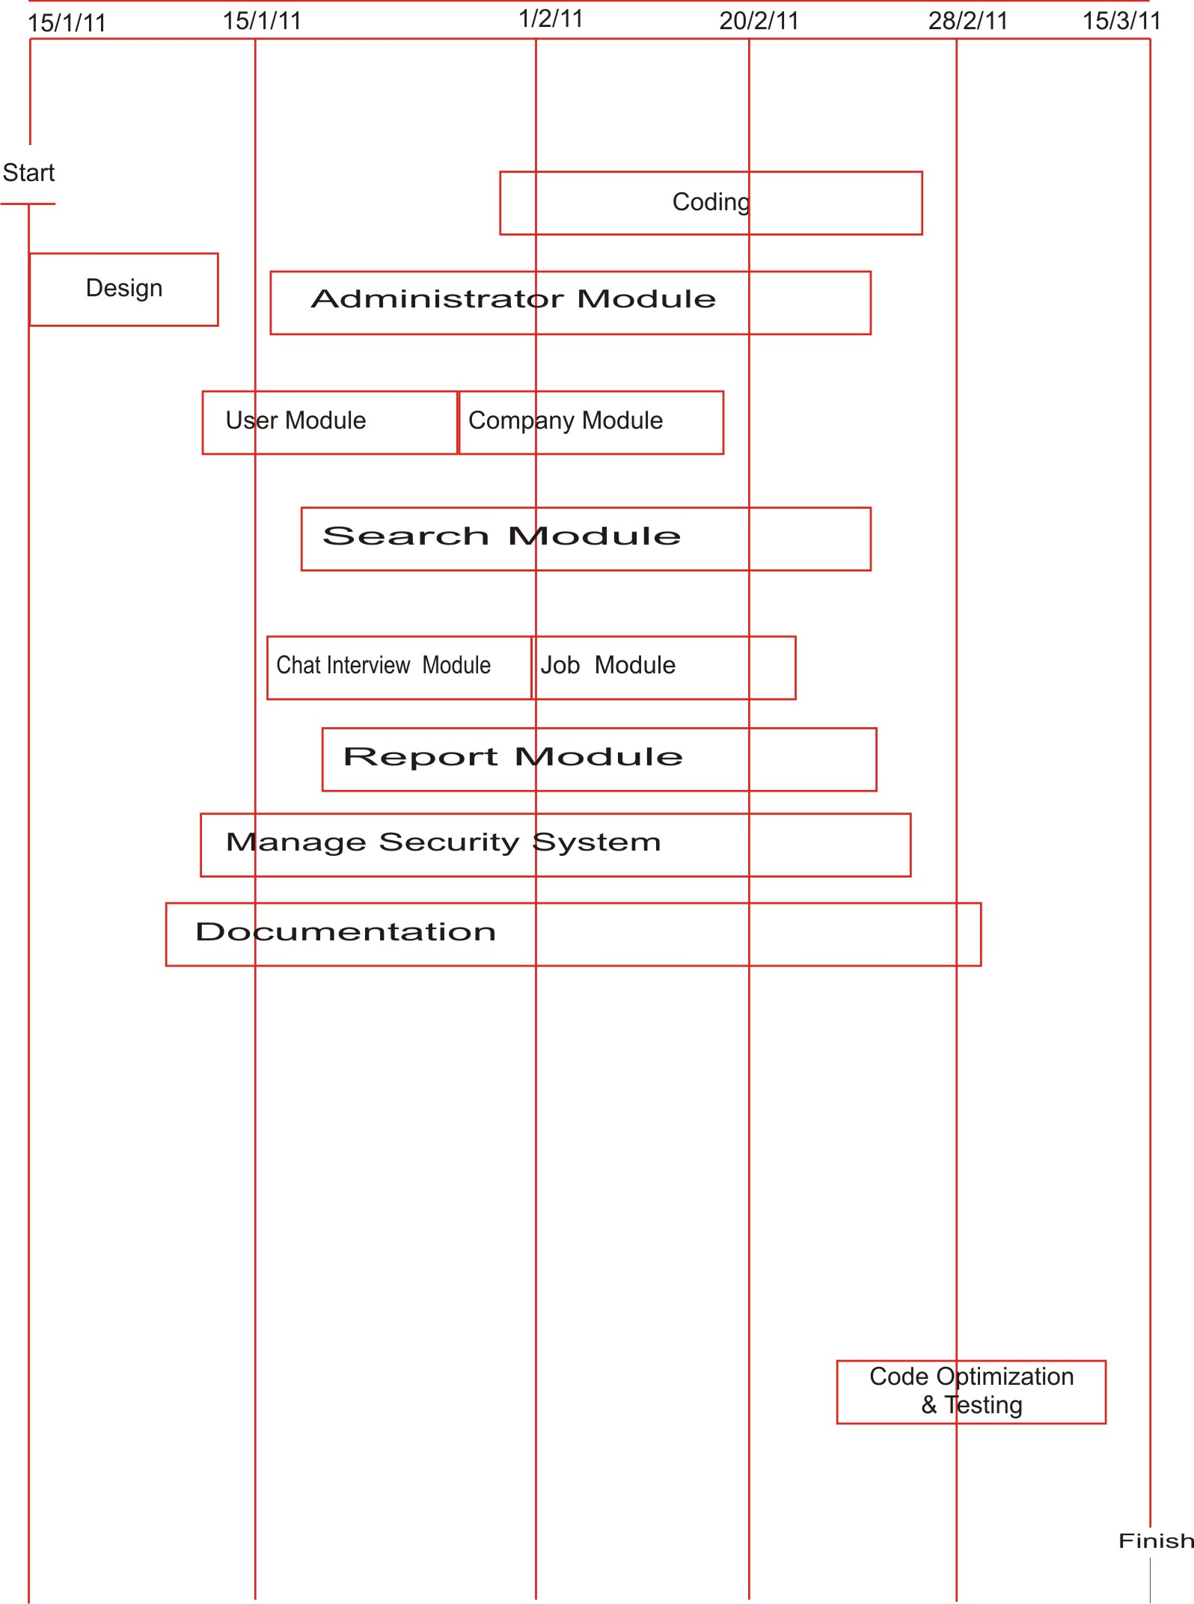

PERT CHART
. PERT analysis generally assumes a beta distribution of activity times using this model, the expected time to compute an activity. PERT is an aid to efficient project management. PERT was developed in the US navy during late 1950’s to accelerates, the development of the Polaris Ballistic Missile. The technique of PERT proved extremely successful in coordination the work of various different groups involved in the project
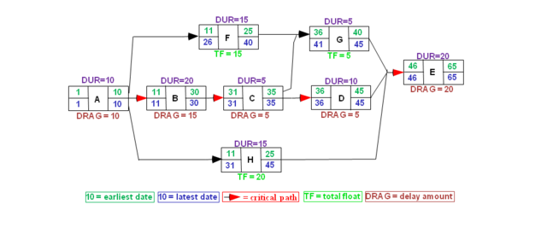

COST ESTIMATION OF THE PROJECT

COCOMO Model
COCOMO model introduced by Barry Bohem stands for Constructive Cost Model.. It perhaps the best known and most thoroughly documented of all the software cost estimation models. It also provides Three level of the models.
- Basic COCOMO: A single value model that computes software development cost as function of estimate LOC
- Intermediate COCOMO: This model computes development cost and effort as a function of program size (LOC ) and set of the cost drivers
- Detailed COCOMO: This model computes development effort and cost which incorporates all characteristics of intermediate level with assessment of cost implication on each step of development (analysis , design , testing).This model may be applied to three classes of software project.
- Organic: Small Size Project
A simple software project where the development team has good experience of the application.
- Semi-Detached
An intermediate size project and project is based on rigid and semi-rigid requirement.
Embedded The project development under hardware , software and operational constraints .Examples are embedded software , flight control.
In COCOMO model , the development effort assumes the following form-
E=aSbm Where E= Effort, S=Value of Source in LOC, M=Multiplier that is determined from a set of 15 Cost driver’s attributes

The following are examples of the above cost drivers
- Size of the applicatio0n database
- Complexity of the project
- Reliability requirements for the software
- Performance constraints in run time
- Capability of the software
- Scheduling constraints
In the early days of computing, software cost constituted a small percentage of the over-all computer based system cost. An order of magnitude error in estimates of software cost had relatively little impact. Today software is the most expensive element of virtually all computer based systems. For complex, custom systems, a large cost estimation error can make the difference between profit and loss. Software cost and effort estimation will never be an exact science. Too many variations- human, technical, environmental, political- can affect the ultimate cost of the software and effort applied to develop it.
To achieve a reliable cost and effort estimates, a number of options arise:
- Delay estimation until late in the project (obviously we can achieve 100% accurate estimates after the project is complete!)
- Base estimate on the similar projects that have already been completed.
- Use relatively simple decomposition technique to generate project cost and effort estimates.
- Use one or more empirical models for software cost and effort estimation.
COST OF THE PROJECT 1,22,000

LIMITATION OF THE PROJECT

The Current Project CRYPTOGRAPHY has as well - few limitations implicated intentionally as –
- I have used Oracle 10g Database product which cost is high.
- Although user is interacted with company but he is given not much facility to communicate directly with the Administrator.
- Login from same place for companies and administrator is a drawback in terms of legal security of the website.
- As mostly there area jsp pages, java beans classes are less integrated which are used to restrict and secure the process to be directly accessed from hackers or unauthorized person encoding and encrypting in secure classes.
- Owner required to have a Tomcat server support to run the application Online.

FUTURE SCOPE OF PROJECT

The project “CRYPTOGRAPHY” is generalized software and can be easily used in any consultancy department. The change in software can be easily accommodated.
The improvement in turnover of company up to any extent will be supported by software. The software will be able to provide its best facilities in case company starts online transactions in future. In this project, all the activities of the organization are performed manually.
To overcome all kind of problems being faced by organization. My project “CRYPTOGRAPHY” will provide efficient and cost effective solution and always have possibilities of enhancement up any legal extent to satisfy user requirement.
Further enhancement may include technical forum, Audio Encryption, mailing server/voice mail & Video Encryption and some extended modules.

BIBLIOGRAPHY

SOFTWARE ENGINEERING: Roger. S. Pressman.
THE COMPLETE REFERENCE JAVA-2: Patrick Naughtion & Herbert Schildt.
PROF. JAVA SERVER PROGRAMMING J2EE1.3: Subrahamanyam Allamaraju, Cedric Buest-Wrox Pub.
Prof. Jsp / Jstruts1.1: James Goodwill, Richard Hightower .
JAVA SCRIPT: Evan Baros.
DEVELOPING JAVA SERVLETS: James Goodwill, Techmedia
INTRODUCTION TO RDBMS: Vipin C. Desai.
WEBSITES REFERENCED
www. learncryptography.com (Overview And Basic Functionality)
www. Crypto101.io (Overview And Basic Functionality)
www. java.sun.com (Java, Jsp, Servlet And Its Related Informations)
www. Oracle.com (Basic Informations Of Oracle 9i And Pdfs)
www.cs.ucl.ac.uk (Project Planning And Scheduling)
www.engin.umd.umich.edu (Software Testing Strategies)
www.GeekInterview.com (Introductions And Differences )
www.roseindia.net (Java, Jsp, Servlet, Oracle Basic Informations)

